10
Modelling and manipulating data

Skill
Tool 2: Technology – Applying technology to collect data and applying technology to
process data

Aim
To model the energy of a photon of specific wavelength in the electromagnetic spectrum (EMS) using spreadsheets.

Introduction
With the progress in computers, the use of spreadsheets to manage big data sets has increased in popularity and is currently one of the most powerful tools that data-scientists, analysts, students and many other professionals use.

Microsoft Excel is one of the most popular spreadsheet programs, and therefore is the one demonstrated below, but the proposed procedure can work in other applications such as Google Sheets, Numbers etc, with minor adjustments.

In this example you will study the relationship between energy and wavelength, and determine the amount of energy carried by a single photon of specific wavelength. Through the process you will familiarize yourself with a few of the tools available that allow for the quick and easy generation of data that can be further studied.

Materials needed
Access to a laptop or computer

Method
Note: The procedure steps given refer to the desktop version of Microsoft Excel. Some of the commands described here are not supported in the online version of Excel. Note that Mac and PC versions of Excel may differ in layout from the screenshots provided.

- Launch MS Excel and open a new spreadsheet.
- Rename Sheet 1 as InputData.

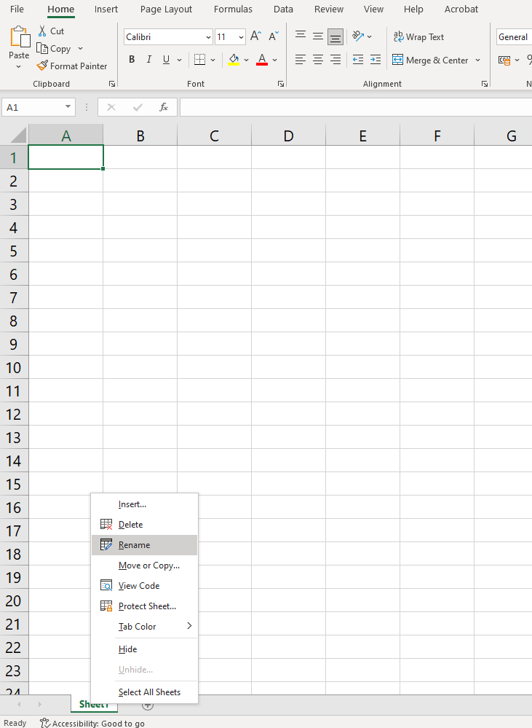



- Enter the following:
  - ‘Speed of light’ in cell A1
  - ‘Planck’s constant’ in cell A2
  - the value ‘3.00E+08’ in cell B1 (note: capital E followed by a number is translated by Excel as ×10 to the power of the stated number)
  - the value ‘6.63E-34’ in cell B2
  - ‘m/s’ in cell C1
  - ‘m^2 kg/s’ in cell C2.

Your spreadsheet should look like this:
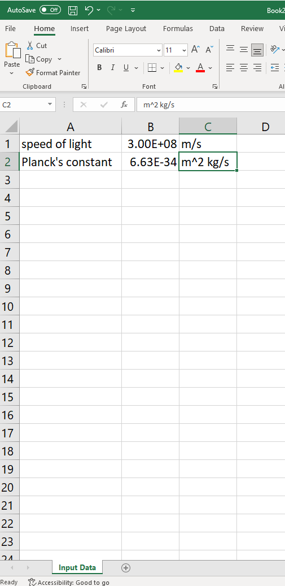

- We need to define these cells because we will be opening a new sheet within this workbook. It is good practice to keep the input variable in a separate sheet as it will make it easier to revisit and refine a model at a later stage if necessary. To simplify the references, we will define names for cells B1 and B2 by right clicking on the individual cells and selecting ‘Define Name...’ from the drop-down menu.

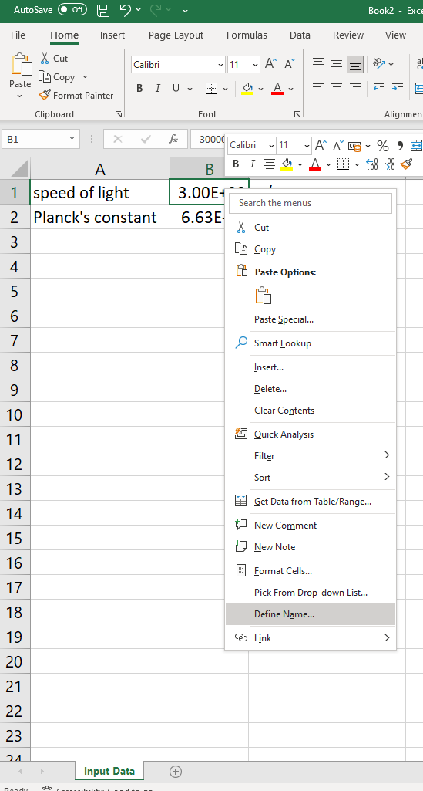

- Define cell B1 as ‘speed_of_light’ and cell B2 as ‘Planck_constant’

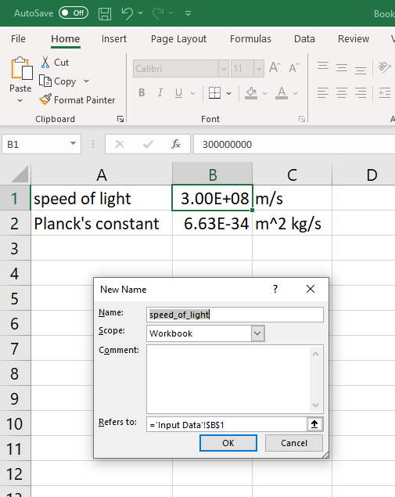

- Open a new sheet by pressing the ‘+’ button at the bottom left of the spreadsheet and name it DATA.



- This model will calculate the energy of a photon given the photon’s wavelength. Name the top cells A1, B1, C1, D1 with their related units as shown below:

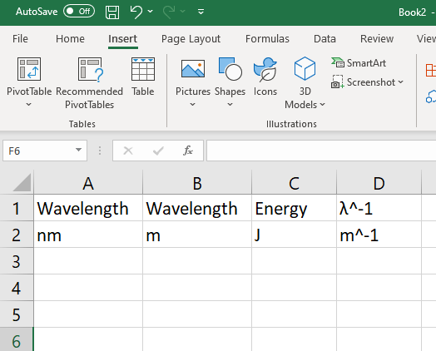

- In Cell A3 type ‘10’ (since 10 nm is the lower range of the UV spectrum).
We want to generate data for every 10 nm up to the upper range of the visible spectrum which is 800 nm. To do this easily, in Cell A4, type the command ‘=A3+10’.

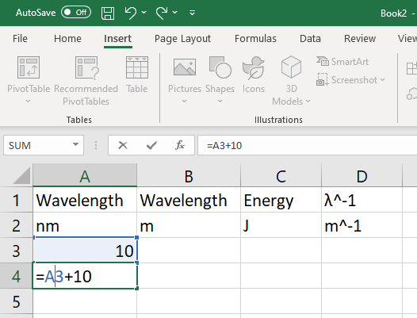

By pressing Enter you will see the value 20 replacing your command.

- Select cell A4 and scroll down to A83 selecting all these cells. Then click on the command Fill on the top right corner of the spreadsheet and select ‘Down’ as shown:



This will populate the cells with the wavelength increasing by a step of 10 nm per cell.

- In our calculations we will need the wavelength expressed in m, so we will calculate the wavelength in m in the next column. To do so, in cell B3, type the command ‘=A3*1E-9’
Then select all cells between B3 and B83 and ‘Fill’ ‘Down’ as in step 8.

- To calculate the energy, we need to apply the formula $E=h\frac{c}{λ}$. To have this calculated automatically, go to cell C3 and enter the command ‘=Planck_constant*speed_of_light/B3’
Your defined variables must show up automatically as you start writing them so you can click on them to easily select them.

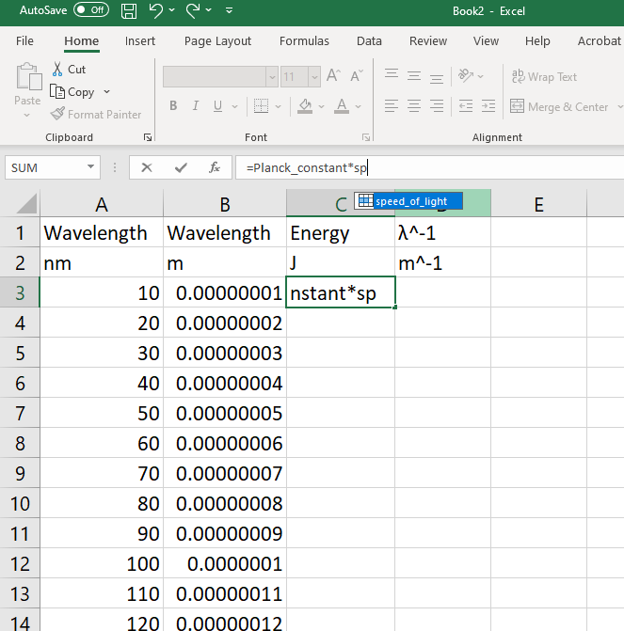

- As before, select all cells from C3 to C83 and then use the ‘Fill’ ‘Down’ command to generate the data.

- In the last column we will calculate the inverse of the wavelength values. To do so, in Cell D3, type the command ‘=1/A3’. Then use the Fill’ ‘Down’ command once again to generate the relevant data.

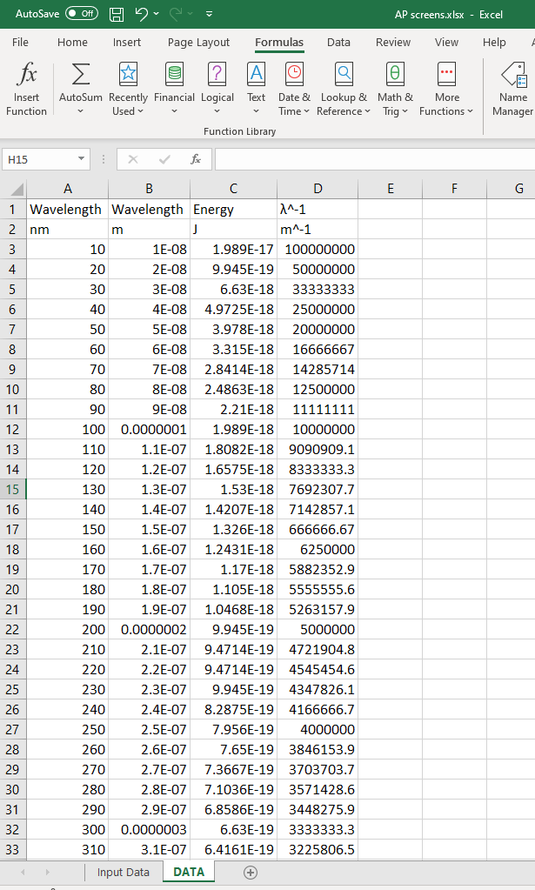

DATA analysis
- With all the relevant data generated by our model we can generate some graphical representations. Select all cells in columns B and C. With the cells selected, click the button ‘Recommended Charts’ and select ‘Scatter’.

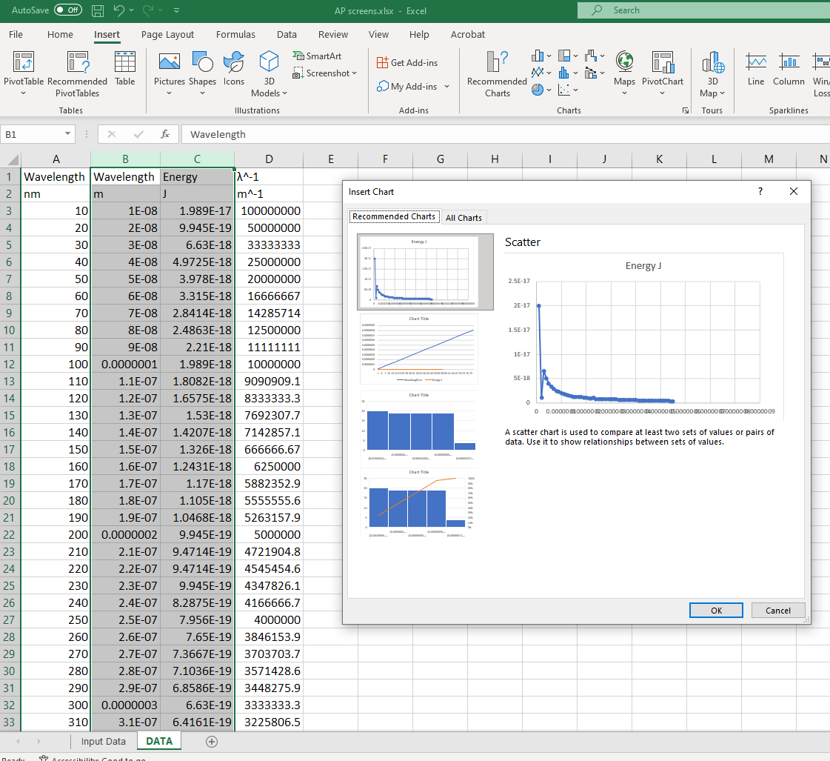

- From the graph, the inverse relationship between energy and wavelength is immediately obvious.

- Now, select all cells in columns C and D. With the cells selected, click the button ‘Recommended Charts’ and select ‘Scatter’. A linear graph is then produced. Right click on the line and select ‘Add trendline…’ from the dropdown menu:

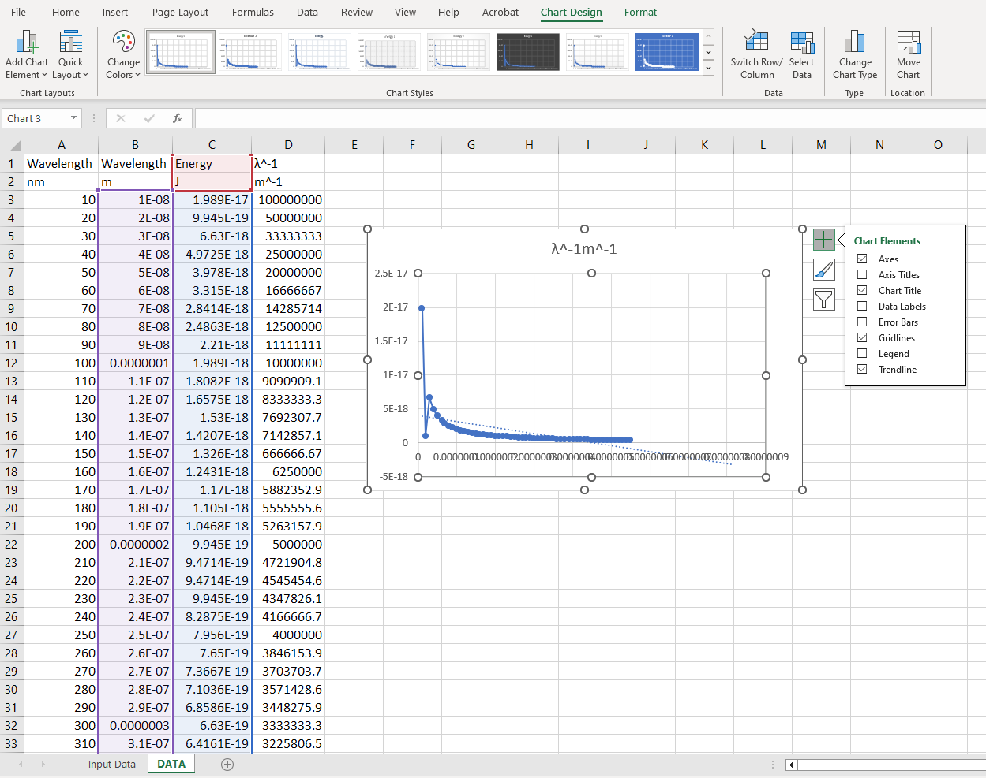

- On the ‘Format Trendline’ menu that opens up, select ‘Linear’ and tick the boxes for displaying the equation on the chart and for displaying the correlation coefficient (R²) on the chart.
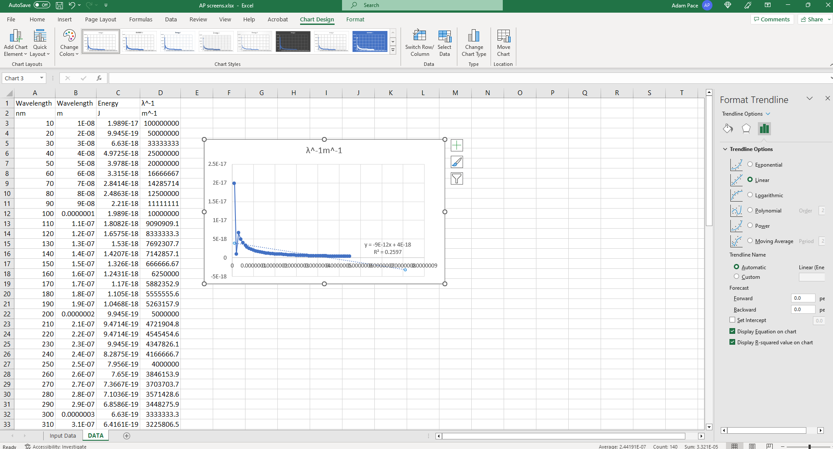

Notice that the slope of the line is 2 × 10⁻²⁵. If you are getting a different value it may be because the axes are not set correctly.
You can click on the ‘Select Data’ button on the top right and select the appropriate data set for the x- and y-axis cells manually:

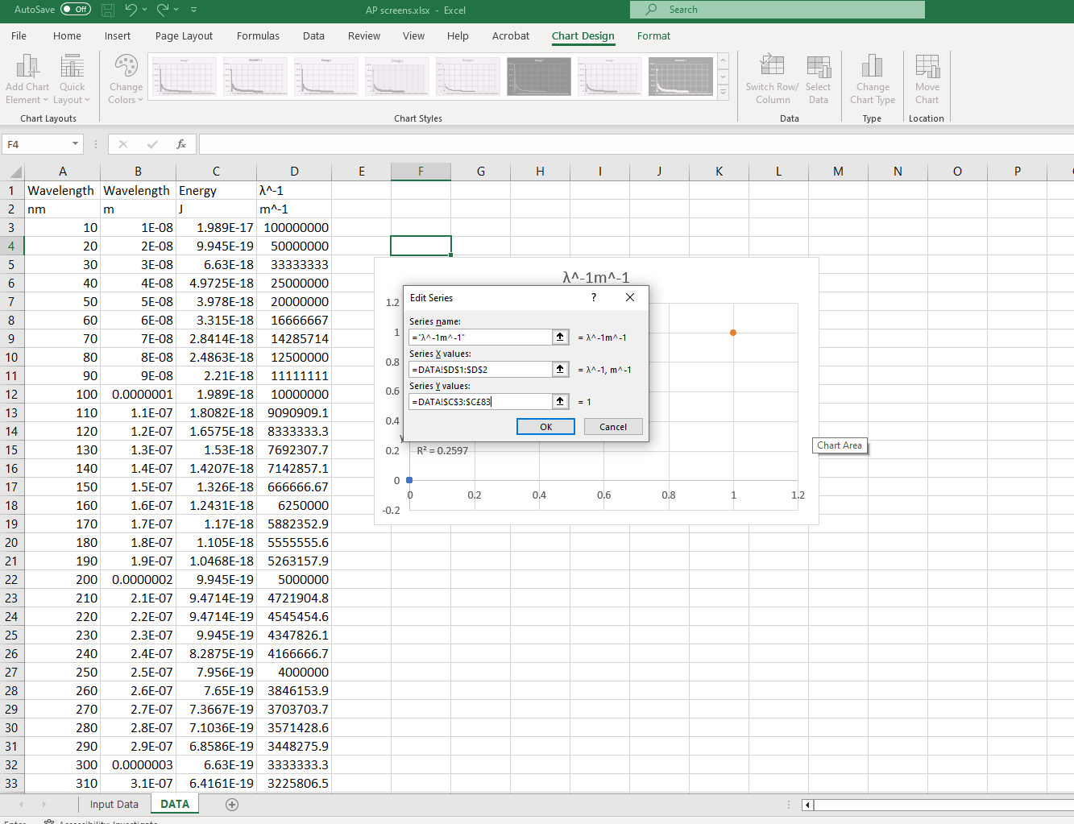

The slope of the line is shown to be equal to 2 × 10 ⁻²⁵. This is the product of Planck’s constant multiplied by the speed of light. You can double-check this in a random cell by writing the command ‘=speed_of_light*Planck_constant’ and then pressing Enter.

You will see the value ‘1.989E-25’ showing up as expected.

This justifies the expression $E=h\frac{c}{λ}$
that can also be given as $E=hc\frac{1}{λ}$
which is of the form $y=kx ($for y = E and $x=\frac{1}{λ}$).

Reflection
- Models, like the one presented here, are only as accurate as the inputs used to create the model. Models can be complex or very basic such the one presented above. Discuss.
- Evaluate your digital skills and consider the parts that may have been challenging
for you.

Post–lab report
Write a report where you:
- Summarize the important theoretical concepts described in this lab.
- Summarize the experimental procedures.
- Highlight any important health and safety matters.
- Consider how the presented model can be expanded or propose a similar model for studying a different phenomenon.

