Structure 1.4.5
Preparation and standardization of aqueous solutions

References:
S1.4.5 The molar concentration is determined by the amount of solute and the volume
of solution.
T1 Applying techniques

Aim
To prepare a standard solution and use it to standardize the solutions of NaOH(aq) and HCl(aq) prepared in the Preparing solutions lab.

Introduction
Standard solutions are aqueous solutions in which the concentration is precisely known.
A standard solution can be prepared in the lab and be used to ‘standardize’, or in other words, to accurately determine the concentration of, other solutions in volumetric analysis.

To prepare a standard solution the solute used needs to meet some criteria; it must:
- be available in high purity
- be stable in air
- be fully soluble in water
- have a high molar mass
- react completely and quickly with the solution being standardized.

Pre-lab question
Potassium hydrogen phthalate (C₈H₅O₄K) and sodium carbonate (Na₂CO₃) are commonly used as standard solutions, while compounds such as sodium hydroxide or potassium permanganate are not preferred. Explain why.

Please note
- A full risk assessment should be carried out prior to commencing this experiment.
- Personal safety equipment should be worn.
- Chemicals should be disposed of safely and with due regard to any environmental considerations.

Risk assessment
Material name and chemical formula | Associated risks | Measures taken

Environmental risks
Waste products (if any) | Associated risks | Waste management

Ethical risks
Small amounts should be used when possible. Produced solutions will be used in subsequent experiments. No harm to people and the environment will be caused by this experiment.

Equipment list
Chemicals/materials | Apparatus (per group of students)
solutions of HCl and NaOH from ‘Preparing solutions’ lab  potassium hydrogen phthalate (C₈H₅O₄K(s))  sodium carbonate (Na₂CO₃(s))  phenolphthalein indicator solution  deionized water | volumetric pipette and pipette filler  burette  conical flask

Method
A. Preparation of potassium hydrogen phthalate solution

Using the procedures described in ‘6 – Preparing solutions’ lab, prepare 200 cm³ solution of potassium hydrogen phthalate with a concentration of 1.0 mol dm⁻³ (or a solution of sodium carbonate with a concentration of 1 mol dm⁻³, depending on what is available in the lab).

In the Preparing solutions lab, you prepared a 2.0 mol dm⁻³ solution of NaOH and a 0.2 mol dm⁻³ solution of HCl. In this lab you will perform a titration of these two solutions against your standard solution and accurately determine their concentrations, which will probably deviate from what is stated on their labels. For this reason, you should assume that the solutions of NaOH and HCl both have an unknown concentration.

B. Standardization of NaOH(aq) with 1.0 mol dm⁻³ C₈H₅O₄K(aq) solution

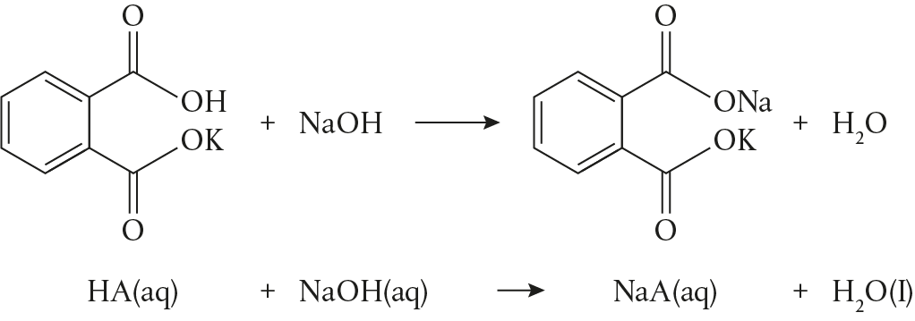

- Rinse the burette with some of the NaOH solution then fill the burette with NaOH(aq) and record the initial volume.
- Into a clean, dry conical flask, transfer exactly 25.0 cm³ of the potassium hydrogen phthalate solution you prepared in A using a volumetric pipette.
- Add a few drops of phenolphthalein indicator to the potassium hydrogen phthalate in the conical flask.
- While swirling the conical flask, start adding NaOH from the burette until the solution in the conical flask turns a light pink colour that persists.
- Record the final volume in the burette.
- Repeat the process 5 times and determine the average volume of the base used.

By standardizing your NaOH solution you can then use it to standardize your solution of HCl.

C. Standardization of HCl(aq) with 1.0 mol dm⁻³ Na₂CO₃(aq) solution

Na₂CO₃(aq) + HCl (aq) NaHCO₃ (aq) + NaCl (aq)

- Rinse the burette with some of the Na₂CO₃ solution and fill the burette with Na₂CO³(aq) and record the initial volume.
- In a clean, dry flask, transfer exactly 25.0 cm³ of HCl(aq) using a volumetric pipette.
- Add a few drops of phenolphthalein indicator to the conical flask with the phthalate.
- While swirling the conical flask, start adding Na₂CO₃ from the burette until the solution in the conical flask obtains a light pink colour that persists.
- Record the final volume in the burette.
- Repeat the process 5 times and determine the average volume of the base used.
- Store any excess of Na₂CO₃ solution (in an appropriate and clearly labelled container) as it can be used in other experimental procedures.

By standardizing your HCl solution you can then use it to standardize solutions of NaOH.

Analysis

Table 1 – Standardization of NaOH
Analyte |  |  | Trials
Titrant
Indicator
 |  | Pilot | 1 | 2 | 3 | 4 | 5 | Average volume (cm³)
Burette readings | Initial volume |  |  |  |  |  |  | Average volume (cm³)
Burette readings | Final volume |  |  |  |  |  |  | Average volume (cm³)
Volume used

Since the reaction between the potassium hydrogen phthalate (the acid) and the sodium hydroxide (the base) has a 1:1 molar relationship the following formula applies:

C_{acid}V_{acid} = C_{base}V_{base}
Use this formula and the data below to determine the concentration of NaOH(aq).
C_{acid} = 1.0 mol dm⁻³
V_{acid} = 25.0 cm³
V_{base} = average volume determined experimentally

Table 2 – Standardization of HCl
Analyte |  |  | Trials
Titrant
Indicator
 |  | Pilot | 1 | 2 | 3 | 4 | 5 | Average volume (cm³)
Burette readings | Initial volume |  |  |  |  |  |  | Average volume (cm³)
Burette readings | Final volume |  |  |  |  |  |  | Average volume (cm³)
Volume used

Since the reaction between the HCl (the acid) and the sodium carbonate (the base) has a 1:1 molar relationship, the following formula applies:
C_{acid}V_{acid} = C_{base}V_{base}
Use this formula and the data below to determine the concentration of HCl(aq).
C_{base} = 1.0 mol dm⁻³
V_{acid} = 25.0 cm³
V_{base} = average volume determined experimentally

Reflection
- In the Preparing solutions lab, you prepared a 2.0 mol dm⁻³ solution of NaOH and a 0.2 mol dm⁻³ solution of HCl. Using the data from this lab, determine the absolute error in the concentrations of these solutions.
- What are some reasons that can account for the deviation of the concentration of the solutions prepared in the Preparing solutions lab from the concentration determined after their standardization?
- In the reaction between HCl and Na₂CO_{3,} NaHCO₃ can further react with HCl to produce CO₂(g) and water:
NaHCO₃(aq) + HCl(aq) NaCl(aq) + CO₂(g) + H₂O(l)
In the titration above, how do we know that the reaction does not proceed to completion?

Post–lab report
Write a report where you:
- Summarize the important theoretical concepts described in this lab.
- Summarize the experimental procedures.
- Highlight any important health and safety matters.
- In your discussion, consider that phthalates are an environmental issue and propose measures to be taken for the treatment of the sodium potassium phthalate waste produced in this experiment.

