9
Setting up a reflux and distillation apparatus

Skill
Tool 1: Experimental Techniques – Applying techniques

Aim
To correctly set up a distillation and reflux apparatus.

Introduction
Distillation apparatus is used to separate liquids with different boiling points.
Reflux apparatus is used when it is necessary to evaporate and subsequently condense
and return vapours back to their original system. This allows reactions to be run at
elevated temperatures safely and without loss of the solvent due to evaporation.

Pre-lab question
Research the process of petroleum refining. Describe how the distillation tower functions.

Equipment list
Chemicals/materials | Apparatus (per group of students)
tap water | round bottom flask ×3  condenser  simple still head  solvent still head  still receiver  thermometer  water tubing  anti-bumping granules  magnetic stirring bar  heating mantle or hot plate and water bath  stand and clamps

Method

A Setting up reflux for a reaction
Reflux is always required whenever a reaction takes place in a low boiling point solvent, as a safety precaution. The set-up is relatively easy and requires a stand, clamps, a condenser and the reaction flask (Figure 1).

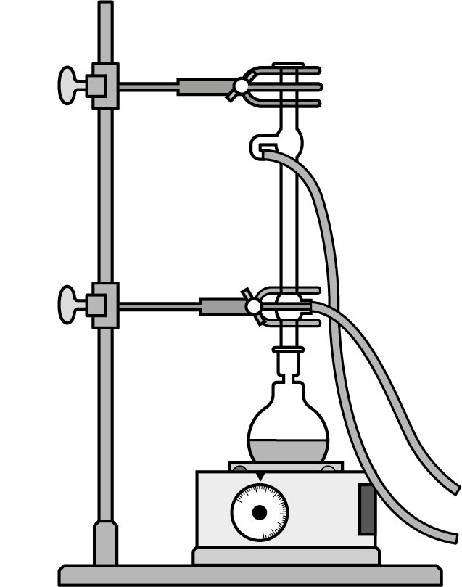

Figure 1. Reflux heating using an electric mantle

The reaction flask is stabilised using a clamp on a stand at a height that allows the flask to be submerged in the heating bath, or the heating mantle, used. An upright condenser is connected on the top of the flask and secured with a clamp.

The condenser is connected to running water with the cold water entering from the lower end and exiting at the top end of the condenser, because you want the coolest part of the condenser to be at the beginning of the tube.

When refluxing a reaction mixture or a solution, a stirring magnet or a few anti-bumping granules (boiling chips) must be added in the solution to ensure even distribution of the heat in the liquid and to avoid ‘bumping’.

B Setting up reflux for the purification of a solvent
Reflux can be set up for the purification of a solvent prior to its use. In this case, an additional piece of glassware – a solvent still head (Figure 2) – is introduced between the round-bottomed flask and the condenser.

The still head can collect a volume of solvent less than the volume of solvent available in the round bottom flask and return any excess back to the original flask, which must always contain some liquid during the process.

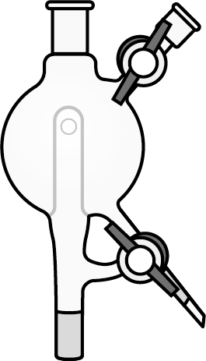

Figure 2. Solvent still head

C Setting up distillation apparatus
Distillation uses the same pieces of glassware as reflux, but they are connected in a different way, using a simple still head (Figure 3).

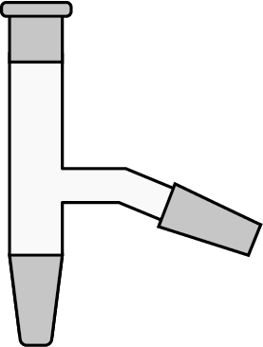

Figure 3. Simple still head

The simple still head is placed on the top of the round bottomed flask and allows for the placement of a thermometer on the top and a horizontal condenser on the side (Figure 4).

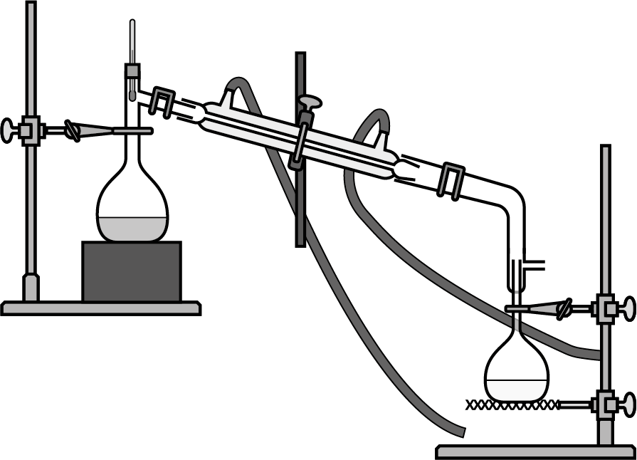

Figure 4. Distillation apparatus set-up with simple still head

As soon as a liquid reaches its boiling point, it evaporates, and the vapour is directed to the condenser through the still head. The boiling point can be recorded from the thermometer.
As the vapour passes through the condenser it condenses into a liquid and is collected in the flask at the exit.

Since different liquids boil at different temperatures, we can use this apparatus to separate the different components of a liquid mixture using a process called fractional distillation.

Analysis
- What is bumping? Why are anti-bumping granules effective?
- What is an industrial application of fractional distillation?
- Why is it possible to separate mixtures of liquids taking advantage of their boiling
point difference?
- Some mixtures, such as ethanol and water form azeotropes. What is an azeotrope?

Reflection
Evaluate your skills and consider the parts that may have been challenging for you.

Post–lab report
Write a report where you:
- Summarize the important theoretical concepts described in this lab.
- Summarize the experimental procedures.
- Highlight any important health and safety matters.
- Consider the parts of the method that are prone to random errors and consider how that can affect your results.

