Reactivity 3.1.7 and Reactivity 3.1.8
Acid–base titrations using a pH sensor – identifying the equivalence point

References:
R3.1.7 Acids react with bases in neutralization reactions.
R3.1.8 pH curves for neutralization reactions involving strong acids and bases have characteristic shapes and features.
T1 Experimental techniques
T2 Digital technology
T3 Mathematical skills

Aim
To perform an acid–base titration using a pH sensor and identify the equivalence point.

Introduction
When performing a titration using an indicator it is possible to identify the end-point of the titration based on the colour change of the indicator. This colour change will occur at the equivalence volume, the volume of titrant required for the neutralization of the acid.

A pH sensor can identify the equivalence point, which can then be used to determine the equivalence volume.

In a strong acid–strong base titration, the expected neutralization curve will be of the form shown in Figure 1.

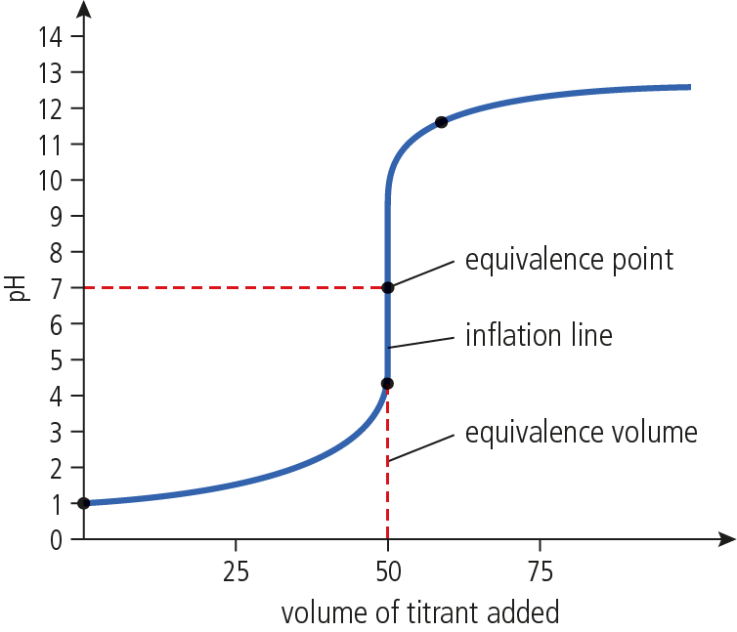

Figure 1. The neutralization curve for a strong acid–strong base titration

Note that the equivalence point is exactly at the middle of the inflation line at the equivalence volume.

There is a subtle difference between the equivalence point and the end-point of a titration, because the end-point depends on the indicator used. For example, if phenolphthalein indicator (pH range of 8.3–10.0) is used in the titration, then the end-point will be identified as shown in Figure 2.

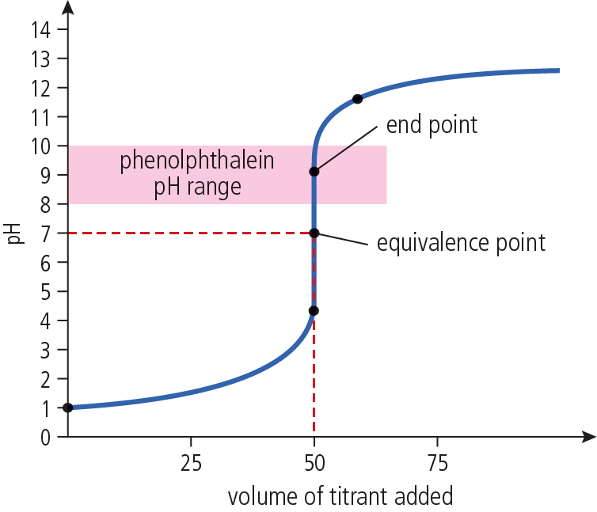

Figure 2. The end-point on a neutralization curve

Even though the end-point and equivalence point are not exactly the same, they both lie on the inflation line and either can be used to identify the equivalence volume.

Please note
- A full risk assessment should be carried out prior to commencing this experiment.
- Personal safety equipment should be worn.
- Chemicals should be disposed of safely and with due regard to any environmental considerations.

Risk assessment
Material name and chemical formula | Associated risks | Measures taken

Environmental risks
Waste products (if any) | Associated risks | Waste management

Ethical risks
Risks to humans | Justification | Management
Risks to the environment | Justification | Management

Equipment list
Chemicals/materials | Apparatus (per group of students)
hydrochloric acid solution, HCl(aq), unknown concentration  sodium hydroxide, NaOH (0.100 mol dm⁻³) standard solution  deionized water | burette  100 cm³ beaker  funnel  20 cm³ graduated pipette and pipette filler  magnetic stirrer and magnetic stirring bar  pH sensor  data-logging equipment  stand and clamp

Method
Before starting the experiment, ensure that the pH sensor is calibrated and properly stored. The sensor should be removed from the storing solution, rinsed with deionized water, and gently dried with a soft tissue before use. Ensure that sensors are properly cleaned and stored upon completion of the experiment.

- Use a pipette to transfer exactly 20.0 cm³ (V_{a}) of a hydrochloric acid solution of unknown concentration to a 100 cm³ beaker.
- Set the beaker on a magnetic stirrer and place the magnetic stirring bar in the solution.
- Set up the stirring at a gentle rate so there is no spillage.
- Using a stand and clamp, fix the pH sensor so that it is immersed in the solution without touching the sides of the beaker or interfering with the stirring.
- Set the data-logger for an events-with-entry data collection. Refer to the data-logger software manual for more details on this. If you are not using a software, record your data in an appropriate table (such as Table 1).
- Start data collection and make an entry for every 1 cm³ of base added to the beaker.

Analysis

Table 1
Volume of base (cm³) | pH of solution
… | …

- From the graph generated by the collected data, identify the equivalence point and the equivalence volume (V_{eq}) of base.
- From the equation:
NaOH(aq) + HCl(aq) NaCl(aq) + H₂O(aq)
Molar ratio: 1 mol 1mol
n_{b} n_{a}

we see that the reaction has a 1:1 molar ratio, so n_{a} = n_{b}
- Therefore, the concentration of the acid (C_{a}) can be determined using the formula:
C_{a}V_{a} = C_{b}V_{eq}

Reflection
The formula C_{a}V_{a} = C_{b}V_{eq} can only be used in this form when the stoichiometric relationship of the acid and the base is 1:1.

How would the formula differ if the acid used was sulfuric acid (H₂SO₄) instead?

Post–lab report
Write a report where you:
- Summarize the important theoretical concepts described in this lab.
- Summarize the experimental procedure.
- Highlight any important health and safety matters.
- Present your observations and discuss your results.
- State the concentration of the acid. Your teacher will tell you the exact value.
Determine your experimental error.
- List the sources of random and systemic error and consider their effect in the determination of the concentration of the acid.

