Reactivity 2.2.1 and Reactivity 2.2.9 (HL)
Investigating rates of reaction

References:
R2.2.1 The rate of reaction is expressed as the change in concentration of a particular reactant/product per unit time.
HL ONLY 2.2.9 Rate equations depend on the mechanism of the reaction and can only be determined experimentally.

Aim
To compare the rate of the reaction between sodium thiosulfate and hydrochloric acid at different concentrations of hydrochloric acid

Introduction
When we want to investigate the effect of a specific factor on the rate of a reaction, it is sometimes convenient to choose a detectable end-point. By timing how long it takes the reaction to reach this end-point under different conditions, we can compare rates of reaction.

In this lab we will compare the time it takes for a solution to reach a certain level of turbidity (cloudiness) as we change the concentration of one of the reactants.

Sodium thiosulfate, Na₂S₂O₃, and hydrochloric acid, HCl, react together to form sodium chloride, sulfur dioxide, and sulfur.

Na₂S₂O₃(aq) + 2HCl(aq) → 2NaCl(aq) + SO₂(aq) + H₂O(l) + S(s)

The sulfur that is formed in the reaction precipitates and causes the solution to increase in turbidity. The end-point is identified when a black cross drawn on a piece of paper placed under the reaction mixture is no longer visible (Figure 1).

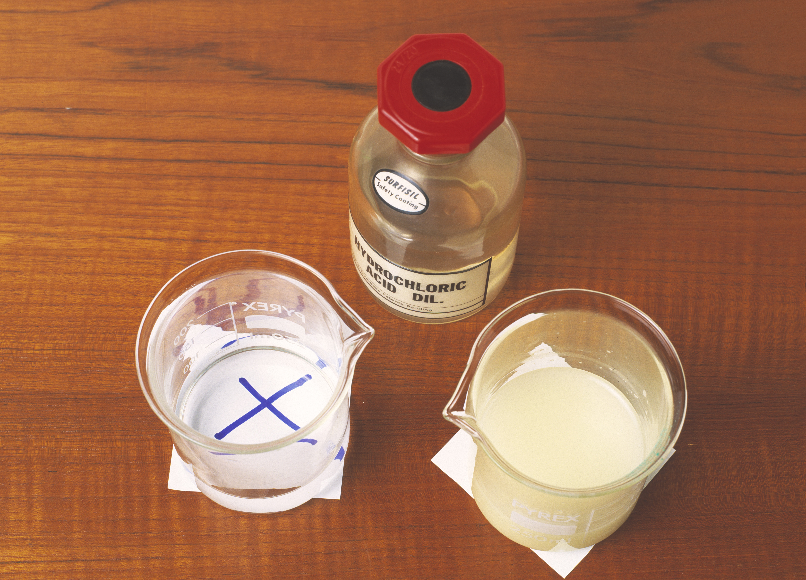

Figure 1

In the experiment, we will vary the concentration of HCl from 0.05 mol dm⁻³ to 1.0 mol dm⁻³.
By measuring the time it takes for the reaction to reach the end-point in each case, we can calculate the rate of reaction from the relationship:
$$rate \left(s^{-1}\right)=\frac{1}{time (s)}$$

In order to compare the results at different HCl concentrations, we must keep all other variables that could influence the rate of reaction as constant as possible.

Itemize those variables here and suggest how they could be controlled.
Variable to be controlled | How it will be controlled

Pre-lab questions
- Identify the dependent and independent variables in this experiment.
- What would you expect the effect of changing the concentration of HCl to have on the rate of the reaction? Explain this in terms of collision theory.
- Other than changes in turbidity, what other ways could be used to measure the rate of this reaction?

Please note
- A full risk assessment should be carried out prior to commencing this experiment.
- Personal safety equipment should be worn.
- Chemicals should be disposed of safely and with due regard to any environmental considerations.

Risk assessment
Material name and chemical formula | Associated risks | Measures taken

Environmental risks
Waste products (if any) | Associated risks | Waste management

Ethical risks
Risks to humans | Justification | Management
Risks to the environment | Justification | Management

Equipment list
Chemicals/materials | Apparatus (per group of students)
sodium thiosulfate solution, Na₂S₂O₃(aq), 0.5 mol dm⁻³  hydrochloric acid, HCl(aq), 1.0 mol dm⁻³ | 5 volumetric flasks  25.00 cm³ and 10.00 cm³ pipettes  pipette filler  burette  conical flask  white paper  black marker pen  stop clock  thermometer

Method
- Using the 1.0 mol dm⁻³ HCl supplied, prepare serial dilutions of the following concentrations: 0.5 mol dm⁻³, 0.25 mol dm⁻³, 0.1 mol dm⁻³, and 0.05 mol dm⁻³.
- Fill a burette with the 0.5 mol dm⁻³ sodium thiosulfate solution, then measure 25.00 cm³ of the solution into a conical flask.
- Place the conical flask on a piece of white paper with a black cross marked on it.
- Pipette 25.00 cm³ of 1.0 mol dm^{–3} hydrochloric acid into the conical flask and time the reaction from when the reactants mix. Stop timing when the black cross is no longer visible.
- Repeat the process with the four solutions of HCl of different concentration.
- Carry out repeat trials for each HCl concentration.

Analysis
- Set your results out clearly in appropriate tables, showing qualitative data and quantitative data.
- Remember to include uncertainties and units with all your measurements.
- Use your data to calculate the average rate of the reaction for each concentration of HCl.
- Draw graphs of time versus concentration and rate versus concentration. Refer to the first pre-lab question to make sure you have correctly identified the dependent and independent variables to determine which variable to plot on each axis.

Conclusion and evaluation
- What can you conclude about the effect of the concentration of HCl on the rate of the reaction?
- Does this fit with your expectations based on collision theory?
- Calculate the % error arising from random errors in the experiment.
- HL ONLY Determine the rate equation for this reaction from your experimental data.
- Itemize systematic errors and suggest modifications to the experiment to reduce these.

Reflection
- What can you conclude about the order of the reaction with respect to HCl from the experimental results?
- Consider which other factors affect the rate of this reaction and could be investigated using this ‘clock’ method.
- The time taken to reach the endpoint of the reaction is measured by making a subjective judgement based on the apparent ‘disappearance’ of the black cross. Suggest a suitable control to test the repeatability of this method.

Post–lab report
Write a report where you:
- Summarize the important theoretical concepts described in this lab.
- Explain why pure deionized water was not used in this experiment.
- Summarize the experimental procedure.
- Highlight any important health and safety matters.
- Present your observations and discuss your results.
- Present and justify your conclusion.
- Evaluate the process. Propose a quantitative extension for this laboratory experience.

