Reactivity 2.1.4 and Structure 3.2.5
Synthesis and purification of Aspirin

References:
R2.1.4 The percentage yield is calculated from the ratio of experimental yield to
theoretical yield.
S3.2.5 ‘IUPAC nomenclature’ refers to a set of rules used by the International Union of Pure
and Applied Chemistry to apply systematic names to organic and inorganic compounds.
T1 Experimental techniques

Aim
To synthesize Aspirin and purify the product by recrystallization.

Introduction
The mild analgesic Aspirin, acetylsalicylic acid (ASA), was first synthesized from salicylic acid in 1890. The reaction is an esterification process where the –OH group of salicylic acid is converted into an ester group. The reaction can be carried out in the laboratory using acetic anhydride (IUPAC name, ethanoic anhydride) and a phosphoric acid catalyst.

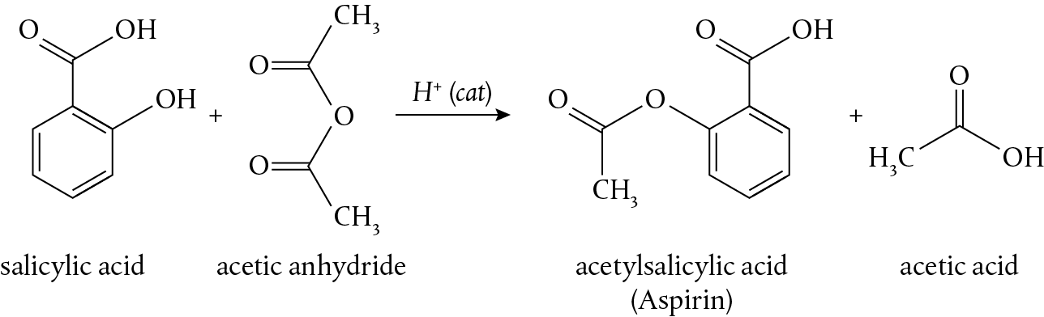

Synthesis of Aspirin

In this lab we will synthesize a sample of acetylsalicylic acid and purify it using recrystallization.

Pre-lab questions
- What are the IUPAC names of salicylic acid and acetylsalicylic acid?
- In this experiment, 2.0 g of salicylic acid will be reacted with 5.0 cm³ of acetic anhydride. Identify the limiting reagent and determine the theoretical yield of Aspirin expected.
- Why is hot ethanol an appropriate choice of solvent for the recrystallization process?
- Propose a mechanism for this reaction using curly arrows.
- Explain the effect of the catalyst in this reaction.

Please note
- A full risk assessment should be carried out prior to commencing this experiment.
- Personal safety equipment should be worn.
- Chemicals should be disposed of safely and with due regard to any environmental considerations.

Risk assessment
Material name and chemical formula | Associated risks | Measures taken

Environmental risks
Waste products (if any) | Associated risks | Waste management

Ethical risks
Risks to humans | Justification | Management
Risks to the environment | Justification | Management

Equipment list
Chemicals/materials | Apparatus (per group of students)
salicylic acid  acetic anhydride  85% phosphoric acid  ethanol  1% iron(III) chloride solution, FeCl₃(aq)  distilled water | digital balance  weighing boats  50 cm³ conical flask  glass rod  10 cm³ measuring cylinder  large beaker for water bath  magnetic stirrer  thermometer  hot plate  clamp and stand  Buchner vacuum filtration apparatus  filter paper  100 cm³ round-bottomed flask  condenser  3 test tubes and dropper  ice bath

Method

Synthesis of Aspirin
Record values in Table 1.
- Fill a large (500 cm³) beaker approximately two-thirds full of water. Heat it to 75°C on a hot plate, using a stirring magnet.
- Accurately weigh approximately 2 g of salicylic acid into a weighing boat, and then transfer it to a 50 cm³ conical flask. Record the exact mass of salicylic acid used.
- In the fume cupboard, use a 10 cm³ measuring cylinder to obtain 5.0 cm³ of acetic anhydride. Add the acetic anhydride and 5 drops of 85% phosphoric acid to the salicylic acid in the conical flask and gently swirl the mixture.
- Using a stand and clamp, suspend the conical flask in the 75°C water bath prepared in step 1. Heat the reaction mixture for 15 minutes, stirring occasionally with a glass rod. After 10 minutes add 2.0 cm³ of distilled water to the mixture.
- While the reaction is proceeding, prepare a Buchner vacuum filtration apparatus. Ensure the filter paper is cut to the right size to cover the holes and dampen it with a small amount of cold distilled water before turning on the vacuum.
- Turn off the water bath and remove the conical flask. Add a further 20 cm³ of distilled water to the reaction mixture and allow it to cool to room temperature before cooling for a further 5 minutes in an ice bath. White crystals of acetylsalicylic acid should appear during this cooling phase.
- After cooling, filter off the crude solid acetylsalicylic acid using the Buchner filter.
- After the liquid has passed through the filter turn off the vacuum, ‘break’ the seal, and add 5 cm³ of cold distilled water. After 15 seconds, turn the vacuum back on to remove the distilled water. Repeat for a total of three washings with distilled water then leave the solid to air dry for 5 minutes on the filter funnel with the vacuum applied.
- Transfer the crude solid to a pre-weighed weighing boat and record the mass obtained.

Purification of Aspirin
Record values in Table 2.
- Transfer the crude acetylsalicylic acid to a 100 cm³ round-bottomed flask. Add about 10 cm³ of ethanol and a magnetic stirrer. Clamp the round-bottomed flask in the water bath you used previously, add a condenser vertically to the round-bottomed flask, and connect the water.
- Turn on the water so that there is a gentle flow through the condenser, then heat the water bath until the ethanol is refluxing. Make sure that the solution in the round-bottomed flask is being stirred all the time. If the acetylsalicylic acid does not completely dissolve add more ethanol in small amounts (0.5–1 cm³) until the solid is completely dissolved. The goal is to dissolve the solid in the minimum amount of ethanol.
- Once the acetylsalicylic acid is completely dissolved, turn off the heat, remove the round-bottomed flask from the water bath and allow the solution to slowly cool down to room temperature. Remove the magnetic stirrer as soon as you start cooling the solution.

- After the solution has cooled to room temperature, filter off the recrystallized acetylsalicylic acid using the Buchner filter. Wash the solid obtained with 10 cm³ of ice-cold ethanol then air-dry it on the filter paper.
- Transfer the purified solid to a pre-weighed weighing boat and record the mass obtained.

Purification test
Determine if any unreacted salicylic acid is present in the purified Aspirin product.
- Obtain 3 small test tubes.
- Add about 5 cm³ of distilled water to the first test tube (A) and a pen-tip size amount of the purified Aspirin product.
- Add about 5 cm³ of distilled water to the second test tube (B) and a pen-tip size amount of salicylic acid (the starting material).
- Add about 5 cm³ of the filtrate to the third test tube (C) from the synthesis procedure (crude).
- Add about 10 drops of 1% iron(III) chloride solution to each test tube and stir.
- Compare the colour in the three test tubes.

Analysis
Record full observations at every step.

Synthesis of Aspirin
Table 1
Mass of salicylic acid used (g) |  | Number of moles:
Volume of acetic anhydride (cm³)
Mass of acetic anhydride (g)  density = 1.08 g cm^{–3} |  | Number of moles:
Mass of crude acetylsalicylic acid obtained (g)

Purification of Aspirin
Table 2
Mass of crude acetylsalicylic acid used (g)
Mass of purified acetylsalicylic acid obtained (g) |  | Number of moles:

Purification test
Colour change
Test tube A
Test tube B
Test tube C

- Use your data to calculate the theoretical yield of product based on the starting amounts.
- Calculate the percentage yield of crude acetylsalicylic acid.
- Calculate the percentage yield of recrystallized acetylsalicylic acid.
- Comment on the purity of your final product based on the observations in your purification test.

Reflection
A thin layer chromatography (TLC) test could be used to determine the purity of the product. Describe the process of TLC in this case.

Post–lab report
Write a report where you:
- Summarize the important theoretical concepts described in this lab.
- Summarize the experimental procedure.
- Highlight any important health and safety matters.
- Present your observations and discuss your results.
- Comment on your % yield and atom economy of this synthetic process.
- Evaluate the process.

