Reactivity 1.3.5
Preparing a simple fuel cell: electrolysis of water

Reference:
R1.3.5 A fuel cell can be used to convert chemical energy from a fuel directly to electrical energy.

Aim
To set up a simple electrolysis of water experiment and investigate the concept of fuel cells

Introduction
There are two types of electrochemical cells, voltaic cells (also referred to as primary cells) and electrolytic cells.

In a voltaic cell, redox reactions occur spontaneously and result in the production of electrical energy. You can imagine a voltaic cell as a process that converts chemical energy into electrical energy.

In an electrolytic cell, electrical energy is used to cause chemical reactions to occur. Therefore, an electrolytic cell is a process that converts electrical energy to chemical energy.

A fuel cell converts chemical energy directly to electrical energy.

The main difference between a fuel cell and a primary (voltaic) cell is that fuel is supplied continuously to a fuel cell so that it will not run out. In a primary cell, the chemicals are contained within the cell so the cell will stop working when the redox reaction that generates the current is complete.

An electrolytic cell consists of two electrodes (e.g., metallic plates or graphite bars) immersed in an electrolyte. The electrodes are connected to a source of direct current, for example a battery.

In an electrochemical cell, the electrode connected to the negative side of the battery is negatively charged and is the cathode (reduction occurs), while the electrode connected to the positive side is positively charged and is the anode (oxidation occurs).

Note that the reverse applies in a voltaic cell where the cathode is positively charged, and the anode is negatively charged.

In this lab you will use inert graphite bar electrodes and a very dilute solution of sulfuric acid, H₂SO₄ (0.0001 mol dm⁻³) to perform an electrolysis of water. In this process, water will break down to H₂(g) and O₂(g). Reversing this process so H₂(g) + ½O₂(g) → H₂O(l) would result in a hydrogen–oxygen fuel cell.

Deionized water is a very weak electrolyte, so a small concentration of a strong electrolyte is added to speed up the process.

Please note
- A full risk assessment should be carried out prior to commencing this experiment.
- Personal safety equipment should be worn.
- Chemicals should be disposed of safely and with due regard to any environmental considerations.

Risk assessment
Material name and chemical formula | Associated risks | Measures taken

Environmental risks
Waste products (if any) | Associated risks | Waste management

Ethical risks
Risks to humans | Justification | Management
Risks to the environment | Justification | Management

Equipment list
Chemicals/materials | Apparatus (per group of students)
sulfuric acid solution, H₂SO₄(aq), 0.0001 mol dm⁻³  graphite electrodes | beaker  clamps and stand  DC power supply  wires and crocodile clips  voltmeter

Method
- Add about 70 cm³ of dilute H₂SO₄ solution to a 100 cm³ beaker.
- Insert the graphite electrodes into the liquid, holding them in place with a clamp and stand.
- Connect the electrodes to a voltmeter using wires and crocodile clips. The voltmeter should register 0.0 V. It is common for sensitive voltmeters to register ±0.001 V value.
- Replace the voltmeter with your DC power source. A 9 V battery is adequate.

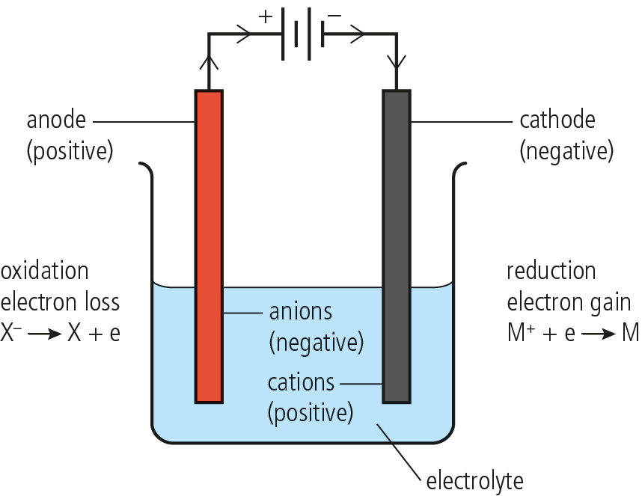

A simple fuel cell

- Allow the cell to work for a few minutes.
- Write down what you observe (include reactions where necessary):

  - at the anode (−): ………………………………………………………………………………………

………………………………………………………………………………………
  - at the cathode (+): …………………………………………………………………………………….…

………………………………………………………………………………………

- Which gas is being released at the anode?
- Which gas is being released at the cathode?
- Remove the battery and connect the voltmeter in its place. Record the voltage. Explain your observations.

Reflection
Propose a quantitative extension for this lab.

Post–lab report
Write a report where you:
- Summarize the important theoretical concepts described in this lab.
- Explain why pure deionized water was not used in this experiment.
- Summarize the experimental procedure.
- Highlight any important health and safety matters.
- Present your observations and discuss your results.
- Present and justify your conclusion.
- Evaluate the process.

