Reactivity 1.2.3 (HL) and Reactivity 1.3.3
Comparing the enthalpy of pentane and hexane

References:
HL ONLY R1.2.3 Standard enthalpy changes of combustion, 𝚫𝑯_{c}⦵, data can be used in thermodynamic calculations
R1.3.3 Fossil fuels include coal, crude oil and natural gas, which have different advantages and disadvantages.
T3 Mathematical skills

Aim
To calculate the enthalpy of combustion of two fuels: pentane (C5H12) and hexane (C6H14).

Introduction
When a fuel is burned in a spirit burner, the energy released as heat is transferred to water placed in a copper cup directly above the spirit burner. Assuming that all the energy is transferred as heat to the water and using the heat capacity of water c = 4.18 J g^{–1} K^{–1}, the amount of energy released by the spent fuel can be calculated. This can then be then converted to the amount of energy given out per mole of fuel, in order to find the molar enthalpy change of combustion of each fuel.

Pre-lab questions
- The water is contained in a metal can. Why is a metal can used and not a glass beaker or other similar container?
- Pentane and hexane were chosen for this experiment because they are members of a homologous series. Identify the homologous series to which they belong and give the next member of the series.
- One of the biggest causes of error in this experiment is heat loss. Does this lead to systematic or random errors? Suggest where these heat losses occur and how to improve the experiment to minimize these errors.

Please note
- A full risk assessment should be carried out prior to commencing this experiment.
- Personal safety equipment should be worn.
- Chemicals should be disposed of safely and with due regard to any environmental considerations.

Risk assessment
Material name and chemical formula | Associated risks | Measures taken

Environmental risks
Waste products (if any) | Associated risks | Waste management

Ethical risks
Risks to humans | Justification | Management
Risks to the environment | Justification | Management

Equipment list
Chemicals/materials | Apparatus (per group of students)
pentane (about 20 cm³)  hexane (about 20 cm³) | small copper can (or metal container)  clamp and stand  thermometer (or temperature probe and data-logger)  measuring cylinder (100 cm³)  digital balance  draught shields (e.g. heat-resistant mats)  glass rod  2 spirit burners with wicks  matches

Method
- Set up your apparatus as shown in the diagram.

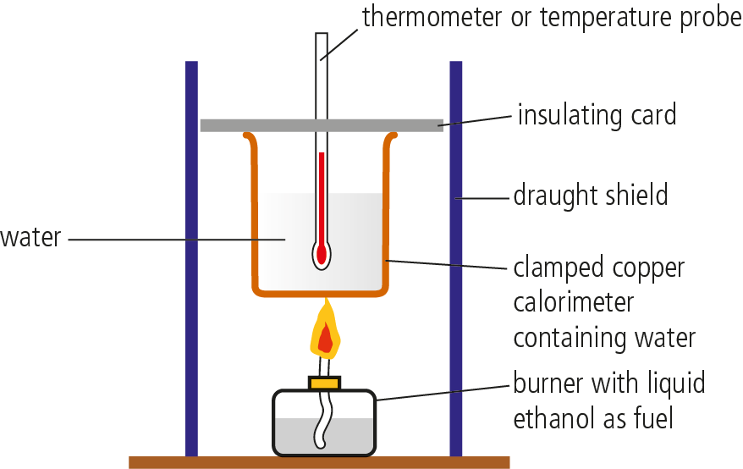

- Put 200 cm³ of cold water into the copper can. Record the temperature of the water.
- Support the copper can over a spirit burner containing the fuel that you are going to burn. It should be arranged so that when the wick is lit, the flame just touches the bottom of the can.
- Weigh the spirit burner and fuel.
- Record the initial temperature (T₁) on the thermometer or start data collection if you are using a temperature probe with a data-logger. It may take several seconds for the temperature probe to reach the temperature of the water in the can.
Do not leave the thermometer/temperature probe resting on the base of the can or it will not register the correct temperature of the water.

- Replace the burner under the can and light the wick. Use a glass rod to gently stir the water all the time that the fuel is being burned.
- Continue heating, and stirring with the glass rod, until the temperature of the water has risen by about 20°C.
- Extinguish the flame and weigh the burner.
- Continue stirring the water until there is no further rise in temperature. Note the final reading (T₂) on the thermometer or terminate the trial by stopping data collection on the data-logger.
- Repeat using the other fuel. Do not forget to use fresh cold water in the copper can.
- If time allows, repeat the experiment for each alcohol three times and average the results.

Analysis
Use the readings obtained to work out:
- the mass of water used
- the mass of fuel used
- the temperature change of the water in each case.

Carry out the following calculations for each fuel
Assume that all the energy released from the burning fuel is transferred to the water:

energy transferred to water = (mass of water × temperature change × 4.18) J = q

Calculate the energy released per mole of fuel by completing the following:

- formula of fuel = ____________________

- mass of 1 mole of fuel = ____________________ g

- mass of fuel burned = ____________________ g

- number of moles of fuel burned = ____________________

- energy transferred by this number of moles of fuel = −q = ____________________ J
(q is the quantity calculated in step 1)

- energy transferred by 1 mole of fuel = ____________________ J

- therefore enthalpy change of combustion = ____________________ kJ mol^{–1}

Reflection
- Using Section 14 in the data booklet, look up the accepted values for the enthalpies of combustion of your fuels.
- Calculate the percentage difference between each of the values you obtained and the quoted values. For which of your fuels was your experimental value most accurate? Why do you think this was?
- Suggest ways in which the accuracy of your experiment could be improved.
- The next member of the homologous series of alkanes is heptane. Predict the expected enthalpy of combustion for heptane.
- Explain why you would expect a (roughly) similar increase in enthalpy of combustion between members of a homologous series.

Post–lab report
Write a report where you:
- Summarize the important theoretical concepts described in this lab.
- Summarize the experimental procedure.
- Highlight any important health and safety matters.
- Present your data and your data analysis.
- Present and justify your conclusion. Compare the obtained values with the ones in the data booklet and determine your experimental error.
- List the various stages in your experiment that could lead to inaccuracies. How would these affect the overall value you obtained for the enthalpy of combustion? Which would have the largest impact on the overall results?

