Reactivity 1.2.2
Finding the enthalpy change of hydration

References:
R1.2.2 Hess's law states that the enthalpy change for a reaction is independent of the pathway between the initial and final states.
T2 Apply digital technology to collect data
T3 Mathematical skills

Aim
To determine the enthalpy change of hydration of MgSO₄ by applying Hess’s law.

Introduction
Hess’s law states that the enthalpy change of a reaction will be the same regardless of the reaction pathway. So the overall enthalpy change for a reaction to proceed from reactant A to product C will be the same whether the reaction proceeds directly to C, or if it proceeds via an intermediate B: ΔH₁ + ΔH₂ = ΔH₃

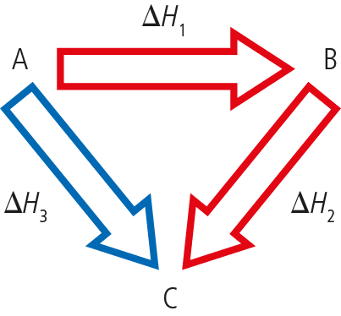

Enthalpy of hydration is the change in enthalpy that results when 1 mol of an anhydrous substance is converted to 1 mol of the hydrated substance.

Enthalpy of solution is the change in enthalpy that results when 1 mol of solute is dissolved in a solvent.

In this lab, you will determine the enthalpy change of hydration of MgSO₄ by measuring the temperature change of the solution of both anhydrous magnesium sulfate and hydrated magnesium sulfate. The crystals of hydrated and anhydrous MgSO₄ you prepared in Structure 2.1.3 Preparing crystals could be used here, otherwise powdered anhydrous MgSO₄ and powdered MgSO₄.7H₂O can be used.

The reactions involved in this lab are:

equation 1: MgSO₄(s) $\underset{→}{H_{2}O}$ MgSO₄.7H₂O(s) ΔH_{hyd}
equation 2: MgSO₄(s) $\underset{→}{H_{2}O}$ Mg²⁺(aq) + SO₄²⁻(aq) ΔH_{sol1}
equation 3: MgSO₄.7H₂O(s) $\underset{→}{H_{2}O}$ Mg²⁺(aq) + SO₄²⁻(aq) ΔH_{sol2}

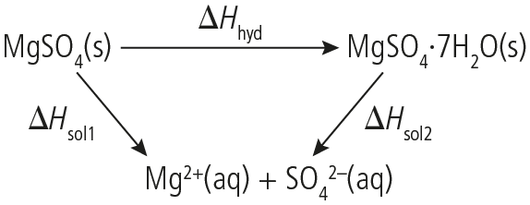

From Hess’s law, it is evident that reversing equation 3 gives:
equation 4: Mg²⁺(aq) + SO₄²⁻(aq) $\underset{→}{H_{2}O}$ MgSO₄.7H₂O(s) $-$ΔH_{sol2}

Combining new equation 4 with equation 2 results in equation 1:

equation 2: MgSO₄(s) $\underset{→}{H_{2}O}$ Mg²⁺(aq) + SO₄²⁻(aq) ΔH_{sol1}
equation 4: Mg²⁺(aq) + SO₄²⁻(aq) $\underset{→}{H_{2}O}$ MgSO₄.7H₂O(s) –ΔH_{sol2}
equation 1: MgSO₄(s) $\underset{→}{H_{2}O}$ MgSO₄.7H₂O(s) ΔH_{hyd} = ΔH_{sol1} – ΔH_{sol2}

The enthalpy of solution of each sample is determined via coffee-cup calorimetry. The results are then used to calculate the enthalpy of hydration.

Please note
- A full risk assessment should be carried out prior to commencing this experiment.
- Personal safety equipment should be worn.
- Chemicals should be disposed of safely and with due regard to any environmental considerations.

Risk assessment
Material name and chemical formula | Associated risks | Measures taken

Environmental risks
Waste products (if any) | Associated risks | Waste management

Ethical risks
Risks to humans | Justification | Management
Risks to the environment | Justification | Management

Equipment list
Chemicals/materials | Apparatus (per group of students)
magnesium sulfate, MgSO₄(s)  magnesium sulfate heptahydrate, MgSO₄.7H₂O(s)  deionized water | digital balance (±0.001g)  coffee-cup calorimeter  graduated cylinder  spatula  stirring rod  thermometer (or temperature probe and  data-logger)

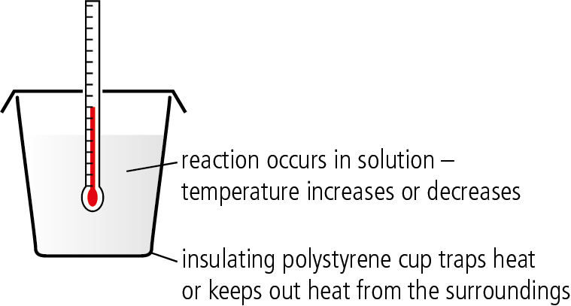

Coffee-cup calorimeter

Method
- Measure about 7 g of MgSO₄ powder and record the exact mass to 4 significant figures.
- Fill the coffee-cup calorimeter with 100.0 cm³ of deionized water.
- Place the thermometer (or temperature probe) in the water and allow the temperature to equilibrate before recording the starting temperature (T_{init}) or starting the data collection of the data-logging software.
If you are using a data-logger, set up the experiment for a 15-minute data collection, with the temperature being recorded once every 30 seconds, then start the data collection.
- Add the MgSO₄ powder to the coffee-cup calorimeter in one go, while stirring continuously.
- If you are using a thermometer instead of a probe, make sure you observe the temperature change and record the maximum temperature (T_{max}) reached within the next 5 minutes.
- When the reaction is completed, wash out the coffee-cup calorimeter then fill it with a fresh 100.0 cm³ of deionized water.
- Measure about 15.3 g of MgSO₄.7H₂O(s) and record the exact mass to 4 significant figures.
- Repeat steps 3–5 with the hydrate.

Analysis
- If you have used a data-logger, extrapolate the temperature restoration line to identify the theoretical maximum temperature change.
- If you are using a traditional thermometer, use the T_{max} recorded in step 5.
- First calculate q.
  - Use the equation q = mcΔΤ = mc(T_{max} − T_{init})
  - Assume that the specific heat capacity of the solution is 4.18 J g⁻¹ °C⁻¹ and the mass of the solution is 100.0 g.
- To determine the ${ΔΗ}_{sol1}^{Ꝋ}$ (kJ/mol) of the process, use the formula:
$${ΔΗ}_{sol}^{Ꝋ} = -\frac{M_{r}×q}{m}$$

- Repeat the process for both ${ΔΗ}_{sol1}^{Ꝋ}$ and ${ΔΗ}_{sol2}^{Ꝋ}$, then determine ${ΔΗ}_{hyd}^{Ꝋ}$.

Reflection
Compare the obtained values with the expected ones and determine your experimental error.

Post–lab report
Write a report where you:
- Summarize the important theoretical concepts described in this lab.
- Summarize the experimental procedure.
- Highlight any important health and safety matters.
- Present your data and your data analysis.
- Present and justify your conclusion.
- Evaluate the processes.

