Reactivity 1.1.4
Coffee-cup calorimeter

References:
R1.1.4 The standard enthalpy change for a chemical reaction, ΔH^{Ꝋ}, refers to the heat transferred at constant pressure under standard conditions and states. It can be determined from the change in temperature of a pure substance.
T2 Applying digital technology to collect data
T3 Mathematical skills

Aim
To calculate the enthalpy change of solution of different ionic compounds.

Introduction
The enthalpy change that occurs when a salt dissolves in water depends on:
- the lattice enthalpy of the compound, which is endothermic
- the hydration enthalpies of the separated ions, which are exothermic.

Depending on the relative values of these enthalpy changes, the process of forming an aqueous solution of a salt may be an endothermic or an exothermic reaction. The value for the enthalpy change can be derived from calculations based on data booklet values or from experimental measurements.

In this lab you will start with a known mass of a specific salt and a known volume of water. By measuring the temperature change that occurs during the dissolving process, you will calculate the molar enthalpy of solution of the salt. This value can then be compared with theoretical values, and with values obtained from an online simulation.

You will use a ‘coffee-cup calorimeter’ – a simple calorimeter comprising a polystyrene cup and lid – to carry out this experiment.

Pre-lab question
Explain why the value of the lattice enthalpy used to determine the enthalpy of solution must be an endothermic value.
The calculation of molar enthalpy is based on the equations $ΔH=\frac{q}{n}$ and q = mcΔT.
We will assume that c = 4.18 J g⁻¹ K⁻¹ and that the density of the solution is 1 g cm⁻³.
Consider the validity of these assumptions, and how they may affect the accuracy of the results.

Please note
- A full risk assessment should be carried out prior to commencing this experiment.
- Personal safety equipment should be worn.
- Chemicals should be disposed of safely and with due regard to any environmental considerations.

Risk assessment
Material name and chemical formula | Associated risks | Measures taken

Environmental risks
Waste products (if any) | Associated risks | Waste management

Ethical risks
Risks to humans | Justification | Management
Risks to the environment | Justification | Management

Equipment list
Chemicals/materials | Apparatus (per group of students)
potassium nitrate, KNO3(s)  sodium hydroxide, NaOH(s)  ammonium chloride, NH4Cl(s)  sodium chloride, NaCl(s)  other ionic compounds can be added/substituted – see examples used in the simulation  distilled water | balance  50 cm³ measuring cylinder  polystyrene cups and lids (coffee-cup calorimeter)  thermometer (or temperature probe and data-logger)

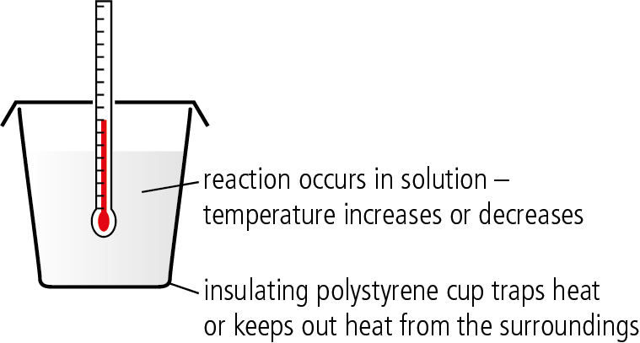

Coffee-cup calorimeter

Method
- Measure accurately 4 g of potassium nitrate.
- Measure 40.00 cm³ of distilled water and pour it into a polystyrene cup. Record the temperature of the water.
- Add the potassium nitrate to the water in the cup and swirl the cup to help the KNO3 to dissolve.
- Record the maximum temperature that is reached.
- Repeat the experiment with sodium chloride, ammonium chloride, and sodium hydroxide.
- Carry out a simulation of the experiment at the Pearson Chemistry Simulation site. Instructions are provided within the simulation.

Results
- Record all quantitative data and qualitative data from the experiment in an
appropriate table.
- Record all quantitative data from the simulation in an appropriate table.
- Identify the enthalpy of solution values from Section 16 in the data booklet
and record them in an appropriate table.

Analysis
Process your data to calculate the molar enthalpy of solution for each salt dissolved, showing
all units through your calculations.

Make a table of your results and compare:
- values of ΔH_{sol} obtained from your experimental data
- values of ΔH_{sol} obtained from the simulation
- values of ΔH_{sol} found in your data booklet.

Conclusion and evaluation
- Compare your experimental result with the data booklet values and calculate the percentage difference.
- Compare your simulation results with the data booklet values and calculate the percentage difference.
- Calculate the % error arising from random errors in the experiment and compare this with the figures above.
- Discuss the difference in accuracy from theoretical models (simulations) and experimental data.
- Discuss the values for molar enthalpy of solution of the different salts in terms of the relative charges and sizes of the ions involved.

Reflection
- Read about the calculation of lattice enthalpies. What assumptions about ionic bonding are made in these calculations?
- Consider to what extent the pure ionic bonding model may be less valid for some of the salts used in this experiment.
- Comment on the different merits of obtaining data from a simulation and from hands-on experimentation. Consider cases when each approach may be more suitable.
- Why do calorimetry experiments typically measure a smaller change in temperature than is expected from theoretical values?

Post–lab report
Write a report where you:
- Summarize the important theoretical concepts described in this lab.
- Summarize the experimental procedure.
- Highlight any important health and safety matters.
- Present your data and your data analysis.
- Present and justify your conclusion. Compare the obtained values with the reported
ones and determine your experimental error.
- Evaluate the process.

