Reactivity 1.1.2
Observe endothermic and exothermic processes in action

References:
R1.1.2 Reactions are described as endothermic or exothermic, depending on the direction
of energy transfer between the system and the surroundings.
T3 Mathematical skills

Aim
To observe and compare an endothermic reaction and an exothermic reaction.

Introduction
Chemical reactions can either absorb energy from their environment, so energy is being
added to the chemical system from the environment, or release energy to the environment.
An endothermic reaction makes the environment around the chemical system cold, since thermal energy is being absorbed by the system. An exothermic reaction releases energy
to the environment, which makes the environment around the chemical system warmer.

This concept is used in the design of fridges, and also by hikers. Evaporation of water is an endothermic process, as energy needs to be taken from the surrounding environment to break the intermolecular bonds during the phase change from liquid to gas. Wetting a water-skin that holds your water bottle will keep the water in the bottle cool because of the endothermic process of evaporation of the water.

Pre-lab questions
- Explain how bond breaking is an endothermic process and bond forming is an exothermic process.
- Explain which phase changes (condensation, freezing, evaporation, melting, sublimation, deposition) are exothermic and which are endothermic.
- What are ‘instant cold packs’ made of?
- Figure 1 shows the refrigeration cycle. Describe the process.
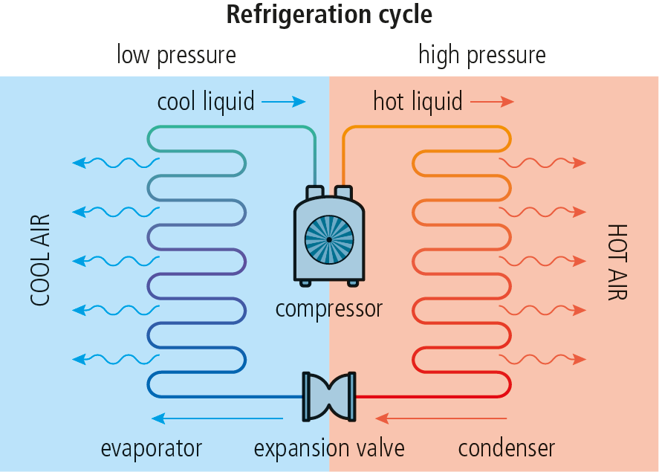

Figure 1

Please note
- A full risk assessment should be carried out prior to commencing this experiment.
- Personal safety equipment should be worn.
- Chemicals should be disposed of safely and with due regard to any environmental considerations.

Risk assessment
Material name and chemical formula | Associated risks | Measures taken

Environmental risks
Waste products (if any) | Associated risks | Waste management

Ethical risks
Risks to humans | Justification | Management
Risks to the environment | Justification | Management

Equipment list
Chemicals/materials | Apparatus (per group of students)
sodium hydroxide pellets, NaOH(s)  instant cold pack  deionized water | beakers  thermometer  temperature probe with data-logger  clamp and stand  glass rod  magnetic stirring bar and electrical stirrer  stop clock

Method
You will carry out each experiment twice, first using a thermometer and then using a temperature probe with a data-logger.

Experiment 1
- Add 100.0 cm³ of deionized water to a beaker. Place a thermometer in the water and record the initial temperature. Add 0.4 g of sodium hydroxide pellets, and stir the mixture with a glass rod. Record the temperature once every minute for the next three minutes. Is the process endothermic or exothermic?

- Connect a temperature probe to the data-logger. Configure the data-logger to collect data for 10 minutes. To a clean beaker, add 100.0 cm³ of deionized water and insert a magnetic stirring bar. Place the beaker on an electrical stirrer and set stirring to a moderate speed that will not cause the water to spill. Clamp the temperature probe in the water at an appropriate height so it does not touch the glass walls or interfere with the stirring magnet. Start recording temperature data. Pause the stirring momentarily and add 0.4 g of NaOH(s) to the beaker. Continue recording the temperature until the 10-minute mark.
Determine the enthalpy change (ΔΗ ^{Ꝋ}) of this process. Assume c = 4.18 J g⁻¹ K⁻¹ and that the density of the solution is 1 g cm⁻³.

Experiment 2
- Record the room temperature with a thermometer. Take an instant cold pack and follow the instructions on the pack. Place the pack so that it encases the thermometer. Record the temperature once every minute for the next 3 minutes. Is the process endothermic or exothermic?

- Connect a temperature probe to the data-logger. Configure the data-logger to collect data for 10 minutes. Start recording temperature data. Take an instant cold pack and follow the instructions on the pack. Place the pack so that it encases the temperature probe. You may use a beaker to contain the cold pack with the probe. Continue recording the temperature until the 10-minute mark. How much heat is absorbed?

Analysis

Experiment 1

Room temperature  (°C) (T_{init}) | Temperature of reaction mixture (°C)
Room temperature  (°C) (T_{init}) | After 1 min | After 2 min | After 3 min (T_{fin})

ΔT_{after 3 min} = T_{fin} − T_{init} = _________________________________________________________

Reaction is __________________________________________________________________

- The use of data-logging equipment allows you to identify the final temperature reached, T_{fin}, as well as the maximum theoretical temperature reached, T_{max}, by extrapolating the ‘temperature restoration’ line.
Your graph should look similar to Figure 2 (red solid line). The theoretical temperature reached is identified by extrapolation (black dotted line).

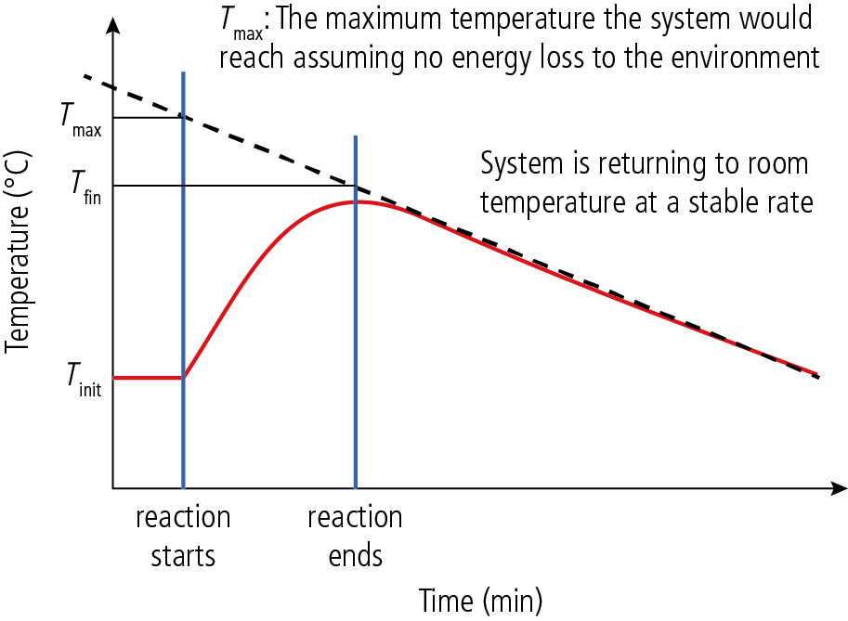

Figure 2
First calculate the heat of reaction, q, using the equation: q = mcΔT = mc(T_{max} – T_{init})
Assume that the specific heat capacity of the solution is 4.18 J g⁻¹ °C⁻¹ and that the mass of the solution is 100.0 g. Due to conservation of energy, the energy absorbed by the water (q) is equal to the energy released (−q) by 0.4 g (or 0.01 mol) of NaOH.
Determine ΔH^{Ꝋ} (kJ/mol) using the equation: ΔH^{Ꝋ} = –q/n

Experiment 2

Room temperature  (°C) | Temperature of reaction mixture (°C)
Room temperature  (°C) | After 1 min | After 2 min | After 3 min

ΔT_{after 3 min} = T_{fin} – T_{init} = __________________________________________________________

Reaction is ___________________________________________________________________

- The use of data-logging equipment allows you to identify the minimum temperature reached on the resulting graph, as well as the minimum theoretical temperature reached by extrapolating the temperature restoration line. The process is similar to the one discussed for Experiment 1.
Using the data given on the instant cold pack, determine the ΔΗ^{Ꝋ} (kJ/mol) of the process.

Reflection
- Compare the obtained values with the expected ones and determine your experimental error.
- Did you get different information for the same experiment when you used different equipment?
- How is the analysis different when data-logging equipment is used?

Post–lab report
Write a report where you:
- Summarize the important theoretical concepts described in this lab.
- Summarize the experimental procedure.
- Highlight any important health and safety matters.
- Present your data and your data analysis.
- Present and justify your conclusion.
- Evaluate the process.

