Structure 3.2.1
Molecular modelling and prediction of properties

References:
S3.2.1 Organic compounds can be represented by different types of formulas. These include empirical, molecular, structural (full and condensed), stereochemical and skeletal.
T2 Digital Technology

Aim
To become familiar with the use of computer modelling software and perform simple calculations using predictive software.

Materials needed
In this lab, you will need access to a computer or smartphone with appropriate software installed or accessed online.

Some popular software is listed below:

- ACD/ChemSketch – Freeware (Windows only) available for academic use from https://www.acdlabs.com/resources/freeware/chemsketch/

- MarvinSketch – Available for download (Windows/MacOS/Linux) at https://chemaxon.com/products/marvin You can request a free academic license.

- Chemicalize – Available online at https://chemicalize.com/welcome Free, but you will need to register.

- Molview Online. Free access at https://molview.org/

- ChemDraw online. Free access at https://chemdrawdirect.perkinelmer.cloud/js/sample/index.html
Can only be used for structure drawing – no calculations.

Introduction
All of the software listed can be used for sketching skeletal formulas and visualizing them in various ways. Some can provide additional information and contain various predictors (NMR, IR, MS, elemental analysis, dipolar moment etc...) Your teacher will choose one of the software packages for you to use during this lab.

This example uses the most user-friendly of the suggested applications – MolView online.

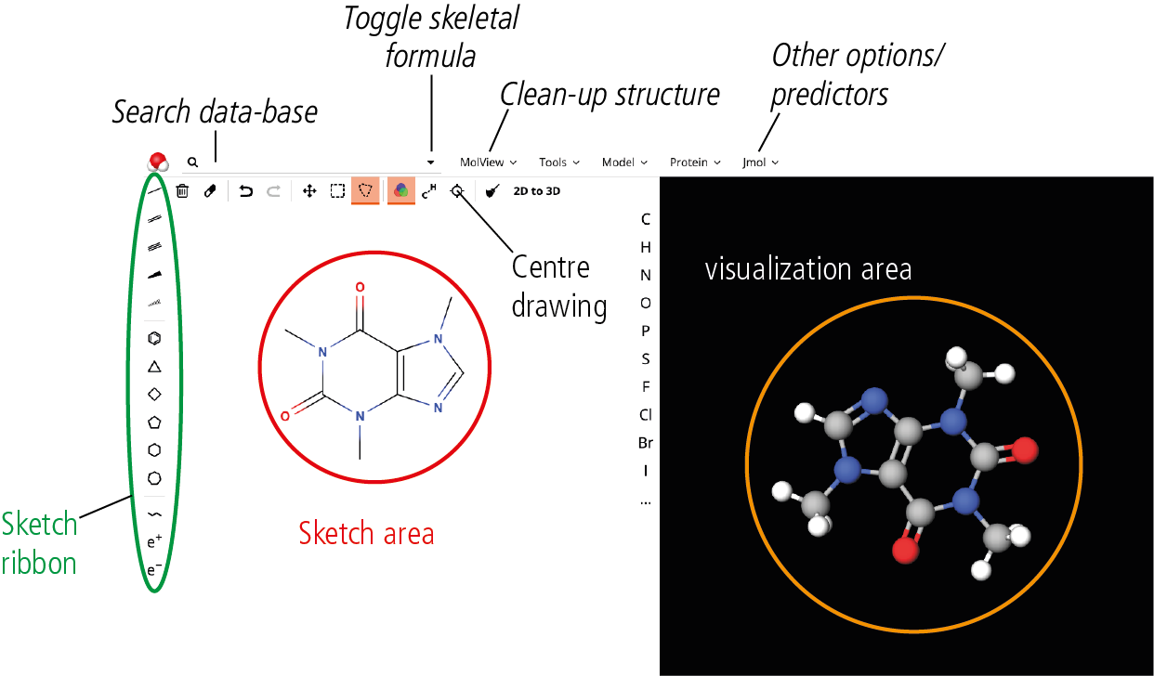

MolView was chosen because of its simplicity and the 3D visualization in a ball-and-stick animation is immediately obvious. The sketch ribbon provides options for drawing chemical bonds, and is similar to the sketch ribbon of other chemistry modelling software, which allows for skill transfer to more advanced software.

Method
For each of the condensed formulas in Table 1, draw the structural formula.

Then draw the skeletal formulas in MolView and paste the skeletal and stereochemical structures into Table 2.

Table 1
Condensed formula | Structural formula
CH₄

CH₃CH₂C(CH₃)₃

CH₃(CH₂)₄CH₂OH

Ph-COOH

H₂C=CHCH₃

Table 2
Condensed formula | Skeletal formula | Stereochemical
CH₄

CH₃CH₂C(CH₃)₃

CH₃(CH₂)₄CH₂OH

Ph-COOH

H₂C=CHCH₃

Analysis

Perform simple calculations
Step 1: Draw the structure of 2-chloro-3-methyl-pent-1-ene.
As you draw, the structure appears in a ‘linear’ fashion as shown below.
This is normal but remember to press the ‘Clean structure’ <tick icon> button when you are done.
After you clean your skeletal formula, press the 2D to 3D button. A 3D model of your structure will be generated to replace the default model that is visible during your drawing process.

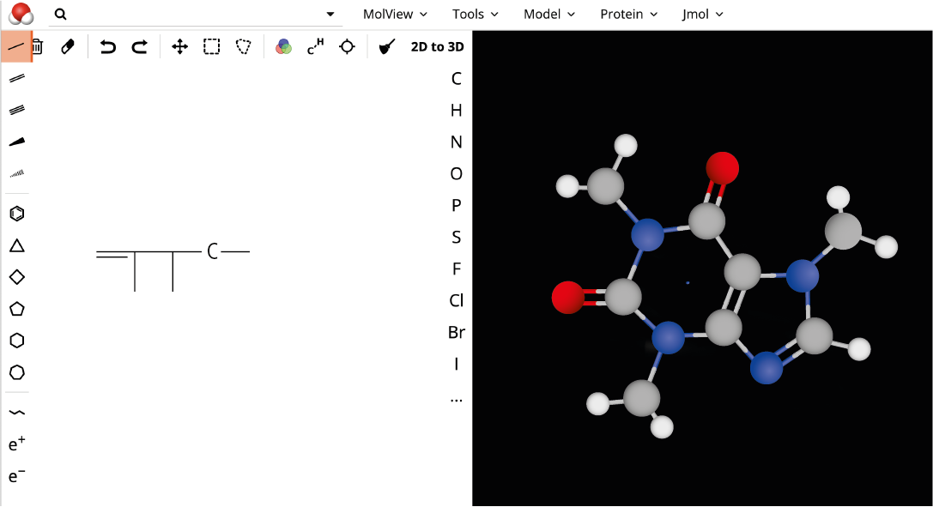

Step 2: Check if you have drawn the correct molecule.
Click on ‘Tools’ and, in the drop-down menu, select ‘information card’.
When the information is resolved, check the ‘Systematic name’ to ensure that 2-chloro-3-methyl-pent-1-ene was drawn.

From the information card fill in the blanks in Tables 3 and 4.

Table 3
Formula
Molecular weight

Table 4
 | Percent composition
C | %
H | %
Cl | %
When done, click ‘Return’ at the top left corner of the page.

Step 3: Determine the highlighted bond length and bond angles.

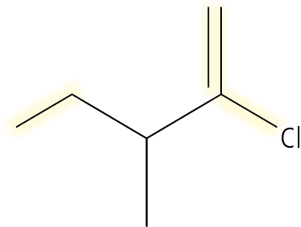
To determine length of a bond, click on ‘Jmol’ and, in the drop-down menu, select ‘Distance’. Then move your mouse cursor in the 3D visualization area. Click on any atom.
You will see that your cursor is now a crosshair. By moving this crosshair to different atoms, a distance measurement (in Angstrom) shows up. This measurement becomes permanently visible when you click a second atom and shows the distance between the two atoms.
You can clear these measurements by clicking on ‘Jmol’ again and selecting ‘Clear’ from the drop-down menu.

To determine bond angles, you follow a similar procedure by selecting ‘Angle’ from the drop-down menu of ‘Jmol’. The difference is that you now have to click three different atoms in order to define the bond angle that you wish to calculate.
You can clear these measurements by clicking on ‘Jmol’ again and selecting ‘Clear’ from the drop-down menu.

Research the database
On the top ribbon, in the search box, write Ibuprofen. A drop-down menu will show up as soon as you type the first few letters and you can select from the menu.

This will immediately show the skeletal and stereochemical structures of ibuprofen.
Click on ‘Tools’ and then select ‘Spectroscopy’ from the drop-down menu.

This will take you in a new page. Click on ‘Choose a spectrum’ to see what kind of spectroscopic data are available. Select ‘mass spectrum’.

Use the displayed mass spectrum to complete the table of the major fractions of ibuprofen.

Table 5
m/z | Relative intensity %

sad

When you have finished click ‘Return’ at the top left corner of the page.
Use MolView to research a compound that you are interested in.

Post–lab report
- Write a report with the information you have collected by using MolView.

