Structure 3.1.5
Oxides of period 3

Reference:
S3.1.5 Metallic and non-metallic properties show a continuum. This includes the trend from basic metal oxides through amphoteric to acidic non-metal oxides.

Aim
To investigate the properties of the oxides of period 3.

Introduction
The oxides of period 3 include Na₂O, MgO, Al₂O₃, SiO₂, P₄O_{10,} P₄O₆, SO₂, SO₃, Cl₂O₇
and Cl₂O. In this lab, we will observe the physical state of these oxides at room temperature
and investigate the solubility (or reactivity) of some of these oxides with water, and the acidity/alkalinity of the resulting solution, to identify any trends that may emerge.

The acidity of the resulting solutions will be tested with bromothymol blue, a 3-colour indicator solution, which is yellow in acidic solutions, green in neutral solutions and blue in alkaline/basic solutions. A universal indicator may be used instead.

Pre-lab questions
- Name all the oxides of the period 3 elements according to IUPAC rules.
- Write down the chemical equations of the reaction of each oxide of period 3
elements with water.

Please note
- A full risk assessment should be carried out prior to commencing this experiment.
- Personal safety equipment should be worn.
- Chemicals should be disposed of safely and with due regard to any environmental considerations.
- Note: Na₂O(s) is unstable and may oxidize to explosive Na₂O₂ in solution, so it is not used in this exercise. Oxides of chlorine are also not used due to their known toxicity.

Risk assessment
Material name and chemical formula | Associated risks | Measures taken

Environmental risks
Waste products (if any) | Associated risks | Waste management

Ethical risks
Risks to humans | Justification | Management
Risks to the environment | Justification | Management

Equipment list
Chemicals/materials | Apparatus (per group of students)
solid samples of MgO, Al₂O₃, SiO₂, P₄O₁₀  sodium sulfite solution (Na₂SO₃(aq) 0.5 mol dm⁻³)  deionized water  bromothymol blue indicator  sulfuric acid solution (H₂SO₄(aq), 2.0 mol dm⁻³)  ammonia solution (NH₃(aq), 3.0 mol dm⁻³) | test tubes  test-tube rack  test-tube holder  spatula  Bunsen burner  heat-proof mat  Petri dish  pipettes  wash bottle

Method A
- Place four clean and dry test tubes (labelled A, B, C, D) in a test-tube rack.
- Use a spatula to add a small sample of solid MgO(s) to tube A, Al₂O₃(s) to tube B, SiO₂(s)
to tube C and P₄O₁₀(s) to tube D.
- Record the shape, colour and consistency of each oxide.
- Using your wash bottle, add a small amount of water to each test tube and record your observations.
- If the oxide does not dissolve, gently heat the test tube with a Bunsen burner before recording your observation.
Make sure you use a test-tube holder and take care to point the open end of the test tube away from you as shown in Figure 1.
If the solution was heated, allow to cool before the next step.
- Add a few drops of the bromothymol blue solution and record the observed colour.

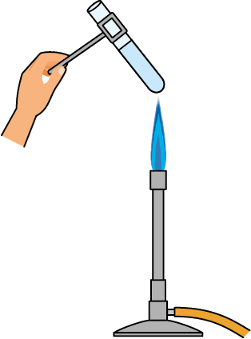

Figure 1

Method B
To test the properties of sulfur dioxide (SO₂), we will first make it by reacting a solution of Na₂SO₃(aq) with H₂SO₄(aq) solution.
- Place a drop of Na₂SO₃(aq) in the centre of the bottom half of a Petri dish.
- Place a few drops of the bromothymol blue indicator at random places in the Petri dish, at some distance from the Na₂SO₃(aq) drop, as shown in Figure 2.

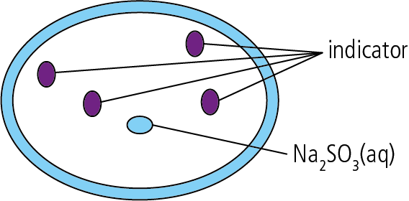

Figure 2

- Hold the Petri dish lid at an angle so that the dish is almost covered, then add a drop
of H₂SO₄(aq) to the central Na₂SO₃(aq) drop and quickly close the lid.
A colour change in the indicator bubbles is also an indication of solubility in water.
- After you have recorded your observations in the table, open the lid slightly and add two drops of NH₃(aq) to stop the reaction. Close the lid and allow the Petri dish to sit for a minute before thoroughly cleaning with water.
- Dry the Petri dish and reuse if required.

Analysis
Oxide | Qualitative observations | Soluble in cold water? (Y/N) | Soluble in warm water? (Y/N) | Colour of bromothymol blue (Yellow / Green / Blue) | Solution is:  Acidic / Neutral / Basic
MgO
Al₂O₃
SiO₂
P₄O₁₀
SO₂ | Gas, colourless

Post–lab report
Write a report where you:
• Summarize the important theoretical concepts described in this lab.
• Summarize the experimental procedures.
• Highlight any important health and safety matters.
• Present your findings. Based on your findings, make a prediction for the behaviour of the oxides of sodium and chlorine. State a conclusion.
• Support your conclusion based on your understanding of periodic table trends.
• Evaluate the experimental procedure.

