Structure 3.1.1
Redesigning the periodic table

References:
S3.1.1 The periodic table consists of periods, groups and blocks.
TOK Patterns and trends

Aim
To review some proposals of different designs for the periodic table and collaborate with peers to propose your own design.

Introduction
If there is a defining object in a chemistry lab, or a science classroom, it must be the periodic table of the elements. Since its conception, the periodic table has revolutionized and pushed the boundaries of chemistry. But the familiar image of the periodic table is very different from what Mendeleev originally proposed in 1871.

The periodic table design in use today was finalized by Seaborg in 1945. Besides being engaged with the discovery of 10 new elements and 100 isotopes, Seaborg proposed the addition of the actinide and lanthanide series as an additional group (the rare-earth metals or
f-group) below the main table, giving the modern periodic table the well-defined shape we all recognize.

The current periodic table was completed in 2016 with the addition of the elements nihonium (Nh, Z = 113), moscovium (Mc, Z = 115), tennessine (Ts, Z = 117) and oganesson (Og, Z = 118) to complete period 7.

The design of the periodic table has always been of great interest to chemists and physicists alike, with numerous scientists proposing different designs based on different principles. Some of the main drivers behind novel designs of the periodic table are: the disputed positioning of hydrogen; the elimination of empty space between consecutive elements (consider the distance between H and He, or Be and B); and the positioning of the lanthanoids and actinoids ‘outside’ the table as a separate group.

Some resources on these designs are given below.

Review these resources in small groups in your class and then propose a design of your own.

- https://www.researchgate.net/publication/305891852_An_Element_of_Atomic_Number_Zero

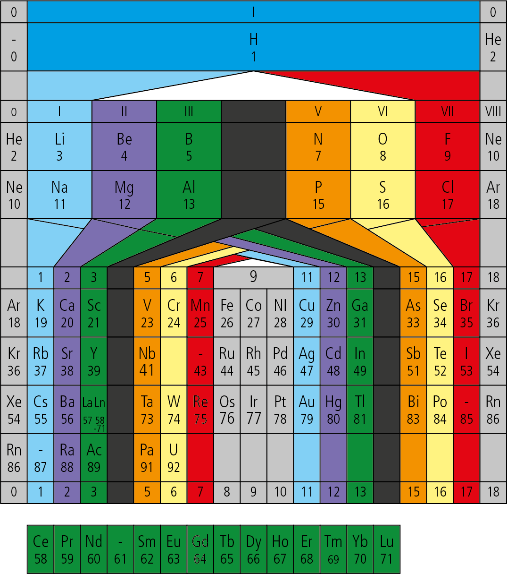

The Andreas von Antropoff periodic table with the inclusion of an ‘element zero’

- http://acshist.scs.illinois.edu/bulletin_open_access/v34-2/v34-2%20p141-145.pdf

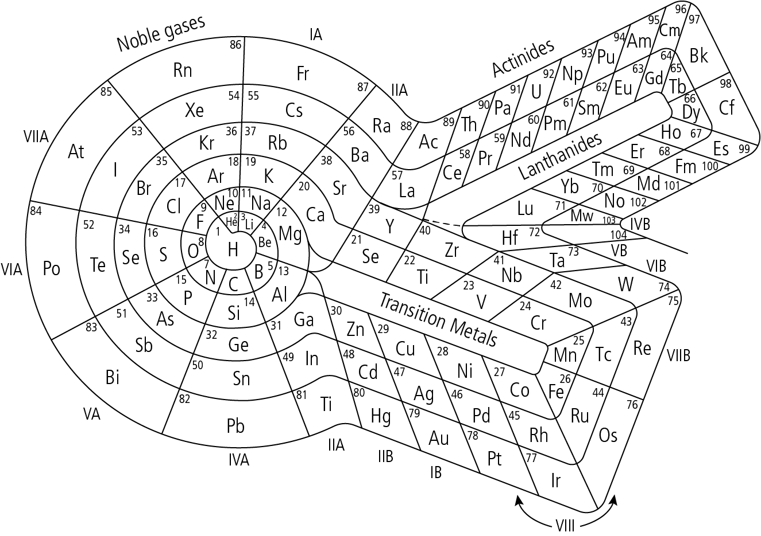

The ‘periodic snail’

- https://www.researchgate.net/publication/225545084_Charles_Janet_Unrecognized_genius_of_the_periodic_system

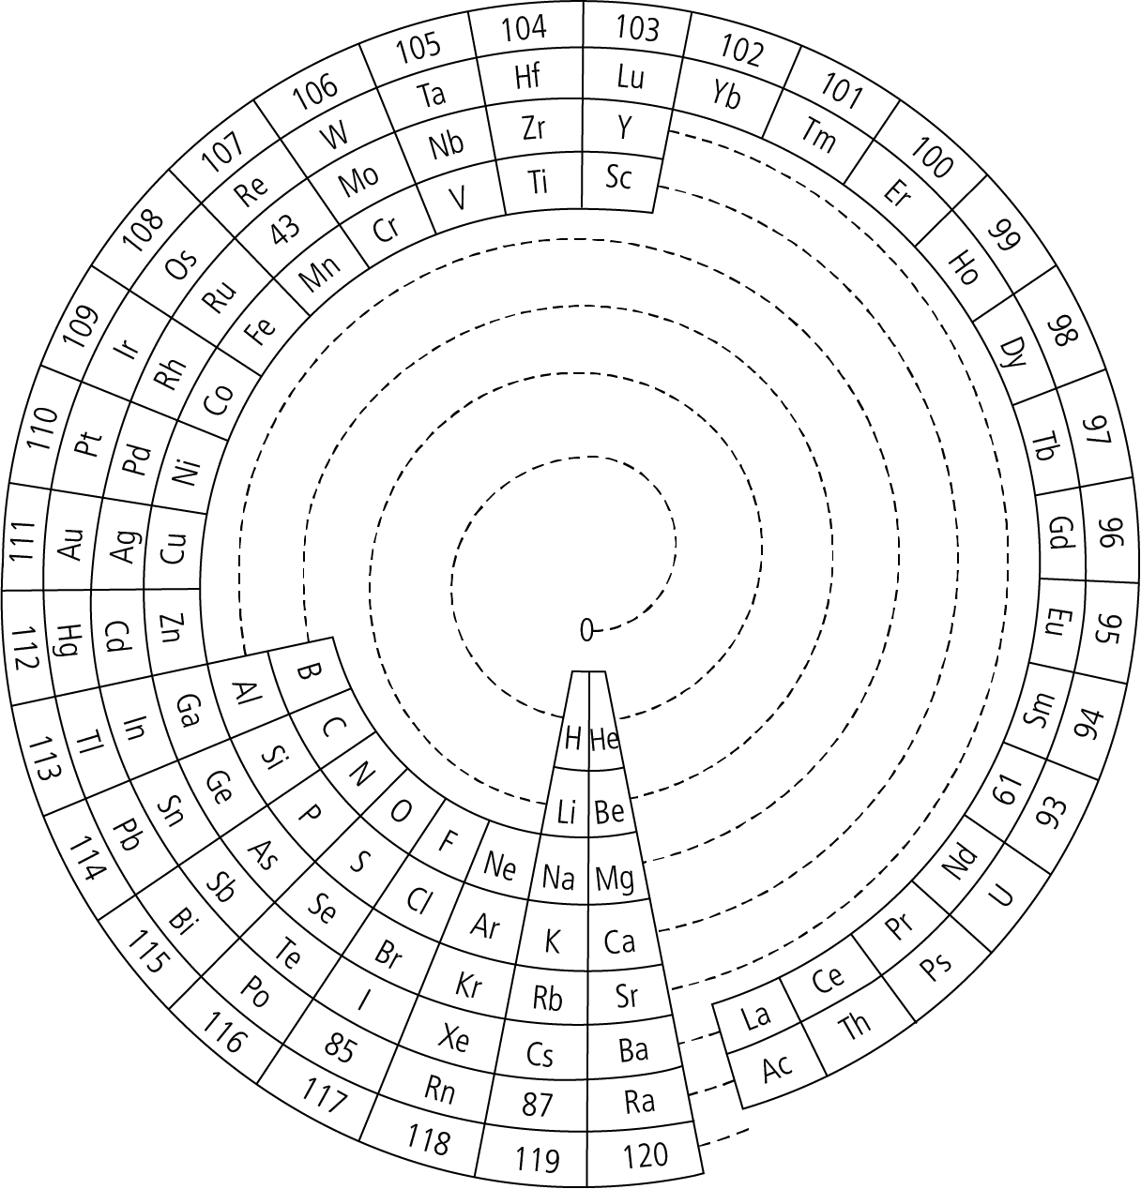

The Charles Janet helicoidal/discoid representation

- https://www.researchgate.net/publication/331285671_From_telluric_helix_to_telluric_remix

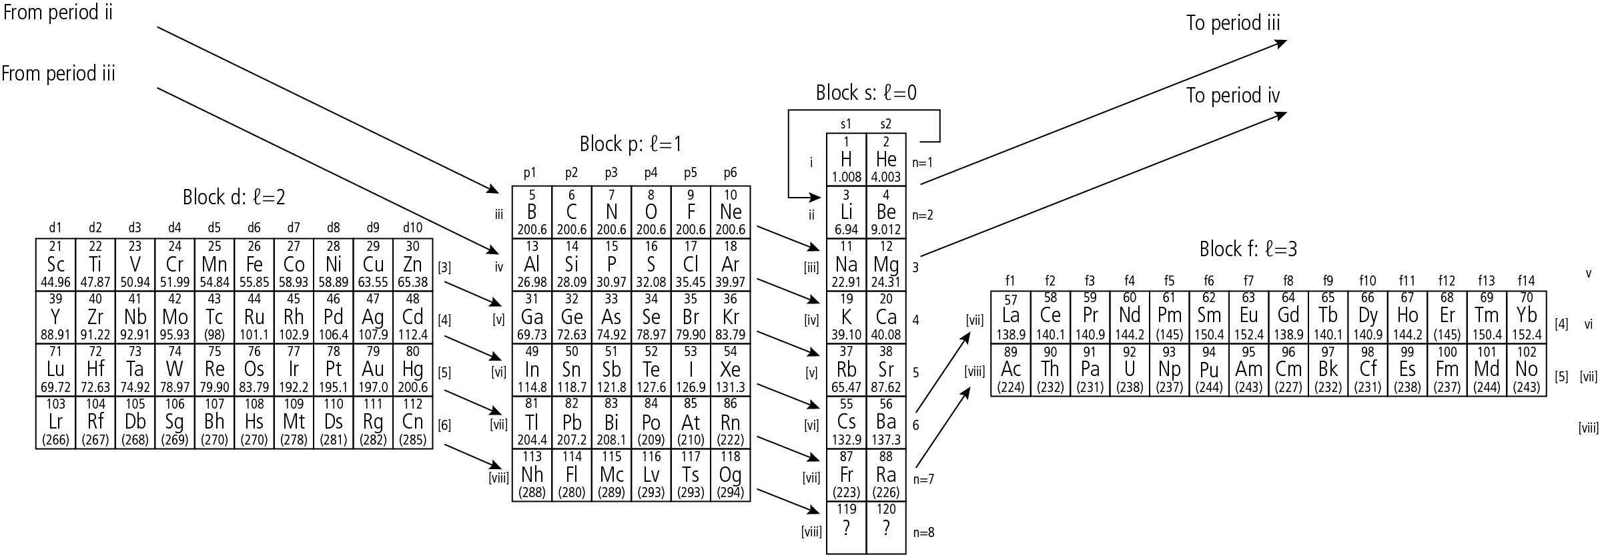

The ‘telluric remix’

- Marks, E.G., Marks, J.A. Mendeleyev revisited. Found Chem 23, 215–223 (2021). https://doi.org/10.1007/s10698-021-09398-4 – A compromise between Mendeleev’s groups and electronic structure configurations.

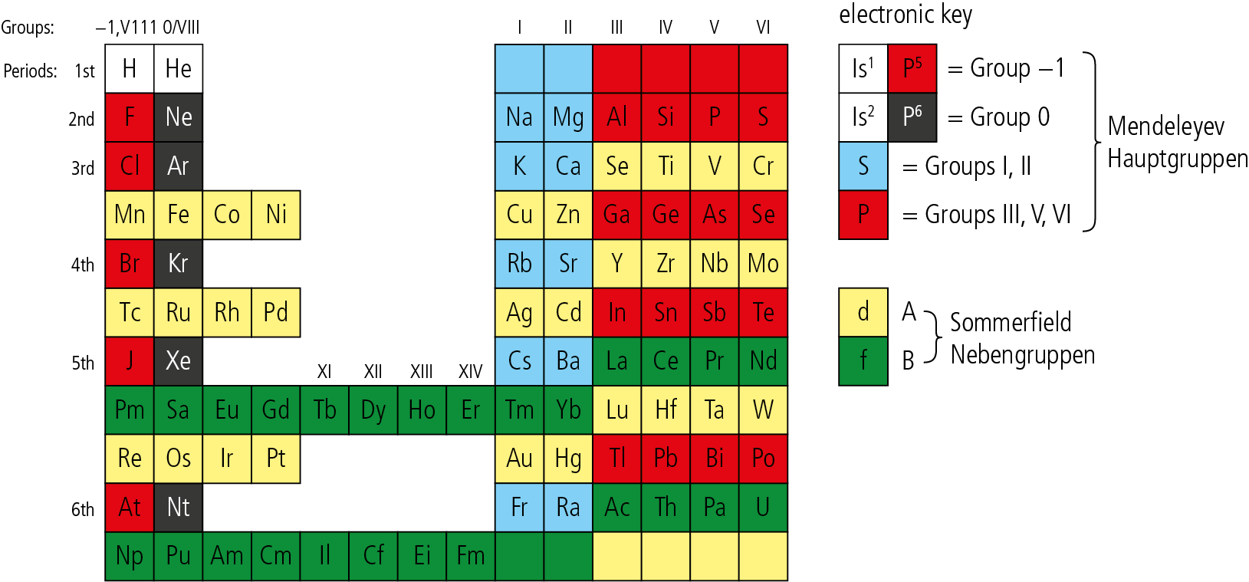

Mendeleev revisited

