Structure 2.4.4
Properties of polymers: polycaprolactone

Reference:
S2.4.4 Polymers are large molecules, or macromolecules, made from repeating sub-units called monomers.

Aim
To investigate the properties of polymers.

Introduction
Polycaprolactone (PCL) is a biodegradable polyester with a low melting point of around 60 °C. PLC is formed by the polymerization of ε-caprolactone, a cyclic ester. The ring breaks under the effect of a catalyst, in a process called ring-opening polymerization, to form the monomer that acts as the repeating unit of the polymer, a biodegradable polyester.
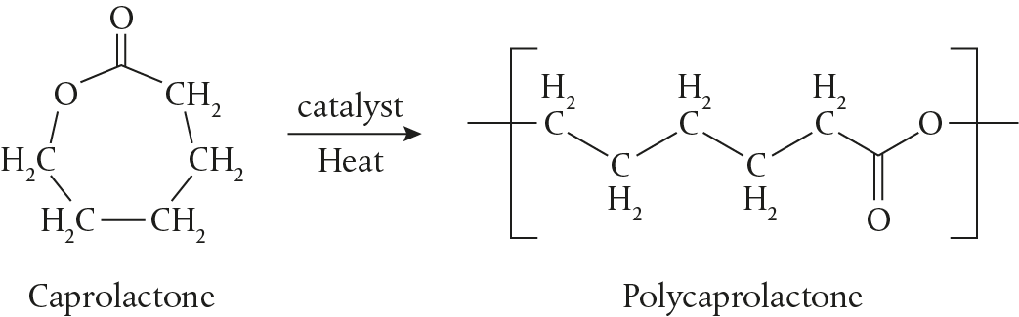

Polycaprolactone is easily sourced. It is sold as small white pellets for arts and crafts. Its thermal properties, exceptional mechanical and chemical properties, and its biocompatibility and biodegradability, have made it an ideal material for applications ranging from casual 3D printing to biomedical tissue engineering, and even for targeted drug delivery.

Pre-lab questions
- Polycaprolactone is considered to be a thermoplastic. Define the term thermoplastic.
- Where in the van-Arkel-Ketelaar triangle should polycaprolactone be? What other properties can you predict for this polymer based on this position in the triangle?

Please note
- A full risk assessment should be carried out prior to commencing this experiment.
- Personal safety equipment should be worn.
- Chemicals should be disposed of safely and with due regard to any environmental considerations.

Risk assessment
Material name and chemical formula | Associated risks | Measures taken

Environmental risks
Waste products (if any) | Associated risks | Waste management

Ethical risks
Small amounts should be used when possible. No harm to people and the environment will be caused by this experiment.

Equipment list
Chemicals / materials | Apparatus (per group of students)
polycaprolactone pellets  hot water | beaker  heat gun  spatula or scoop  paper towels

Method
General method
- Add 2 or 3 spatulas of polycaprolactone pellets to half a beaker of hot, but not boiling, water. Notice that the pellets gradually become translucent.
- When the PCL pellets are completely clear in colour, remove them from the water, taking care not to burn yourself, and place on a paper towel. For a short while the pellets will be elastic and malleable.

Experiment 1: Elasticity
- While they are still warm, shape the pellets into a sphere, and then bounce the sphere on the bench. Record what happens.
- Allow the sphere to cool. Record any colour and texture changes as it cools.
- Try to bounce the sphere on the bench as you did when it was warm, and record what happens now.

Experiment 2: The thread challenge
- Place the polycaprolactone ball back in the hot water and reshape it into a worm.
- Pinch a side and pull. Notice that a thread of plastic is pulled out. How long a thread can you make before it breaks?
- Work with a classmate who can hold the main mass of the polymer, and gently warm it with a heat gun to see how long a thread you can pull out.

Post–lab report
Write a report where you:
• Summarize the important theoretical concepts described in this lab.
• Summarize the experimental procedures.
• Highlight any important health and safety matters.
• This was a qualitative lab. Present your observations and relate them to your understanding of polymer properties.
• Evaluate the experimental procedures. Suggest how the experiment could have been extended.

