Structure 2.4.1
Cement and mortar: Investigating the parameters that affect their properties

Reference:
S2.4.1 Bonding is best described as a continuum between the ionic, covalent and metallic models, and can be represented by a bonding triangle.

Aim
To use the van Arkel-Ketelaar triangle of bonding to explain the properties of a material. Discuss the properties of different construction materials.

Introduction
Chemical bonding is important in material science as it is responsible for the characteristic properties and behaviour of the materials we use in everyday life.
In this lab we will prepare small ornaments using plaster of Paris and cement in small silica moulds, then use the Van Arkel-Ketelaar triangle of bonding to explain their properties.

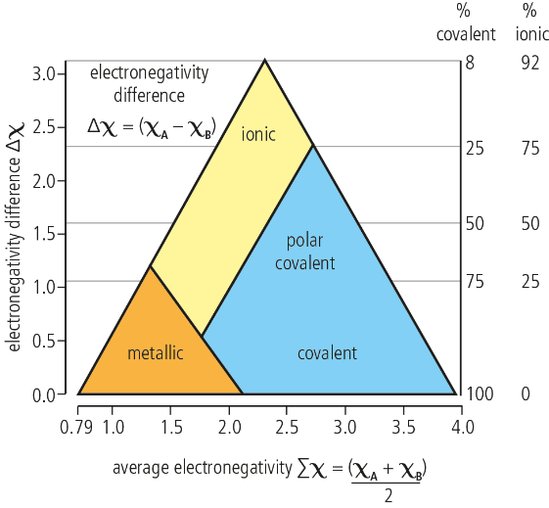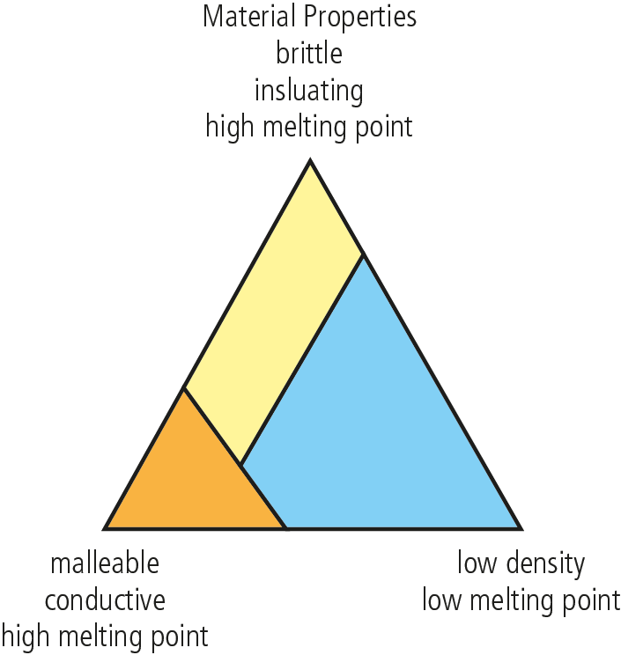

Pre-lab question
Cement is primarily comprised of calcium oxide and silicon dioxide (and other additives). Plaster of Paris is a white powder (calcium sulfate hemihydrate).
Find the positions of calcium oxide, silicon dioxide and calcium sulfate hemihydrate on the van Arkel-Ketelaar triangle and predict the properties of cement and of plaster of Paris.

Please note
- A full risk assessment should be carried out prior to commencing this experiment.
- Personal safety equipment should be worn.
- Chemicals should be disposed of safely and with due regard to any environmental considerations.

Risk assessment
Material name and chemical formula | Associated risks | Measures taken

Environmental risks
Waste products (if any) | Associated risks | Waste management

Ethical risks
Small amounts should be used when possible. No harm to people and the environment will be caused by this experiment.

Equipment list
Chemicals / materials | Apparatus (per group of students)
mould release spray  rapid set cement  plaster of Paris  deionized water | silicone baking moulds  small disposable cups and wooden stir sticks  plastic volumetric cylinders  spatulas

Method
- In a well ventilated area, spray the silicone baking moulds with the mould release spray.
- Measure approximately 40 cm³ of cement powder and 50–60 cm³ of deionized water into a disposable cup.
- Stir using a wooden stir stick until the mixture resembles the texture of pancake mix.
- If the mixture is too thick, add deionized water in small increments (~5 cm³). If the mixture is too thin, add small amounts of cement until the desired consistency is reached.
- Fill your silicone moulds with the mixture. Leave the moulds overnight before removing the solid casts from the moulds.
- Repeat the procedure using plaster of Paris in step 2 instead of cement. Use about 40 cm³ of plaster to 20 cm³ of deionized water.
- Test the resulting materials for brittleness, conductivity and melting point.

Analysis
- Did the materials have the expected properties of brittleness, conductivity and melting point?
- How does the ratio of substance to water affect the final product properties?
- A major component of cement is calcium oxide (CaO). If you decreased the pH of the water you used (by adding a small amount of acid), how would the properties of the solid product be affected?
- Design and carry out an experiment to investigate this relationship.

Post–lab report
Write a report on the lab you have designed where you:
- State your research question.
- Summarize the important theoretical concepts described in your lab.
- State and justify your hypothesis.
- Describe your methodology.
- Highlight any important health and safety matters.
- Present and analyze your results.
- State your conclusion on how your selected variable (in the experiment you designed) affects the properties of the product.
- Research whether your conclusion agrees with the scientific consensus or not. Based on this, evaluate your results and your experimental process.

