Structure 2.4.1
Properties of ionic and covalent compounds

Reference:
S2.4.1 Bonding is best described as a continuum between the ionic, covalent and metallic models

Aim
To relate the solubility of a compound in water or petroleum ether to the ionic or covalent character of the compound, and then measure the solution conductivity to characterize a compound as a strong or weak electrolyte.

Introduction
Ionic compounds consist of ions held together by strong electrostatic attraction. Covalent compounds consist of molecules whose elements are held together by forming bonds through the mutual sharing of electron pairs.
From the early days of chemistry, fundamental differences were observed between these categories of compounds even though, at the time they were not characterized as such. Alchemists ruled that ‘similia similibus solvuntur’, which translates as ‘like dissolves like’ or ‘similar substances will dissolve similar substances’. So, polar solvents will dissolve polar compounds, while non-polar solvents will dissolve non-polar compounds. In this lab we will test this idea using water (a polar solvent) and petroleum ether (a non-polar solvent) on a number of compounds and assign them as polar or non-polar based on their solubility.

In a second experiment, the electrical conductivity of various solutions will be tested and the compounds will be characterized as strong or weak electrolytes. Conductivity of a solution depends on the availability and mobility of ions in the solution. The greater the number of mobile ions that are available in the solution, the higher the conductivity. Therefore, compounds that fully dissociate into their ions when dissolved in water (only hydrated ions are present in the solution)

M_{m}X_{x} → M^{x+}(aq) + X^{m−}(aq)

are considered to be strong electrolytes, while compounds that do not fully dissociate into ions (they form an equilibrium between their molecular form and their hydrated ions)

M_{m}X_{x} ⇌ M^{x+}(aq) + X^{m−}(aq)

are considered to be weak electrolytes. The strength of a weak electrolyte depends on the equilibrium constant of the dissociation above.

Pre-lab questions
1. Is iodine (I₂) a covalent or ionic molecule? Do you expect it to be more soluble in water or in petroleum ether?
2. NaCl is an ionic compound. Its solutions are considered to be strong electrolytes. Explain why solid NaCl crystals do not conduct electricity.

Equipment list
Chemicals / materials | Apparatus (per group of students)
Experiment 1  Solvents:  deionized water  petroleum ether  Substances:  oil  iodine pellets  sodium chloride powder, NaCl(s)  potassium iodide powder, KI(s)  sulfur (flowers), S₈(s)  Experiment 2  deionized water  tap water  ethanol (80% vol, or higher), C₂H₅OH(l)  Dilute solutions of:  hydrochloric acid, HCl  sulfuric acid, H₂SO₄  acetic acid, CH₃COOH  sodium chloride, NaCl  sodium hydroxide, NaOH  ammonium hydroxide, NH₄OH  sucrose  starch | test tubes  test-tube rack  bungs  ammeter (or digital multimeter)  wires/crocodile clips  graphite electrodes  lamp (1.5 V)  battery (3.0 V)  spatulas  pipettes

Method
Experiment 1
- Place a small amount of each substance (~1 g for solid substances and ~1 cm³ for liquid substances) into five test tubes. Add 3–4 cm³ of deionized water to each test tube, then tap the tubes and shake well to dissolve the substance. Record your observations in Table 1. Repeat the process using petroleum ether instead of water and record your observations in Table 1.
- Add 1–2 iodine pellets to a test tube. Add 2–3 cm³ of deionized water and shake well. Record your observations. Add 2–3 cm³ of petroleum ether to the same tube. Notice that a layer of petroleum ether forms on the top. Close the tube with a bung and shake well. Record your observations. Explain what is happening.

Experiment 2
Determining the electrical conductivity of solutions.
- Set-up a simple system to test the electrical conductivity of various solutions. Use a 3 V battery or a DC power supply of similar voltage.

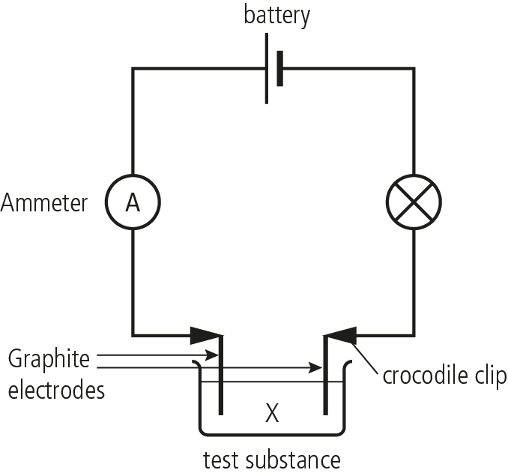
- Submerge the electrodes in the solution to be tested. If an analogue ammeter (galvanometer) is used, just record the deviation of the galvanometer needle instead. Record your observations in Table 2.

Analysis
Table 1
Substance | Better soluble in |  | The compound is
Substance | Water  (polar solvent) | Petroleum ether  (non-polar solvent) | Ionic or  polar covalent | Non-polar
NaCl
KI
I₂
S₈
oil

A polar compound dissolves better in a ______________ solvent.

Table 2
Substance solutions | Ammeter deviation |  |  | Substance can be characterized as:
Substance solutions | high | low | none | strong electrolyte | weak electrolyte | not an electrolyte
deionized water
tap water
C₂H₅OH
HCl
H₂SO₄
CH₃COOH
NaCl
NaOH
NH₄OH
sucrose
starch

Post–lab report:
Write a report where you:
• Summarize the important theoretical concepts described in this lab.
• Summarize the experimental procedures.
• Highlight any important health and safety matters.
• Discuss whether the solubility in polar and non-polar solvents is a good method of determining the polarity of a compound.
• Consider how the investigation could be expanded.

