Structure 2.3.1
Investigating the properties of metals

Reference:
S2.3.1 A metallic bond is the electrostatic attraction between a lattice of cations and
delocalized electrons.

Aim
To investigate the characteristic properties of metals.

Introduction
Metals are characterized by a number of physical properties:
- They are lustrous – most of them are grey shiny solids.
- They have high melting points – with the exception of mercury, which is a liquid at
room temperature.
- They are malleable – they can be moulded into specific shapes, which they retain.
- They are ductile – they can be stretched into wires.
- They are good conductors of electricity and heat.
- They can be mixed together to make alloys.

and chemical properties:
- Most metals react with acids to release hydrogen, H₂(g).
- Metals of Group 1 are highly reactive and react violently with water.
- The more reactive metals of Group 1 (sodium and potassium) are characterized
as pyrophoric because they tend to ignite when they react with oxygen.
- Metal oxides and hydroxides are alkaline.
- More reactive metals will displace less reactive metals from their compounds.
- The transition metals have additional properties.

The physical properties of metals are attributed to the metallic bond, while their chemical properties are attributed to their low ionization energy and their ability to form ionic bonds.

Pre-lab questions
- How does the metallic bond explain the ability of metals to conduct electricity?
- How does the metallic bond explain the malleability of metals?
- Why does the melting point of metals decrease as you go down a group in the
periodic table?

Please note
- A full risk assessment should be carried out prior to commencing this experiment.
- Personal safety equipment should be worn.
- Chemicals should be disposed of safely and with due regard to any environmental considerations.

Risk assessment
Material name and chemical formula | Associated risks | Measures taken

Environmental risks
Waste products (if any) | Associated risks | Waste management

Ethical risks
Small amounts should be used when possible. No harm to people and the environment will be caused by this experiment.

Equipment list
Chemicals/materials | Apparatus (per group of students)
magnesium ribbon  aluminium foil  copper sheet  copper wire  iron filings  iron bar  HCl(aq), 0.1 mol dm⁻³  CuSO₄(aq), 0.1 mol dm⁻³  deionized water  phenolphthalein indicator | wires, crocodile clips, battery, light bulb, switch  Bunsen burner  heat-proof mat  test tubes and test-tube rack  beaker  knife  thermometer

Method

Physical Properties
- Examine the magnesium ribbon, copper wire, copper sheet, aluminium foil, iron filings and the iron bar. Record your observations on their immediately observable characteristics in
an appropriate table.
- Scratch the surface of the metals with a knife. Use gloves when manipulating magnesium and ensure that you are either working in a fume cupboard or a well-ventilated space as you do not want to breath the dust generated. Record your observations of each metal after you have removed the top layer.
- Set up the circuit shown in Figure 1 with a 1.5 V light bulb connected to a 3 V battery and a switch. Insert each of the metal samples into the circuit in turn to see how the light intensity is affected. Record your observations.

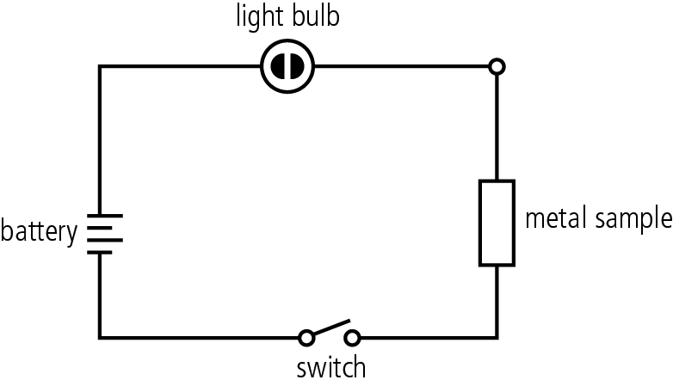

Figure 1

- Hold a piece of copper wire at one end and heat the other end in a Bunsen flame. Record the time required for you to feel the heat at the other end of the wire. Try the same with the copper sheet, aluminium foil and the iron bar. Record your observations. What other parameters should be controlled to improve this experiment?

Chemical properties
- Place two test tubes in a test-tube rack for each of your metal samples. Add some deionized water to the first one and a small amount of 0.1 mol dm⁻³ HCl to the second. Carefully drop a small sample of metal into each of the two test tubes and record your observations. If no reaction is observed, gently heat the test tube using a Bunsen burner. Make a note of any chemical reactions that take place.
- Allow the test tubes to cool to room temperature and then add a drop of phenolphthalein indicator to each tube. Make a note of any changes that occur.
- Add a small amount of CuSO₄(aq) to a beaker. Gently crumple a piece of aluminium foil, but do not turn it into a ball. Place the aluminium foil in the CuSO₄ solution. Record the temperature and the colour of the solution. Record the temperature and any other changes observed 30 minutes later.

Analysis
Record all your observations in appropriate tables. Do you observe any trends?

Post–lab report
Write a report where you:
- Summarize the important theoretical concepts described in this lab.
- Summarize the experimental procedures.
- Highlight any important health and safety matters.
- In this activity, you performed several qualitative experiments. Present all your observations and provide explanations based on metallic bonding.
- Consider how you can extend the experiment on the heat conductivity of metals to turn it into a quantitative lab. What could be investigated in this experiment? Which other experiment could be extended? How?

