Structure 2.2.10
Racing compounds on thin layer chromatography (TLC)

References:
S2.2.10 Chromatography is a technique used to separate the components of a mixture based on their relative attractions involving intermolecular forces to mobile and stationary phases.
T1 Applying techniques

Aim
Explanation, calculation and interpretation of retardation factor, R_{f}, values, of different substances using thin layer chromatography (TLC).

Introduction
Thin layer chromatography (TLC) is a chromatography technique used to separate mixtures of substances. Unlike paper chromatography, thin layer chromatography is performed on silica plates – that is, plates of glass, plastic, or aluminium, coated with a thin layer of silica. The silica layer is the stationary phase (Figure 1a).

Samples of the substance mixtures are prepared by dissolving a small amount of the substance in an appropriate solvent and then using the resulting solution to stain the silica plates at the origin. The plates are then placed in a chamber with a small amount of solution called the eluent. An eluent is a solvent used to separate the components. The eluent is the mobile phase.

The mobile phase slowly moves up the silica plate causing the substances in the sample spot to be distributed at different speeds according to their affinities to the mobile phase and the stationary phase. More polar substances bind better to the stationary phase than to the mobile phase meaning that they move slower (if at all), while compounds that better bind to the mobile phase move further up the plate. This characteristic effectively separates the mixture of substances according to their polarities (Figure 1b). After the ‘migration’ of the mobile phase is complete, you can see the positions of the samples by staining or by viewing under UV light.

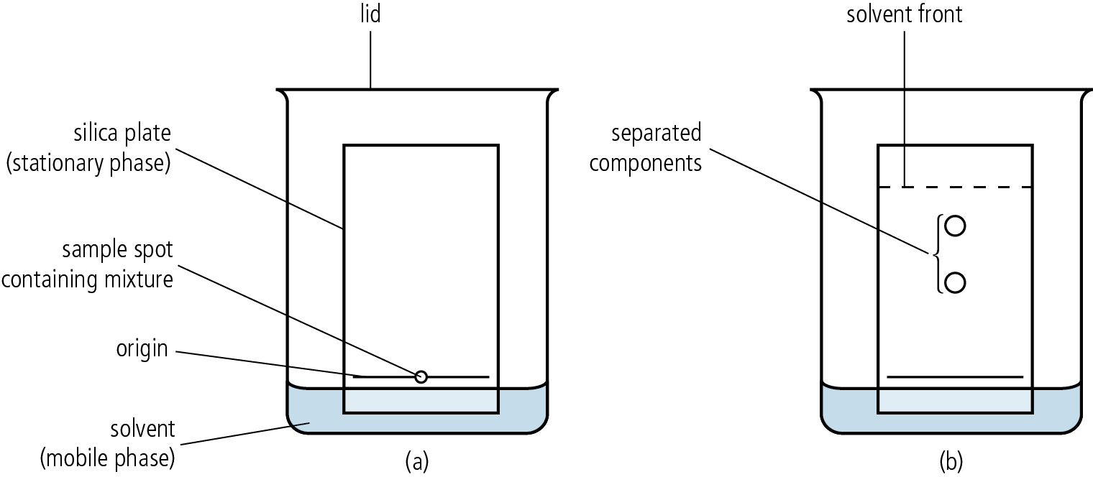

Figure 1

Pre-lab questions
- State which of the following compounds is polar: acetic acid, pentane, hexane.
- Place the following compounds in order of increasing polarity: sodium acetate, butyl ethanoate, benzoic acid.
- In a mixture of the following compounds, state which of them will travel faster on a silica plate (will have the highest R_{f} value): aminophenol, salicylic acid, sodium acetate.

Please note
- A full risk assessment should be carried out prior to commencing this experiment.
- Personal safety equipment should be worn.
- Chemicals should be disposed of safely and with due regard to any environmental considerations.

Risk assessment
Material name and chemical formula | Associated risks | Measures taken

Environmental risks
Waste products (if any) | Associated risks | Waste management

Ethical risks
Small amounts should be used when possible. No harm to people and the environment will be caused by this experiment.

Equipment list
Chemicals/materials | Apparatus (per group of students)
ethyl acetate  petrol ether  acetone  aminophenol (s)  salicylic acid (s)  sodium acetate (s) | TLC chamber (or a 50 cm³ beaker and a watch glass)  silica plates  TLC plate cutter  volumetric cylinder  capillary tubes  Pasteur pipette  sample vials

Method
- Take a small sample of one of the solid substances using a clean Pasteur pipette by placing the pipette tip in the solid to trap a small amount in the small tube.
- Transfer the solid to a small sample vial by washing the pipette with a small amount of acetone.
- Repeat the process with the other two solid substances.
- Extra care should be taken to avoid cross-contamination of your samples.

You should now have three sample vials:
- aminophenol solution in acetone
- salicylic acid solution in acetone
- sodium acetate solution in acetone.

- Prepare the mobile phase by mixing 3 cm³ of ethyl acetate and 7 cm³ of petroleum ether.
- Transfer this to the TLC chamber or place in a 50 cm³ beaker. Cover the chamber with
its lid, or the beaker with an appropriately sized watch glass, while the silica plates are prepared.
- Do not place the silica plate in the chamber yet. Take a silica plate and use the TLC plate cutter to cut it to a size that will fit comfortably inside the chamber with the lid on.
- Observe the level of the solvent in the chamber and draw a straight line using a pencil, slightly higher than the level of the solvent. This will be your origin line. Allow enough space to spot your samples.
- To spot each sample, dip a capillary tube in a sample vial and place a spot on the origin line.

Preparation of capillary tubes was described in the experiment Thin Layer Chromatography (TLC) in a sample of paracetamol.

- Observe how a sample fills the capillary tube. Carefully touch the capillary tube in the position set for the first sample. You will notice that as you touch the capillary on the plate, a dark spot of solution is being formed. Do this slowly so as to keep the radius of the spot as small as possible. This is best achieved by short duration repetitive touches of the capillary tube at the same position on the silica plate. Use a clean capillary tube for each sample to avoid cross-contamination.
- Place the silica plate in the chamber and allow the solvent to move up the silica plate. As soon as the solvent front has reached about 75–80% up the length of the plate, remove the plate from the chamber and draw a line to mark the solvent front.
- Also mark the centre of the spot with a pencil (Figure 2). You can see the position of the spots by placing the plate under UV (254 nm) light.

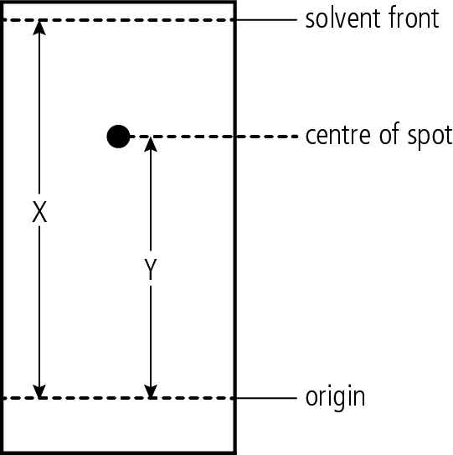

Figure 2

Troubleshooting
- If the spots seem to be dragging (forming a comet-like tail), it means that the sample used is too concentrated. Dilute your sample further and try again.
- If the spots are not visible at all, then your sample solutions are too dilute. Dissolve a bit more of the sample solid in the solution.
- Spots that seem to have moved erratically on the plate can be caused by any of the following:
  - The plate was not placed upright in the chamber.
  - The silica plate surface was damaged when it was cut.
  - The solvent in the chamber was disturbed during the process. Ensure that
after the plate is placed in the chamber, it remains undisturbed until the
process is complete.
- If the spots do not move substantially, your mobile phase is not polar enough. You can increase the polarity of the mobile phase by increasing the ratio of ethyl acetate to petroleum ether in the mixture.
- If the spots move too far up the plate, it means that the mobile phase is too polar. You can decrease the polarity of the mobile phase by reducing the ratio of ethyl acetate to petroleum ether in the mixture.
- Repeat the process until a clear reading is achieved.

Analysis

Finding the R_{f}
The R_{f} of each spot is determined by dividing the length travelled on the plate (Y in Figure 2)
by the length covered by the solvent (X in Figure 2). The R_{f} value is always less than 1.
The smaller the R_{f} value, the more polar the substance is.

Remember that the R_{f} value is not universal but depends on both the mobile phase used as well as the stationary phase (the type of silica plate) used. When reporting the R_{f} value, the mobile phase (solvent) as well as the type of stationary phase used must be stated.

Compound | R_{f} value | Mobile phase solvent | Stationary phase
Aminophenol
Salicylic acid
Sodium acetate

Post–lab report
Write a report where you:
- Summarize the important theoretical concepts described in this lab.
- Summarize the experimental procedures.
- Highlight any important health and safety matters.
- Present your results.
- Discuss the polarity of the three sample substances
- Present your conclusion.
- Evaluate the experimental procedure.

