Structure 2.2.4
Calculating structural properties using computer modelling

References:
S2.2.4 The Valence Shell Electron Pair Repulsion (VSEPR) model enables the shapes of molecules to be predicted from the repulsion of electron domains around a central atom.
T2 Computer modelling

Aim
To use computer modelling and predictive software to collect structural information of halogenated hydrocarbons.

Pre-lab questions
- What is the molecular structure expected for a molecule with four bonding electron domains, for example, CH₄?
- What is the bond angle expected in such a geometry?
- Predict how the presence of one or more halogens (in a compound such as CH_{4-n}X_{n}) will affect this angle.

Materials needed
In this lab, you will need access to a computer or smartphone with appropriate software installed or accessed online.
Some popular software is given below:

- ACD/ChemSketch – Freeware (Windows only) available for academic use from https://www.acdlabs.com/resources/freeware/chemsketch/
- Chemicalize – Available for download (Windows/MacOS/Linux) at https://chemicalize.com/app/calculation; a free academic license can be requested by ChemAxon (https://chemaxon.com/)
- MolView Online. Free access at https://molview.org/

Introduction
Computer modelling is becoming more common because of the increasing demand for quick solutions to complex problems in both pharmaceuticals and material design. Computer software can be used for quick calculations of structure and properties of molecules, or groups of molecules, under different conditions.

In this lab you will use a software package to collect data about the structure of chlorinated carbohydrates, and then determine if a trend can be established.

All of the software listed can be used for sketching skeletal formulas and visualizing them in various ways. Some can provide additional information and contain various predictors (NMR, IR, MS, elemental analysis, dipolar moment etc...). Your teacher will choose one of the software packages for you to use during this lab.

This example uses the most user-friendly of the suggested applications – MolView online.

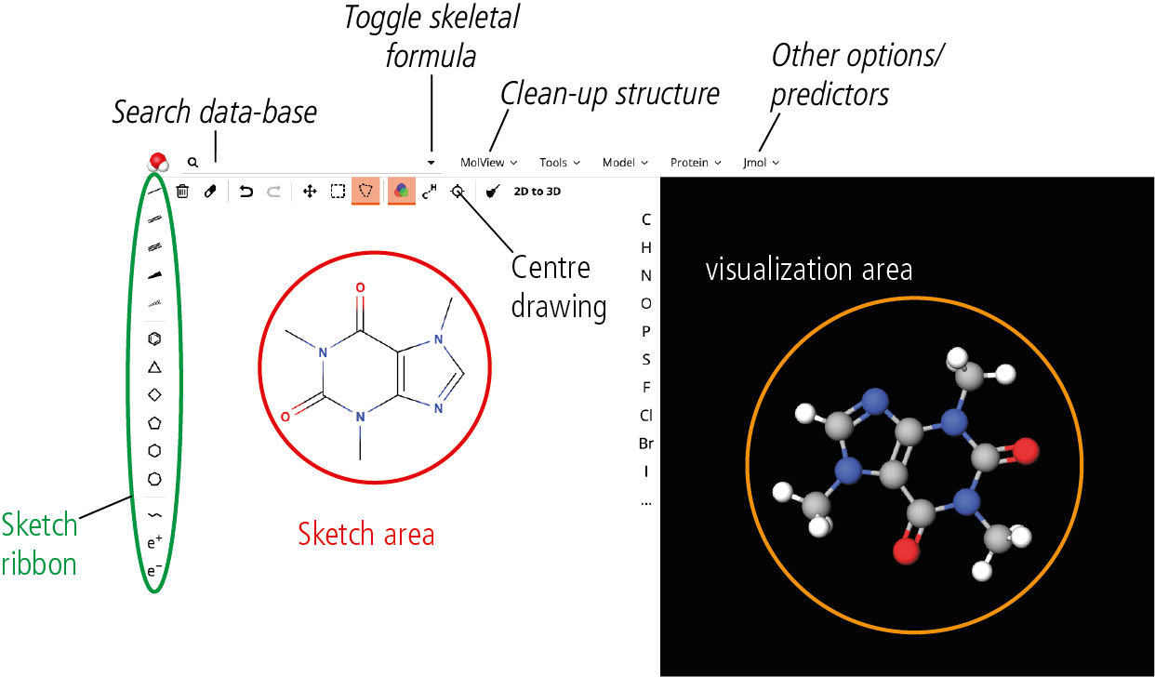

The MolView landing page

MolView was chosen because of its simplicity and the 3D visualization in a ball-and-stick animation is immediately obvious. The ribbon provides options for drawing chemical bonds,
and is similar to the sketch ribbon of other chemistry modelling software, which allows for
skill transfer to more advanced software.

Method
Condensed formula | Structural formula | Stereochemical structure

CH₄

Name: ____________

CH₃Cl

Name: ____________

CH₂Cl₂

Name: ____________

CHCl₃

Name: ____________

CCl₄

Name: ____________

CCl₃Br

Name: ____________

CCl₂Br₂

Name: ____________

CClBr₃

Name: ____________

CBr₄

Name: ____________
For the condensed formulas shown in the table, draw the skeletal formulas in MolView and paste the structural and stereochemical structures in columns 2 and 3 respectively.
Note that you can switch between structural/skeletal structures by pressing the ‘Toggle
skeletal formula’ button that adds or removes implicit hydrogens.

Analysis

To determine bond angles, click on ‘Jmol’ and then in the drop-down menu select ‘Angle’.

Click on any atom in the visualization area. You will see that your cursor is now a crosshair.
By moving this crosshair to different atoms, a distance measurement (in Angstrom) shows up. You need to click three different atoms in order to define the bond angle that you wish to calculate. The angle is then shown.

You can clear these measurements by clicking on ‘Jmol’ again and selecting ‘Clear’ from the drop-down menu. Use the data collected to fill in Table 1.

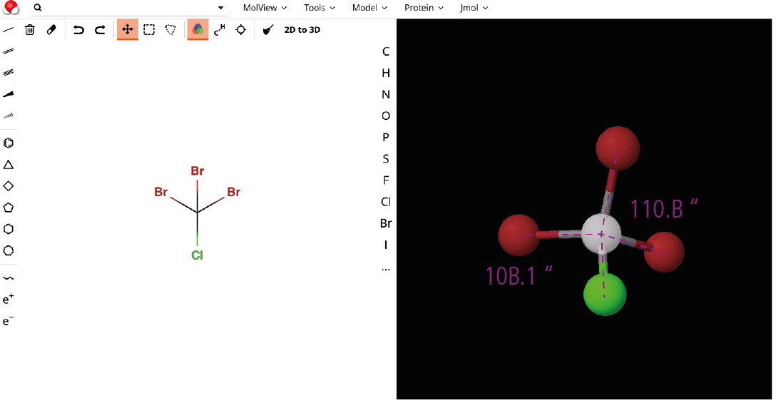

Example of angle measurement

Table 1 Dihedral angles in halogenoalkanes
Condensed Formula | H-C-X angle | H-C-H angle | X-C-X angle
CH₄ | n/a |  | n/a

CH₃Cl

CH₂Cl₂
CHCl₃ |  | n/a
CCl₄ | n/a | n/a
CCl₃Br | n/a | n/a | Cl-C-Br | Cl-C-Cl
CCl₂Br₂ | n/a | n/a | Cl-C-Br | Br-C-Br
CClBr₃ | n/a | n/a | Cl-C-Br | Br-C-Br
CBr₄ | n/a | n/a

You can extend the data collection by including combinations with other halogens.

Do you observe any emerging trend(s)?

Post–lab report
Write a report where you:
- Summarize the important theoretical concepts described in this lab.
- Summarize the experimental procedures.
- Highlight any important health and safety matters.
- State your conclusion and compare it with your prediction in pre-lab question 3.
- This was a simple application of computational chemistry. Can you think of ways
that this activity can be extended?

