Structure 2.1.3
Conductivity of an ionic compound and its aqueous solution

References:
S2.1.3 Explanation of the physical properties of ionic compounds.
T2 Applying digital technology to collect data

Aim
To determine the conductivity of an ionic compound and establish the relationship between conductivity and concentration of solution.

Introduction
The ability of an ionic compound to conduct electricity depends on whether its ions are able to move. Ionic compounds are not able to conduct electricity in the solid state as the ions are fixed within the lattice, but they can conduct electricity in the liquid or aqueous states since the ions are mobile. Ionic compounds are usually strong electrolytes, meaning that they completely dissociate into their ions when dissolved in water.

The electrical conductivity of a material is a measure of the ability of the material to carry electric current. It is affected by a number of factors such as the concentration of ions (current carriers) in the material (or solution), their mobility and their charge. Temperature is also a factor since the movement of the dissolved ions in a solution is affected by it.

In general, the more concentrated a solution is, the higher its conductivity will be.
Since conductivity is related to the concentration of ions in a solution, conductivity can be used to determine the quality of distilled or deionized water in the lab, which has an expected conductivity range of 0.5–3.0 µS/cm (micro Siemens per centimetre).

Pre-lab questions
- Explain why crystalline NaCl(s) does not conduct electricity, but aqueous NaCl(aq) does.
- Would you expect molten NaCl(l) to conduct electricity? Why or why not?

Please note
- A full risk assessment should be carried out prior to commencing this experiment.
- Personal safety equipment should be worn.
- Chemicals should be disposed of safely and with due regard to any environmental considerations.

Risk assessment
Material name and chemical formula | Associated risks | Measures taken

Environmental risks
Waste products (if any) | Associated risks | Waste management

Ethical risks
Small amounts should be used when possible. No harm to people and the environment will be caused by this experiment.

Equipment list
Chemicals/materials | Apparatus
NaCl(s) – sodium chloride  CaCl₂(s) – calcium chloride  AlCl₃(s) – aluminium chloride  deionized water | beakers  digital balance  volumetric cylinder  conductivity probe or  9 V battery or power supply and digital multimeter  wires and crocodile clips

Method

A. Preparation of solutions
- Calculate the necessary amount of each solid to prepare 50 cm³ of 1 mol dm⁻³ solutions of NaCl(aq), CaCl₂(aq) and AlCl₃(aq).
- Prepare each solution following the procedure described in ‘Skills – 6: Preparing solutions’.

Now measure the conductivity of the solutions, following either method B or method C, depending on the apparatus that is available.

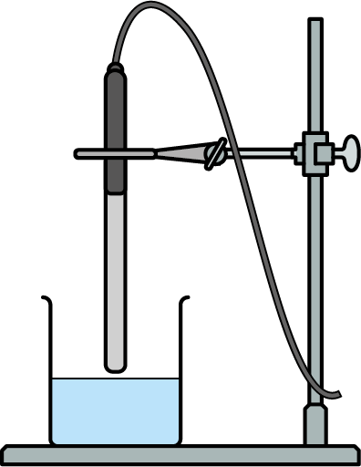B. Using a conductivity probe
- Set up the conductivity probe as shown in the diagram.
- Measure an appropriate volume of the solution to be tested
into a beaker, using a volumetric cylinder.
- Test and record the conductivity in Table 1.
- Ensure that the conductivity probe is rinsed with deionized water between measurements.

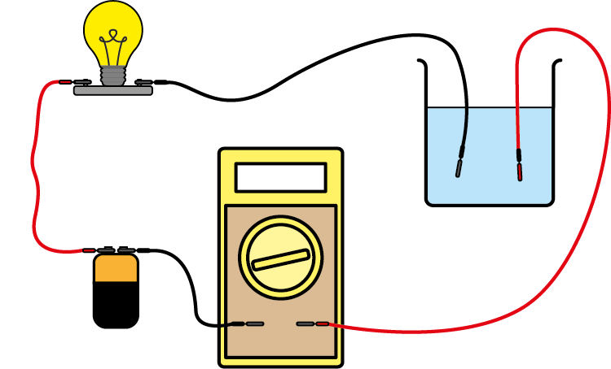C. Using a multimeter and power supply
- Set up the apparatus as shown in the diagram.
- Measure an appropriate volume of the solution to
be tested into a beaker, using a volumetric cylinder.
- Set up the digital multimeter to measure resistance.
- Record the resistance (R) shown by the multimeter in Table 1.
- The conductivity is determined as (R⁻¹).

Analysis

Table 1
Material | Conductivity | Resistance (R)
NaCl(s)
NaCl(aq)
CaCl₂(aq)
AlCl₃(aq)

Post–lab report
Write a report where you:
- Summarize the important theoretical concepts described in this lab.
- Summarize the experimental procedures.
- Highlight any important health and safety matters.
- Present your data and state your conclusion.
- Evaluate the process. Suggest how you could extend this lab activity to investigate
the relationship between concentration and conductivity.

