Structure 1.5.3
Determining the value of absolute zero

References:
S1.5.3 Investigation of the relationship between temperature, pressure and volume for a fixed mass of an ideal gas and analysis of graphs relating these variables.
T2 Applying digital technology to collect data

Aim
To identify the relationship between volume and temperature

Introduction
Charles’ law states that the volume of a gas is directly proportional to the temperature of the gas. This can be empirically observed by blowing up a balloon and then placing it in a freezer. The balloon will seem deflated when observed a few hours later. Alternatively, you could place
a balloon in a beaker of water then heat the water. As you heat the water, the air in the balloon is also heated and you will observe the balloon expanding (increasing its volume).

These experiments make the concept clear, but they do not provide any quantitative data to help us establish the mathematical relationship between the two variables. As experiments
such as these are hard to control, we will use a simulation.

Pre-lab questions
How do we convert degrees Celsius to Kelvin? How do we know that this conversion is correct?

Equipment list
Chemicals/materials | Apparatus (per group of students)
n/a | Computer with internet connection

Method

Experiment 1
- Navigate to https://phet.colorado.edu/sims/html/gas-properties/latest/gas-properties_en.html
- On the landing page, click on ‘Ideal’.
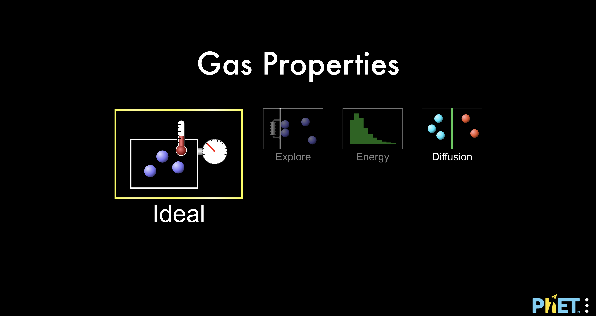

- Use the pump to add some gas particles to the container until the pressure gauge shows a value close to 100 kPa (atmospheric pressure). At that moment, click the button next to ‘Pressure’ to hold it constant.
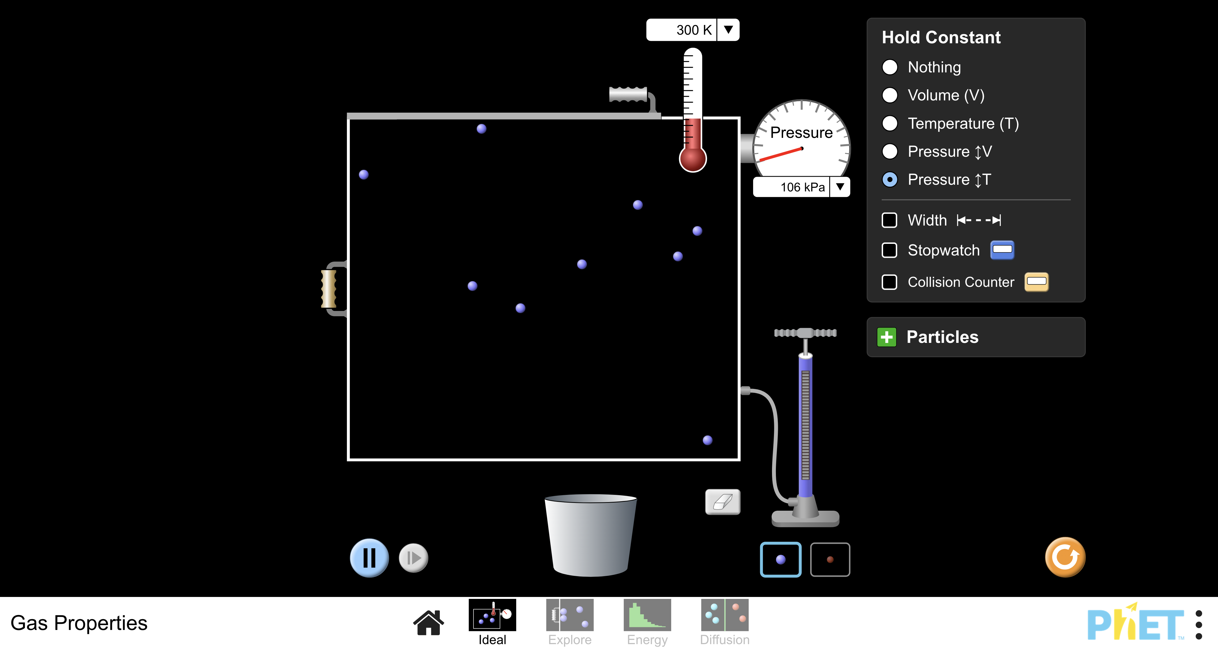

It is possible to select a different variable to hold constant, but for the determination of Charles’ law, we need to select ‘Pressure’ as Charles’ law gives the relationship between volume and temperature under constant pressure.
- Tick the box ‘Width | |’ to display the width dimension of the container.
- Assume the height and depth of the container to be equal to 10.0 nm.

- Record the width and temperature (in both degrees Celsius and Kelvin) in Table 1.
- Use your mouse to change the width of the container to several different values and record the temperature at each width.

Experiment 2
- Repeat Experiment 1, but now select volume as the variable to hold constant.
This will allow you to establish the relationship between pressure and temperature (Gay-Lussac’s law).
- After you select volume to hold constant, use the ‘bucket’ below the container to increase or decrease the temperature of the system.

- Use the pump to add more particles (if necessary) as the reading of the pressure can be erratic with a smaller number of particles present in the container.
- Record the pressure and temperature in Table 2.
- Use the lever on the bucket below the container to change the temperature of the system to several different values and record the pressure at each temperature.

Analysis

Table 1 – Data from Experiment 1
Width (nm) | Volume (m³) | Temperature (°C) | Temperature (K)

- Use the data obtained to draw a graph of volume (in m³) against temperature (in °C.)
- Extrapolate the line and determine the temperature value of the x-intercept (this temperature corresponds to ‘absolute 0’).
- What is the temperature of a gas when the gas particles are theoretically immobilized?

Table 2 – Data from experiment 2
Temperature (°C) | Temperature (K) | Pressure (kPa)

- Use the data obtained to draw a graph of pressure (in m³) against temperature (in °C.)
- Extrapolate the line and determine the temperature value of the x-intercept (this temperature corresponds to ‘absolute 0’).
- What is the temperature of a gas when the gas particles are theoretically immobilized?
- Redraw the same graphs but use temperature expressed in Kelvin instead.
- State the mathematical relationship between V and T in Experiment 1, and the mathematical relationship between P and T in Experiment 2, shown by your new graphs.

Post–lab report
Write a report where you:
- Summarize the important theoretical concepts described in this lab.
- Summarize the experimental procedures.
- Highlight any important health and safety matters.
- Present your data and analyses. State the relationship between volume and temperature when pressure is constant (Charles’ law), and the relationship between pressure and temperature when volume is constant (Gay-Lussac’s law).
- When the gas particles are immobile (they do not move) they exert no pressure and have no volume (they are assumed to be a point mass). What is the implication of this?
- Evaluate the value of simulating experimental processes in chemistry.

