Structure 1.5.3
Investigating Boyle’s law

References:
S1.5.3 Investigation of the relationship between temperature, pressure and volume for a fixed mass of an ideal gas and analysis of graphs relating these variables.
T2 Applying digital technology to collect data

Aim
To investigate the relationship between pressure and volume in a gas.

Introduction
Robert Boyle, along with his assistant, Robert Hooke, confirmed the relationship between pressure and volume by trapping air in a J-tube using mercury. When they added mercury to one side of the tube, they observed that the air on the other side contracted.
Mercury is no longer used in experiments owing to its toxicity, but you can easily observe the relationship using a plastic syringe (Figure 1).

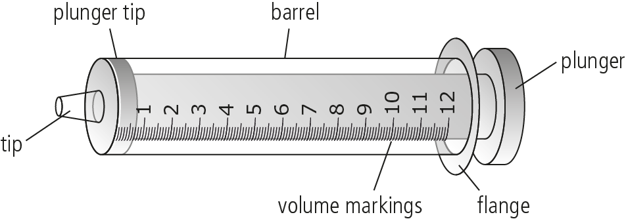

Figure 1

Fill a syringe with air by pulling the plunger, then use your finger to seal the barrel at the tip.
Try to push the plunger down. You should notice that as the volume of the gas in the syringe barrel decreases, the pressure of the gas felt at your finger increases. This happens because the volume available for the gas particles to move is decreased, so the gas particles collide more frequently with the walls of the syringe and with your finger.

We will use a pressure sensor and a plastic syringe to establish the relationship between the volume and the pressure of the gas (Figure 2).

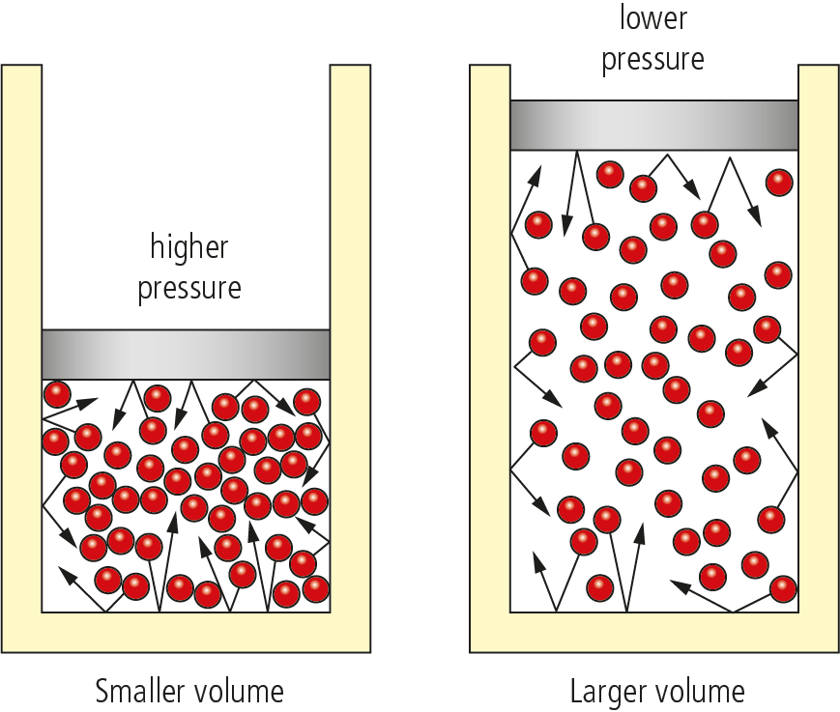

Figure 2

Pre-lab questions
Read the methodology of Experiment 1 and then consider the following question:
The number of moles of air (the particles of air) in the syringe needs remain constant during the experiment. What are some practical issues that you must consider to ensure that the number of moles of air remains constant in the experimental procedure?

Please note
- A full risk assessment should be carried out prior to commencing this experiment.
- Personal safety equipment should be worn.

Equipment list
Chemicals/materials | Apparatus (per group of students)
n/a | plastic syringes (1 × 20 cm³, and 1 × 10 cm³)  pressure sensor  data logger  rubber tubing

Method

Experiment 1
- Connect the pressure sensor to the data logger.
- If you are using a computer to collect the data, set-up the experiment for ‘event entry’
data collection.
- Pull the plunger of the 20 cm³ plastic syringe so that there is 10 cm³ of air in the barrel,
then connect the syringe to the pressure sensor. Ensure that the syringe will remain connected to the sensor until the end of the experiment.
- Record the pressure shown by the pressure sensor. This should be equal to
atmospheric pressure.
- Push and hold the plunger to the 7.5 cm³ mark and as soon as you get a stable pressure reading, record the pressure shown in Table 1.
- Repeat this process for 5.0 cm³, 12.5 cm³, 15.0 cm³ and 20.0 cm³.

Experiment 2
- Take a 20 cm³ syringe and connect it to a 10 cm³ syringe via a short piece of rubber tubing.
- Before connecting the two syringes, ensure that the smaller syringe contains 10 cm³ of air.
- Push the plunger of the small syringe and describe what is happening.
- Relate this to Boyle’s law. Consider any practical applications that this may have.

Analysis

Table 1 – Data collection
Volume  (cm³) | Pressure  (kPa)
5.0
7.5
10.0
12.5
15.0
17.5
20.0

Using the data collected, draw a graph relating the pressure (P) (dependent variable) to volume (V) (independent variable).
What is the relationship between P and V?

Post–lab report
Write a report where you:
- Summarize the important theoretical concepts described in this lab.
- Summarize the experimental procedures.
- Highlight any important health and safety matters.
- Present your experimental data and explain how you can use the data to obtain
the mathematical relationship for Boyle’s law.
- Evaluate the process.

