Structure 1.4.4
Determining the empirical formula of a compound

References:
S1.4.4 The empirical formula of a compound gives the simplest ratio of atoms of each element present in that compound.
T3 Mathematical skills (uncertainties)

Aim
To determine the empirical formula of the compound that forms between magnesium
and oxygen.

Introduction
The empirical formula of a compound gives the simplest ratio of atoms of each element present in that compound.
In this experiment you will calculate the empirical formula of the compound magnesium oxide, which is formed by the combustion of magnesium in air. You will calculate the change in the mass of magnesium on heating it, and assume that the increase in mass is due to the oxygen that has combined with it.
Air, though, is a complex mixture that, besides oxygen, also consists of nitrogen (approximately 78% of air consists of N₂). When magnesium burns in air, the temperature becomes high enough for it to combine with both the oxygen and the nitrogen in the air. The magnesium therefore forms a mixture of magnesium oxide and magnesium nitride after combustion. So we need to convert the magnesium nitride in this mixture to magnesium oxide before we can calculate the change in mass. The conversion of magnesium nitride is done in two steps:
- Step 1: add water to convert magnesium nitride to magnesium hydroxide, releasing ammonia, NH₃(g)
- Step 2: heat the magnesium hydroxide further, to convert it to magnesium oxide.

Pre-lab questions
- What are the formulas of magnesium nitride and magnesium hydroxide?
- Write an equation for the reaction in which magnesium nitride forms when
magnesium burns in air.
- Write an equation for the reaction described in step 1 above.
- Write an equation for the reaction described in step 2 above.

Please note
- A full risk assessment should be carried out prior to commencing this experiment.
- Personal safety equipment should be worn.
- Chemicals should be disposed of safely and with due regard to any environmental considerations.

Risk assessment
Material name and chemical formula | Associated risks | Measures taken

Environmental risks
Waste products (if any) | Associated risks | Waste management

Ethical risks
Small amounts should be used when possible. Products should be collected and appropriately stored for future experiments. No harm to people and the environment will be caused by this experiment.

Equipment list
Chemicals/materials | Apparatus (per group of students)
magnesium ribbon: approx. 6 cm per group (to allow for repeat trials) | crucible and lid  tongs  fine sand paper  pipe-clay triangle / gauze  stand / tripod  Bunsen burner  digital balance (±0.001 g)

Method
- Record the mass of a clean, dry crucible with its lid in Table 1. Handle the crucible and lid with tongs, not your fingers, to avoid moisture and oil from your fingers being transferred to the surfaces.
- Use fine sandpaper to scrape the oxide coating from the surface of a strip of magnesium ribbon of approximately 2 cm length. Cut the ribbon into small pieces, place in the crucible and weigh the crucible, its lid and contents. Record the mass data in Table 1. Record the appearance of the crucible contents in Table 2.
- Heat the crucible in a hot flame for 10 minutes, ensuring that the magnesium is exposed to the air but that no solid escapes. After this time the magnesium should have been converted to a white powder.
- Allow the crucible to cool and then remove the lid, record any qualitative observations
in Table 2, and then add 10 drops of water to convert the magnesium nitride to
magnesium hydroxide.
- Heat the crucible gently to drive off any water, then strongly for 3 minutes to convert the magnesium hydroxide to magnesium oxide.
- Allow the crucible to cool. Weigh the crucible, its lid and the product of the reaction. Record the mass in Table 1 and any qualitative observations in Table 2.

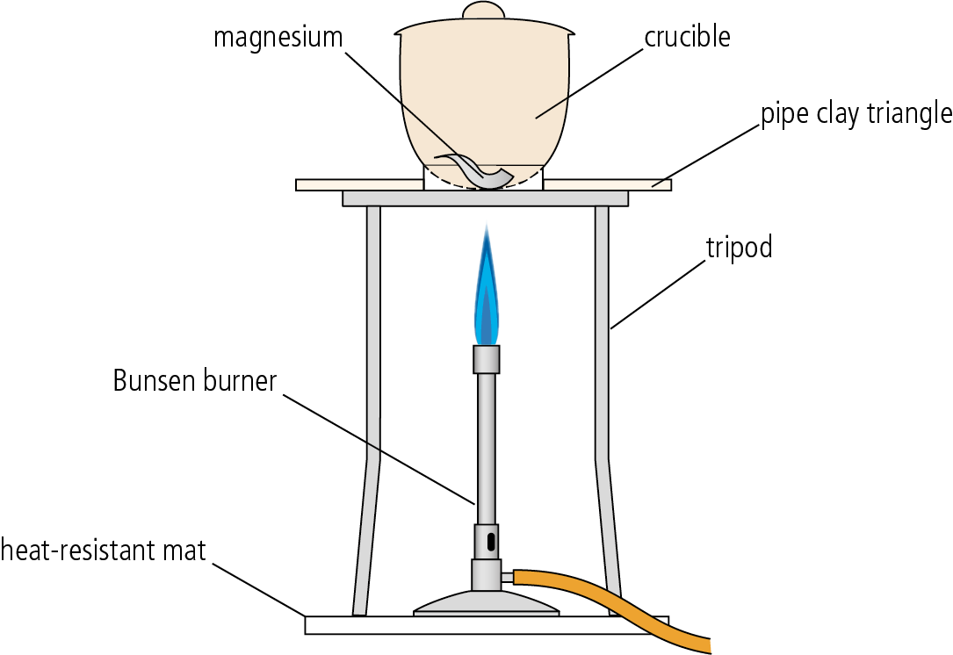

Analysis

Table 1 – recorded data

Mass / g ±0.001
Mass of crucible + lid
Mass of crucible + lid + Mg before heating
Mass of crucible + lid + Mg after heating

Table 2 – qualitative data
 | Before heating | During heating | After heating
Appearance of crucible contents

Using your recorded data and the atomic mass of Mg and O atoms, determine the number of moles of magnesium and oxygen atoms in the product (Table 3). Then find the simplest whole number ratio between these two numbers. State the empirical formula of magnesium oxide.

Table 3 – processed data
 | Magnesium, Mg | Oxygen, O
mass / g ±0.002

M / g mol^{–1}

moles / mol

Work out the simplest ratio of magnesium atoms to oxygen atoms and so the empirical formula of magnesium oxide.

- The theoretical result for the formula of magnesium oxide is MgO.
- Compare your result for the empirical formula of magnesium oxide with the theoretical result, MgO.
- Calculate the % error.
- Calculate the % error arising from random errors in the experiment and compare this with the figure above.

Post–lab report
Write a report where you:
- Summarize the important theoretical concepts described in this lab.
- Summarize the experimental procedures.
- Highlight any important health and safety matters.
- State your experimentally determined formula and compare with the theoretical
formula, MgO.
- List any systematic and random errors and suggest modifications to the experiment
that could potentially reduce these.

Include answers to these questions in your report:
- What can you deduce from the fact that magnesium metal is generally covered in
an oxide layer?
- How could you verify that ammonia gas, NH₃(g), is released during step 4 of the method?
- What is meant by ‘heating to constant mass’? Explain how this could be applied to
this experiment.

