Structure 1.3.7
Successive ionization energies database investigation HL

References:
S1.3.7 Successive ionization energy data for an element give information about its electron configuration.
T2 Applying digital technology to collect and process data
T3 Mathematical skills (graphing)

Aim
To deduce the position of an element in the periodic table from its successive ionization data.

Introduction
Ionization energy is the energy required to remove one mole of electrons from one mole of atoms of a gaseous element in its ground state, and it is expressed in kJ/mol. By graphing the ionization energies of successive elements in the periodic table (in order of increasing atomic number) some of the periodic table trends will emerge.

Pre-lab questions
- What is the generic equation that shows the first ionization energy of an element?
- Why is the first ionization energy of an element always endothermic?

Materials needed
A computer or other device with internet access and capability to run MS Excel or other
similar spreadsheet software.

Method
- Using the IB chemistry data booklet or any other appropriate database, find the first ionization energy and the atomic radius of the first 20 elements and record them in
an appropriate table.

- Calculate the logarithm of the first ionization energy. You can use the command
“=LOG10 (CELL#)” and then use the ‘fill column’ tool to automatically determine the values.

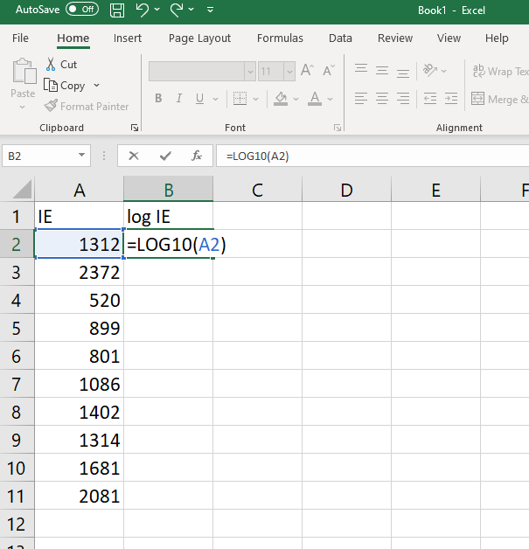

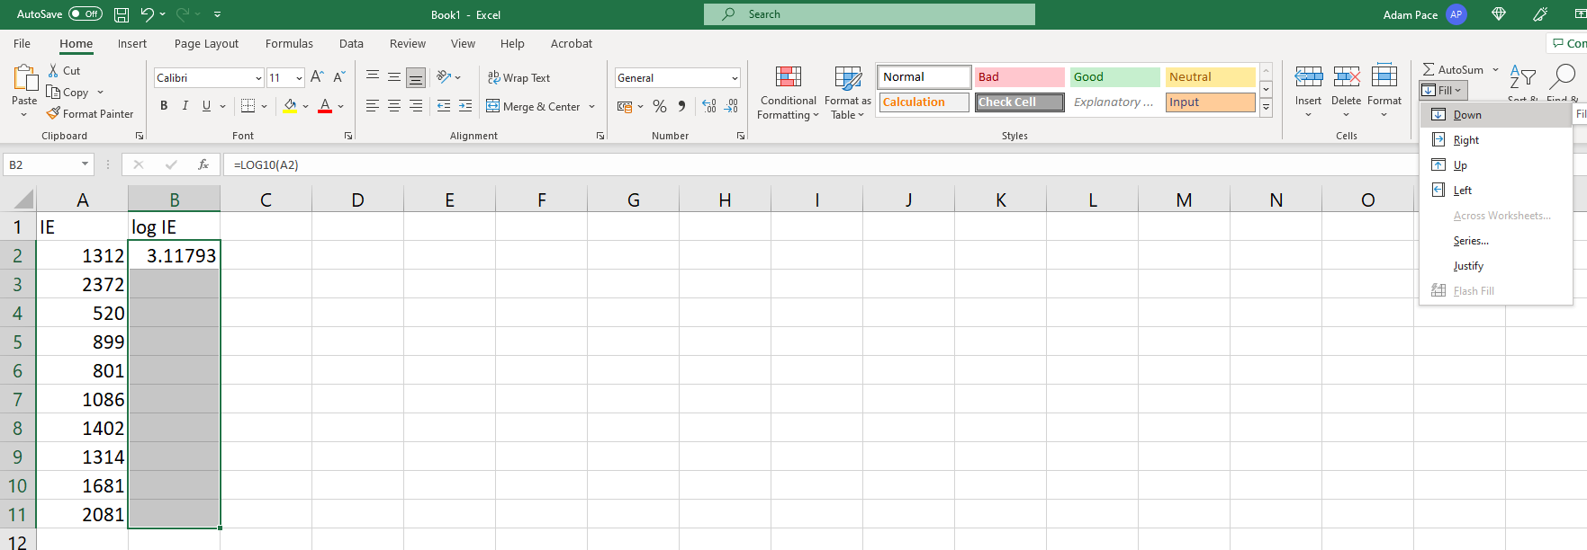

- Make a line plot of a graph of first ionization energy (y-axis) versus atomic number (x-axis) and a plot of a graph of log₁₀ first ionization energy (y-axis) versus atomic number (x-axis).

- Make a separate graph of atomic radius (y-axis) versus atomic number (x-axis).

Atomic number | Element | First ionization energy | Log₁₀ first ionization energy | Atomic radius
1 | H
2 | He
3 | Li
4 | Be
5 | B
6 | C
7 | N
8 | O
9 | F
10 | Ne
11 | Na
12 | Mg
13 | Al
14 | Si
15 | P
16 | S
17 | Cl
18 | Ar
19 | K
20 | Ca

Analysis
- How does the first ionization energy versus atomic number graph compare with the log₁₀
first ionization energy versus atomic number graph? Why is the log₁₀ of the first ionization energy preferable?

- Examine your graph of log₁₀ ionization energy versus atomic number.
- Identify the elements found at the main peaks on your graph. What do these elements have in common?
- Identify the elements found at the valleys on your graph. What do these elements have in common?
- How can this graph be used to explain periodicity?

- Examine your graph of atomic radius versus atomic number.
- Identify the elements found at the main peaks on your graph. What do these elements have in common?
- Identify the elements found at the valleys on your graph. What do these elements have in common?

Reflection
- Draw the Bohr models for K and K⁺. Which of the two will have the greater atomic radius? How do you expect the second ionization energy of potassium (K⁺_{(g)} K²⁺_{(g) +} e⁻) to compare with the first ionization energy? Discuss.
- Draw the Bohr models of Li, Be, B, C and O. What happens to the number of protons as you move across the period? Using the models, explain the trend in atomic radius and ionization energy across a period.

Post-lab report
Write a report where you:
- Summarize the important theoretical concepts described in this lab.
- Summarize the activity procedures.
- Present your tables and graphic analyses.
- Analyse your results by taking into consideration the following questions:
  - Looking at your graphs, how are atomic radii and ionization energy related?
  - What is the trend observed for ionization energy and atomic radius as the atomic number increases in each period?
  - What is the trend for ionization energy and atomic radius as you move down the periodic table?
- State your conclusions.

