Structure 1.2.1 and 1.2.2
Build an atom PhET activity – Interactive simulation

References:
S1.2.1 Use of the nuclear symbol ${}_{Z}^{A}X$ to deduce the number of protons, neutrons and electrons in atoms and ions.
S1.2.2 Isotopes are atoms of the same element with different numbers of neutrons.
T2 Applying digital technology to collect data

Aim
To use the nuclear symbol ${}_{Z}^{A}X$ to deduce the number of protons, neutrons and electrons in atoms and ions.

Introduction
The nuclear symbol provides information on the number of subatomic particles within the atoms of an element.

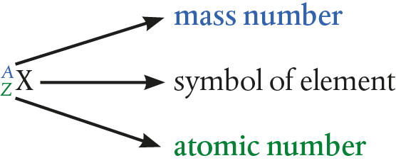

Nuclear symbol

- The mass number, A, is the total number of protons plus neutrons in the nucleus.
- The atomic number, Z, is the number of protons. The atomic number is characteristic for each element. Atoms of the same element always have the same atomic number.
- Since elements have no overall charge (they are net neutral), the number of electrons in the atoms is also equal to Z.
- In ions, the number of electrons is different from the number of protons.
- Isotopes are atoms of the same element with different mass numbers. They have identical chemical properties but different physical properties, namely, mass.

Subatomic particle | Symbol | Relative mass
proton | p⁺ | 1
neutron | n | 1
electron | e– | 0.0005

Pre-lab questions
Use the periodic table to determine the atomic number of the elements in the
following questions.
- How many protons, neutrons, and electrons do chlorine atoms have?
- The mass number of gold (Au) is 197. How many neutrons does it have?
- Carbon has several isotopes. How many protons, electrons and neutrons does ¹⁴C have?
- What is the atomic number of Li? How many protons and electrons does Li have?
- What does the atomic mass in the periodic table represent? Why is the atomic mass
value not exact?

Equipment list
Chemicals/materials | Apparatus (per group of students)
n/a | computer with Internet access

Method
Navigate to the url:
https://phet.colorado.edu/sims/html/build-an-atom/latest/build-an-atom_en.html

Activity 1
- In the welcome screen, there are three options.
Select ‘Atom’ to take you to the first activity.

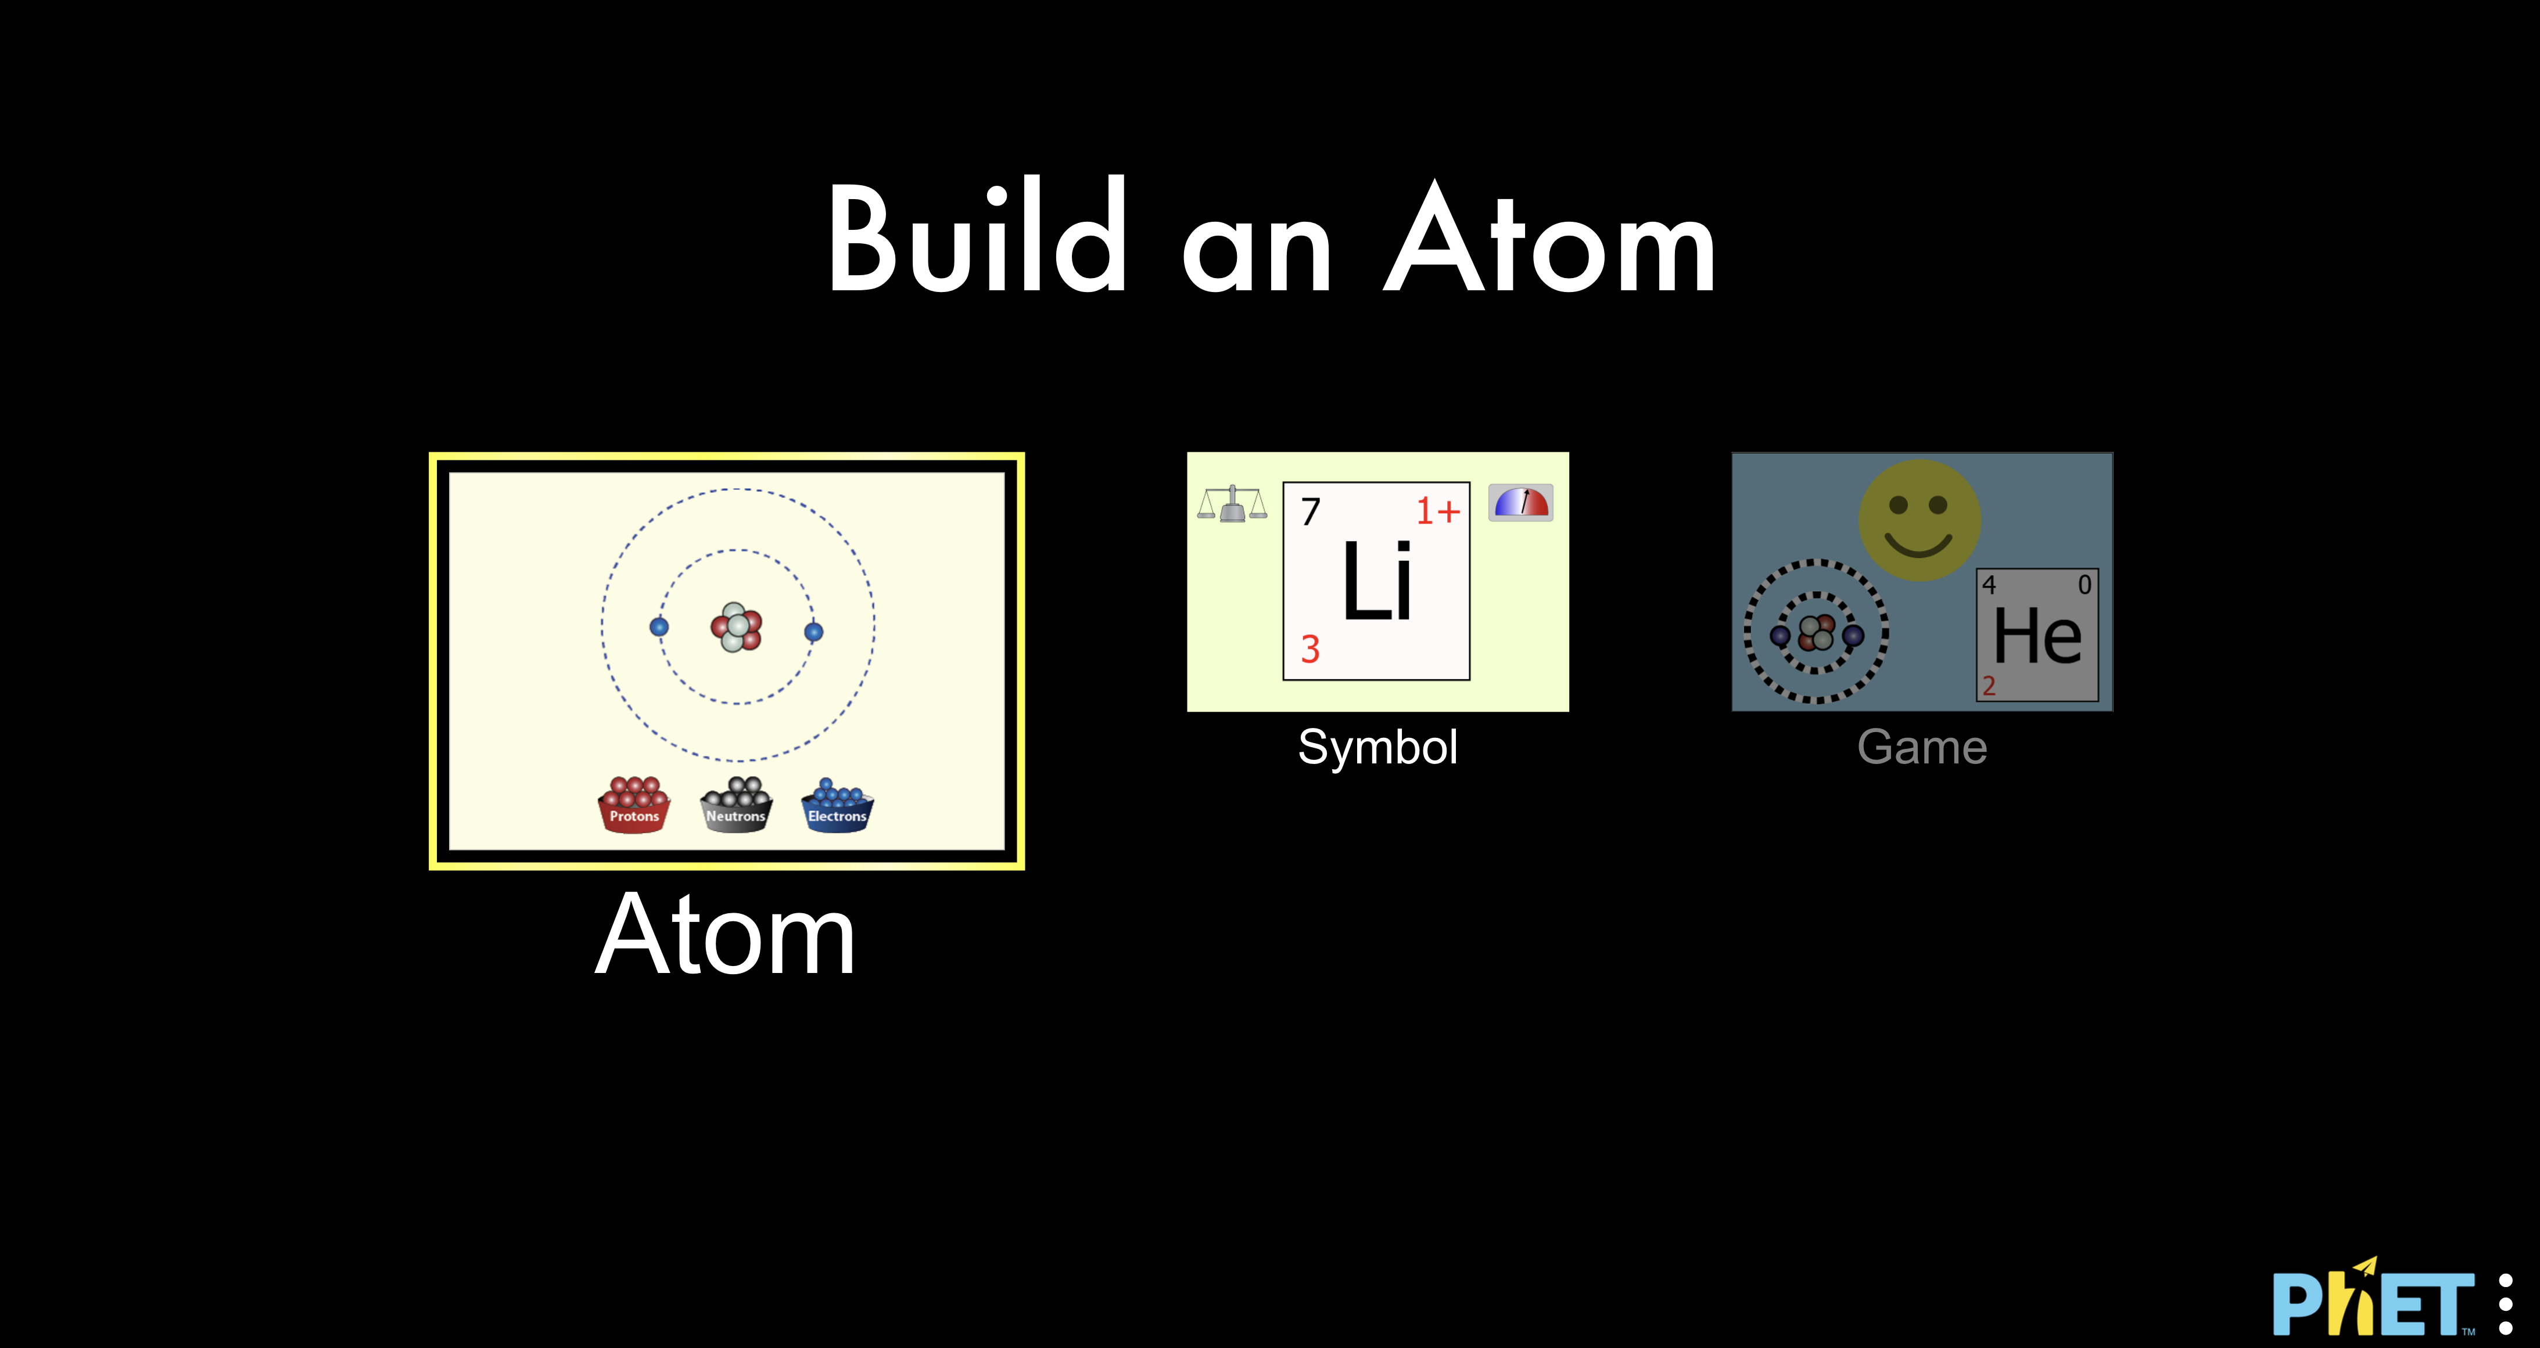

- Click on the + signs to open up the ‘Net Charge’ and ‘Mass Number’ boxes.
Tick the ‘Stable/Unstable’ box as shown.

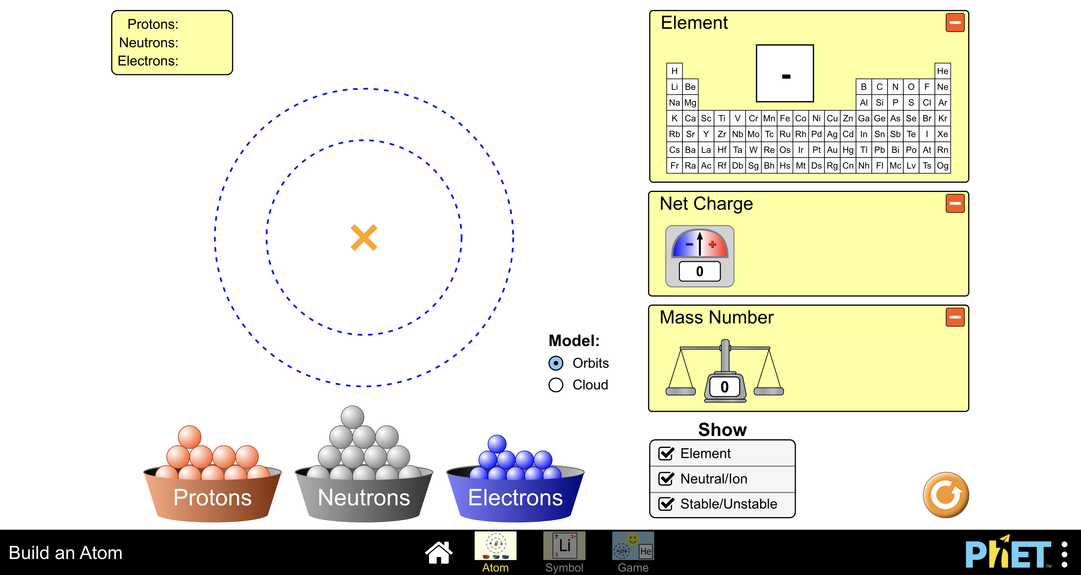

- Transfer the various subatomic particles on the atom model to generate each atom shown in Table 1 in turn. Complete the table.

- What other stable isotopes can you generate for each of the elements in Table 1? Try to identify these by adding additional neutrons to each of your models. Complete Table 2.

- You can check the validity of a proposed nuclide by clicking the ‘Symbol’ box and building a model of the atom of interest. The nuclide symbol with its ionic charge (if any) will be shown on the right-hand bottom box.

Activity 2
- Click on the game icon and try the available games.
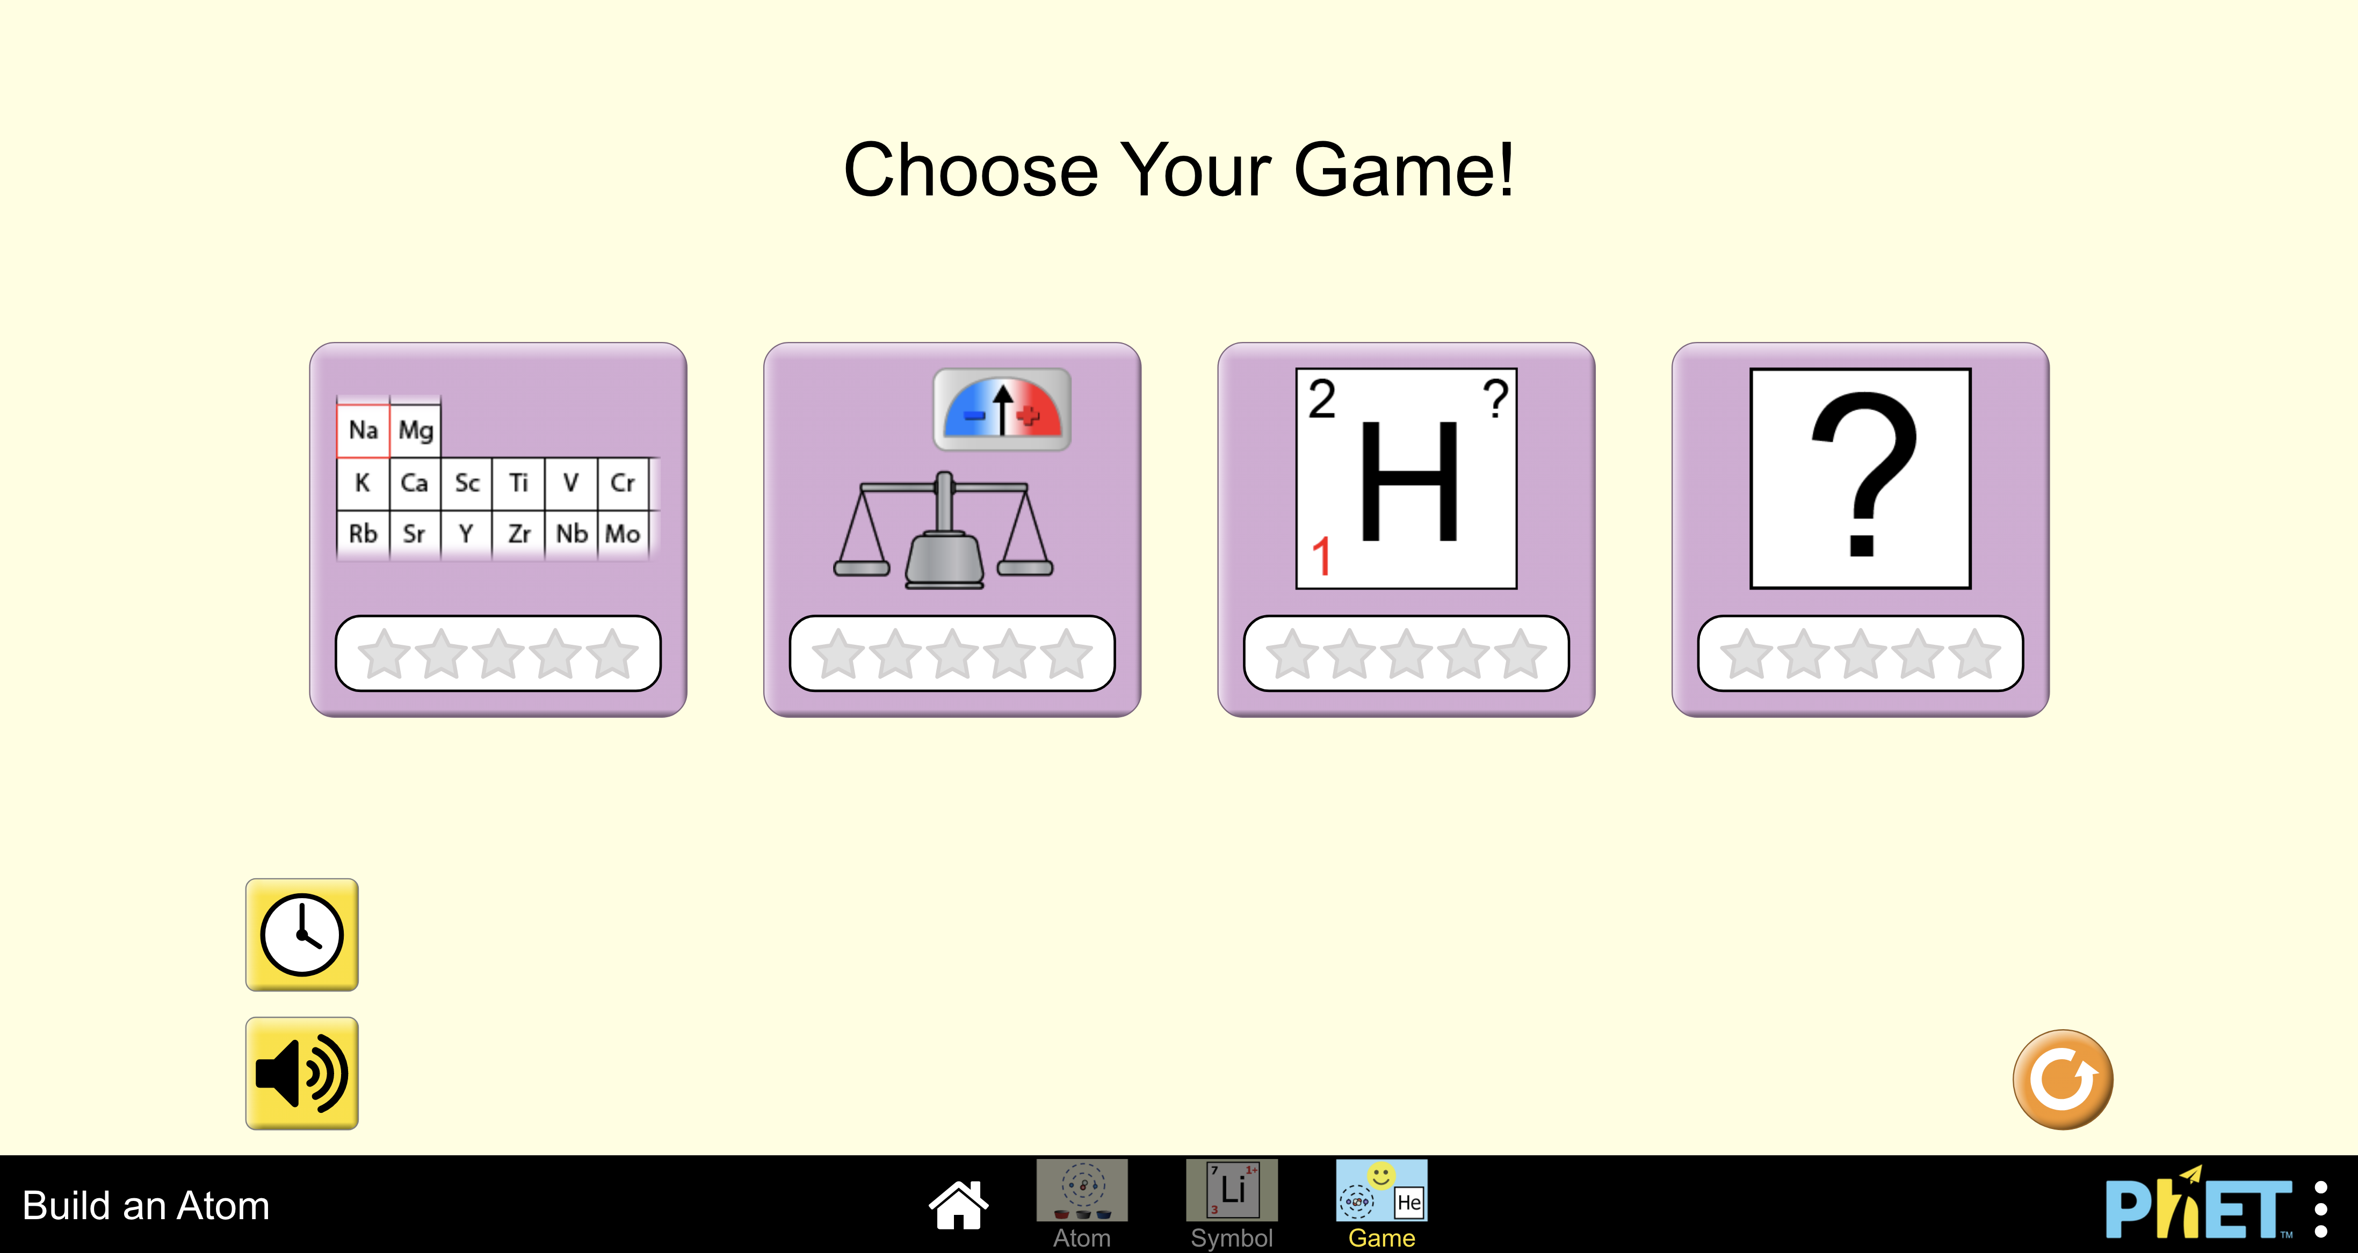

- You can disable or enable the timer as you wish.

Analysis

Table 1
Symbol | Name | Atomic number | Mass number | Number of protons | Number of neutrons | Number of electrons | Nuclide symbol
H
He
Li
Be
B
C
N
O
F
Ne

Table 2
Symbol | Number of stable isotopes | Nuclide symbols of stable isotopes
H
He
Li
Be
B
C
N
O
F
Ne

Reflection
- Play all the available games with the timer function on and challenge your instructor.
- Optional: Research one application of isotopes and report back to the class.

