Structure 1.1.3
The heat curve of water – determining the freezing point of water

References:
S1.1.3 Interpretation of observable changes in physical properties and temperature during changes of state.
T3 Mathematical skills (graphing)

Aim
To monitor the temperature change of a substance (water) as it is cooled and changes state.

Introduction
We can do simple experiments to monitor the temperature change of a substance as it is heated and changes state. Data from such experiments will typically result in a heat curve. Details on the heat curve can be found in Structure 1.1.3.

In this lab we will investigate the reverse process, where the temperature of water is decreasing as it cools down from ~90°C, and form a cooling curve of water instead.

Pre-lab questions
A liquid at 70°C is allowed to cool to a temperature of 25°C. Given that its freezing point is 35°C, sketch the cooling curve that you would expect to obtain.

Please note
- A full risk assessment should be carried out prior to commencing this experiment.
- Personal safety equipment should be worn.
- Chemicals should be disposed of safely and with due regard to any environmental considerations.

Risk assessment
Material name and chemical formula | Associated risks | Measures taken

Environmental risks
Waste products (if any) | Associated risks | Waste management

Ethical risks
Risks to humans | Justification | Management
Risks to the environment | Justification | Management

Equipment list
Chemicals/materials | Apparatus (per group of students)
crushed ice  table salt | data logging equipment  temperature probe  kettle  stand and clamp  test tube  beaker (200 cm³)

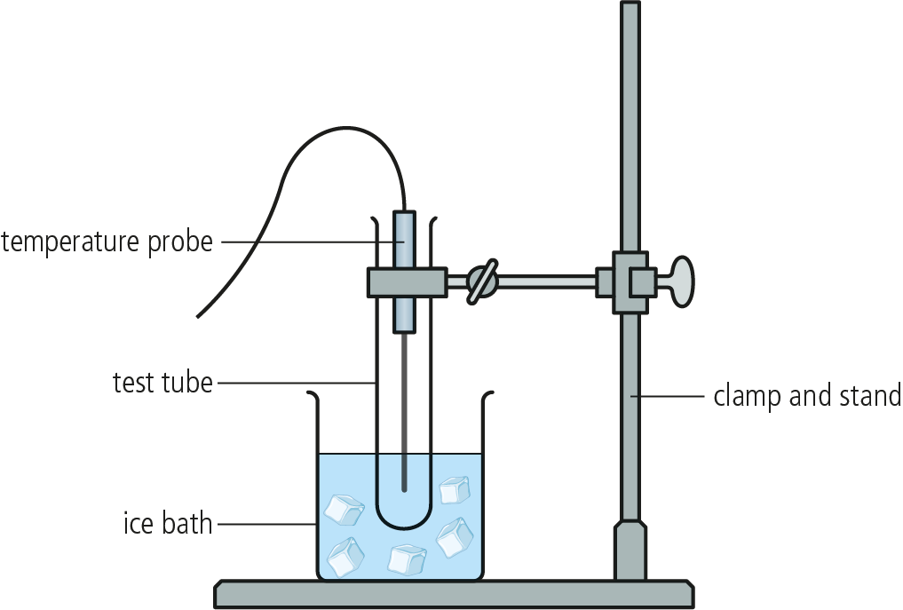
Method
- Set up the temperature probe and data logging equipment according to your equipment specifications.
- Heat some water in a kettle, nearly to boiling point.
- Clamp the test tube on a stand and place it inside the beaker that acts as an ice bath. The test tube should be in the water but should not be touching the glass walls of the beaker.
- Carefully add some of the heated water to the test tube (the test tube should be
no more than half filled).
- Place the temperature probe upright in the hot water inside the inner tube, without touching the walls of the test tube. A second clamp may be required to do this.
- Start the data collection. The process may differ depending on the brand and type of your temperature tube. Your teacher can guide you on how to appropriately set up a data collection for temperature over time. Allow continuous data collection for at least 5 min.
If you do not have a temperature probe, you can use a thermometer and a stopwatch to record the temperature every 30 sec in an appropriate table.
- To accelerate the cooling process, add crushed ice with a small amount of water to the ice bath. Once the internal temperature (the temperature of the water in the test tube) drops below 30°C, empty the ice bath and refill with fresh crushed ice and a small amount of water. Add about 100 g of table salt on top of the crushed ice. This will rapidly reduce the temperature of the ice bath. Continue collecting data until the internal temperature reaches about −5°C.
- Record your observations in an appropriate table.
- While still recording data, remove the test tube from the ice bath and wait for the solid ice inside the test tube to melt.

Analysis
- Draw the cooling curve of water using the data collected.
- Use the curve and your data to determine the freezing point of water.
- Express your answer with a percentage uncertainty.

Reflection
Review your data and consider whether there is any difference between the freezing and melting temperature of water.

Post–lab report
Write a report where you:
- Summarize the important theoretical concepts described in this lab.
- Summarize the experimental procedure.
- Highlight any important health and safety matters.
- Present your qualitative and quantitative observations.
- Explain why the freezing point determined in this experiment is not 0°C.
- Determine your experimental error.
- State a conclusion.
- Evaluate the procedure and identify the sources of error. Consider how the method
could be expanded or used for further study.

