Structure 1.1.2
Sublimation of iron and iodine – Observing the crystalline product under a microscope

Reference:
S1.1.2 The kinetic molecular theory is a model to explain physical properties of matter
(solids, liquids, and gases) and changes of state.

Aim
To observe the process of sublimation.

Introduction
Matter can exist in different states. The fundamental states of matter (the ones that are directly observable) are solid, liquid, gas, and plasma. The states of matter and their characteristics are discussed in Structure 1.1.2.

The states of matter of the substances that appear in a chemical reaction are shown with the state symbols (s) for solid, (l) for liquid, and (g) for gas.

A liquid (l) should not be confused with an aqueous solution, which is denoted as (aq).
For example, NaCl(l) indicates an amount of NaCl that was heated to its melting point to
create molten NaCl. In molten NaCl(l), only liquid Na⁺ and Cl⁻ ions exist (Figure 1).

NaCl(l) Na⁺(l) + Cl⁻(l)



Figure 1. Molten sodium chloride

NaCl(aq) indicates that NaCl was dissolved in water to form a solution of aqueous NaCl(aq), where Na⁺ and Cl⁻ ions surrounded by water molecules are present (Figure 2).

NaCl(aq) Na⁺(aq) + Cl⁻(aq)

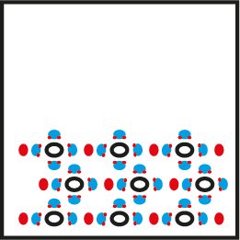

Figure 2. Aqueous sodium chloride

Changes in the state of matter, also referred to as a ‘phase change’, can occur. This is commonly observed when an ice cube – H₂O(s) – turns into liquid water – H₂O(l) – when left
at room temperature, or when liquid water turns to steam – H₂O(g) – when boiled in a kettle.

As the movement (kinetic energy) of the particles increases with temperature, they will overcome the inter-particle forces and change state. These state changes occur at a fixed temperature and pressure for each substance, and are given specific names, as shown
in Figure 3.

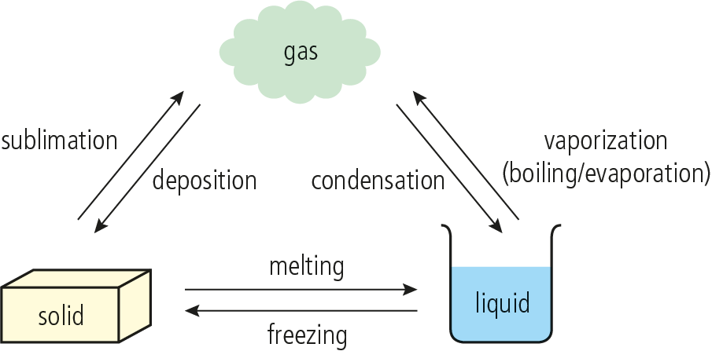

Figure 3. The state changes between the solid, liquid and gaseous states

Sublimation is the direct inter-conversion of a solid to a gas without going through the liquid state. It is characteristic of substances such as iodine, carbon dioxide and ammonium chloride.
Deposition is the reverse of sublimation. It occurs when a gas changes directly to a solid, for example when snow and frost are formed.

Pre-lab questions
The Kinetic Theory of Matter states that all particles of matter are in constant motion.
The extent of this motion determines the state of matter.
- What are the differences between a solid, a liquid, and a gas?
- What are the characteristics of each of the three states of matter, solid, liquid and gas?

Please note
- A full risk assessment should be carried out prior to commencing this experiment.
- Personal safety equipment should be worn.
- Chemicals should be disposed of safely and with due regard to any environmental considerations

Risk assessment
Material name and chemical formula | Associated risks | Measures taken

Environmental risks
Waste products (if any) | Associated risks | Waste management

Ethical risks
Small amounts should be used when possible. Products should be appropriately stored and used in subsequent experiments. No harm to people and the environment should be caused
by this experiment.

Equipment list
Chemicals/materials | Apparatus (per group of students)
iron filings  iodine pellets  ice cubes | 2× beakers 20 cm³ or 2× crystallization dish  2× watch glass  spatula  microscope or magnifying glass  hot plate

Method
- Transfer a few pellets of iodine into a clean and dry 20 cm³ beaker (or crystallization dish).
- Put the beaker on top of a hot plate and turn the heat on.
- Place an ice cube on an appropriately sized watch glass, on top of the beaker.
- Observe the process and note your observations in Table 1. You may have to add more ice cubes to the watch glass in order to complete the process.
- Repeat the process with a new clean and dry beaker and watch glass, using iron filings instead of iodine.
- Observe the process and record your observations in Table 1.
- When the process is complete, pure crystals of iodine and of iron will be present on the underside of the watch glasses. Look at the crystals under a microscope and record their colour, shape and texture in Table 1.

Analysis

Table 1 – Observations
 | Sublimation of iodine |  | Sublimation of iron
Observations during sublimation (deposition) process

 | I₂ pellets | Sublimed I₂ | Iron filings | Sublimed iron
Colour
Shape (geometry)
Texture

Reflection
- This was a skills-building exercise. Evaluate your skills and consider the parts
that may have been challenging for you.
- Describe a method to completely separate a mixture of iron filings, sand and
sodium chloride.

Post–lab report
Write a report where you:
- Summarize the important theoretical concepts described in this lab.
- Summarize the experimental procedures.
- Highlight any important health and safety matters.

