Structure 1.1.1
Preparation of AgI precipitate from aqueous solutions

References:
T1 Applying techniques
S1.1.1 Mixtures contain more than one element or compound in no fixed ratio, which are not chemically bonded and so can be separated by physical methods.
S2.1.2 Deduce the formula and name of an ionic compound from its component ions including polyatomic ions.

Aim
To prepare, isolate and purify an insoluble salt.

Introduction
Even though ionic compounds are generally considered to be strong electrolytes that fully dissociate in water, there are a few cases of ionic compounds that are not soluble in water.
Whether a compound is soluble or not in water, can be determined using solubility tables like the one shown in Figure 1.

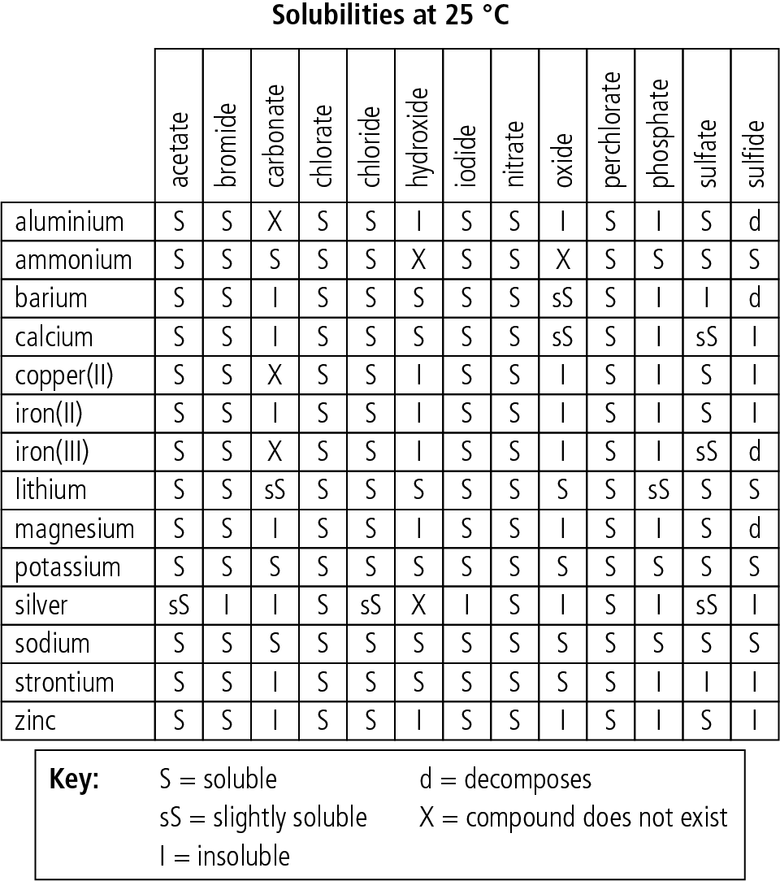

Figure 1

In reality, even the salts that are labelled as insoluble do exchange ions into the solution, albeit at extremely low rates, forming a heterogeneous equilibrium that favours the solid lattice over the aqueous ions.

MX(s) ⇌ M(aq)^{n+} + X(aq)^{n–}

When two soluble ionic compounds are mixed and an insoluble compound is formed, it is stated that a precipitation has occurred. A well-known precipitation reaction is the formation of AgI(s) from AgNO₃(aq) and KI(aq).

Pre-lab questions
- Using the solubility table shown in Figure 1, deduce which of the following reactions will result in a precipitate. Give the IUPAC name of the precipitate.
- BaCl₂(aq) + H₂SO₄(aq)
- Ca(NO₃)₂(aq) + Na₂CO₃(aq)
- FeCl₃(aq) + KNO₃(aq)

- AgNO₃(aq) is used to characterise ionic halides. Complete the following reactions and then research the characteristics of the three precipitates. Explain how this reaction can help you identify the different metal halides.

- KCl(aq) + AgNO₃(aq)
- KBr(aq) + AgNO₃(aq)
- KI(aq) + AgNO₃(aq)

- Silver iodide was initially used in photography. Investigate how.

Please note
- A full risk assessment should be carried out prior to commencing this experiment.
- Personal safety equipment should be worn.
- Chemicals should be disposed of safely and with due regard to any environmental considerations

Risk assessment
Material name and chemical formula | Associated risks | Measures taken

Environmental risks
Waste products (if any) | Associated risks | Waste management

Ethical risks
Small amounts should be used when possible. Products should be stored appropriately for
use in subsequent experiments. No harm to people and the environment should be caused
by this experiment.

Equipment list
Chemicals/materials | Apparatus (per group of students)
KI(aq) 0.1 mol dm^{–3}  AgNO₃(aq) 0.1 mol dm^{–3} | 2× pipette  2× conical flask 50 cm³  1× funnel  1× filter paper  1× stand and ring

Method
- Transfer 5 cm³ of KI solution into a 50 cm³ conical flask using a pipette.
- With a second pipette, transfer 5 cm³ of AgNO₃ solution into the same flask.
- Observe the reaction taking place and note any qualitative changes in Table 1.
Hint: Qualitative changes are any non-quantifiable changes in various aspects of the system being observed, such as colour, smell, bubbling, or formation of precipitate.
- Upon completion of the reaction, prepare a fluted filter paper. Set up a stand with a ring and place the funnel in the ring as shown in Figure 2. Remember to place a clean conical flask below the funnel to collect the filtrate.
- 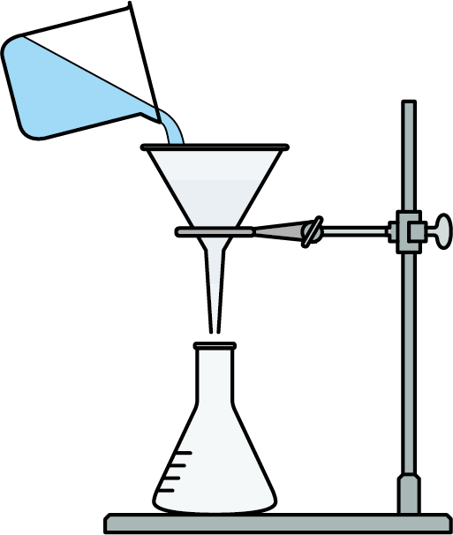Filter the reaction mixture through the filter paper.
- Wash the contents of the reaction flask three times with 5 cm³
of deionized water and pass the wash through the filter to collect all the product and remove any impurities.
- Collect the filter paper with the residue and dry to constant mass.
- Collect the dried material and note any qualitative changes in Table 1.
- Measure the mass of the dried material and fill in Table 2 to determine the % yield of the reaction.

Figure 2

Analysis
Table 1 – Qualitative observations
Colour of KI solution
Colour of AgNO₃ solution
Reaction mixture:
colour of supernatant liquor
colour of precipitate
Dried material (colour, texture, etc.)

Table 2 – Quantitative data
KI(aq) | AgNO₃(aq) | AgI(s)
[KI] = 0.1 mol dm^{–3}  V = 5 cm³  n = ________ mol | [AgNO₃] = 0.1 mol dm^{–3}  V = 5 cm³  n = ________ mol | n = ________ mol  M_{r} = ________ g mol^{–1}  Theoretical mass = ________ g  Dried mass = ________ g  % yield = $\frac{Theoretical yield}{Dried Mass}×100= __________\%$

Note: The collected dried material always contains some grey impurities of metallic silver.
This is because AgI(s) is extremely photosensitive and some of the ionic silver reduces to metallic Ag(s).

Reflection
- Your yield determination is not accurate as it is affected by the presence of metallic silver impurities which cannot be removed with the procedure offered in this lab.
- Consider ways that the procedure could be altered to remove the metallic silver impurities from the product prior to determination of the yield.

Post–lab report
Write a report where you:
- Summarize the important theoretical concepts described in this lab.
- Summarize the experimental procedure.
- Highlight any important health and safety matters.
- Calculate the theoretical yield of AgI(s) expected.
- Determine the amount of purified AgI(s) and determine the yield of the reaction.

